REVELATION 17 — “The Lamb is the Lord”
JESUS REVELATION

Revelation 16 ended at the Battle of Armageddon, with the seventh and final bowl being poured out, and a loud voice coming from the throne in the temple saying, “It is done!” The greatest earthquake in human history follows, the cities of the nations collapse, and then we are told at the end of Revelation 16 “God remembered Babylon the Great and gave her the cup filled with the wine of the fury of his wrath.”

So here in chapter 17, the obvious question is: Who is Babylon the Great, and why does she receive such severe judgment?
Chapters 17 and 18 answer that question. John is given a closer look at this mysterious Babylon that has already been mentioned several times in Revelation. This chapter (17) focuses primarily on the religious and political aspects of what is called “Babylon”.
The image John is shown here is shocking. He sees a woman described as a prostitute, dressed in royal colors, covered with gold and precious stones, holding a golden cup, and sitting on a familiar monster (the scarlet beast with seven heads and ten horns.)
Now fortunately, we are not left to simply guess what all of that means. The angel himself is going to interpret much of the symbolism. He will tell us what the waters mean, what the horns mean, what the heads mean, and ultimately who the woman represents.
What Revelation 17 shows us is the “final form of a world system” that has been developing throughout human history. It is religion without truth, power without righteousness, “unity without God”, and ultimately “worship without Jesus”. And during the Tribulation, that system reaches its fullest and most pervasive expression.
Revelation 17:1-2 “One of the seven angels who had the seven bowls came and said to me, “Come, I will show you the punishment of the great prostitute, who sits by many waters. 2 With her the kings of the earth committed adultery, and the inhabitants of the earth were intoxicated with the wine of her adulteries.”
In the previous chapter, we saw the seven bowl judgments completed, and now one of those same seven angels speaks to John and says, “Come, I will show you the punishment of the great prostitute.”

That language immediately tells us that this woman represents “spiritual corruption”. Throughout the Old Testament, adultery and prostitution are often used as pictures of idolatry and spiritual betrayal. Israel was sometimes described in those terms when the people turned away from the Lord and gave themselves to false gods.
But this woman is NOT Israel. Her influence is much broader than that. We are told that she “sits by many waters,” and later in verse 15 the angel explains exactly what that means. The waters represent “peoples, multitudes, nations and languages.” In other words, this is a worldwide religious influence.
And notice how closely this spiritual corruption is connected with political power. Verse 2 says, “With her the kings of the earth committed adultery.” The rulers of the earth enter into a relationship with her. Religion and political power become intertwined, each one benefiting from the other. In other words One World Religion, and Government.
Then John says that “the inhabitants of the earth were intoxicated with the wine of her adulteries.” That is a powerful picture because intoxication means that they are vulnerable to deceit, and have a distorted view of reality. It causes people to embrace what they might otherwise reject.
False religion can do the same thing spiritually. It can make people feel religious while actually leading them farther from God. It can offer ritual without repentance, spirituality without truth, morality without holiness, and even worship without the true Jesus.
[Did you ever speak with someone in a cult? They almost always have a distant look in their eyes, with obvious unrest and lack of peace. They say things that sound absurd, yet they somehow have allowed themselves to believe it.]
Revelation is telling us that during the Tribulation, that kind of spiritual deception will not diminish. It will intensify.
Revelation 17:3 “Then the angel carried me away in the Spirit into a wilderness. There I saw a woman sitting on a scarlet beast that was covered with blasphemous names and had seven heads and ten horns.”
We have already met this beast. Revelation 13 described a beast coming out of the sea with seven heads and ten horns. Introduced by the dragon that lived by the sea (Satan).
Revelation 13:1 “The dragon stood on the shore of the sea. And I saw a beast coming out of the sea. It had ten horns and seven heads, with ten crowns on its horns, and on each head a blasphemous name. 2 The beast I saw resembled a leopard, but had feet like those of a bear and a mouth like that of a lion.”
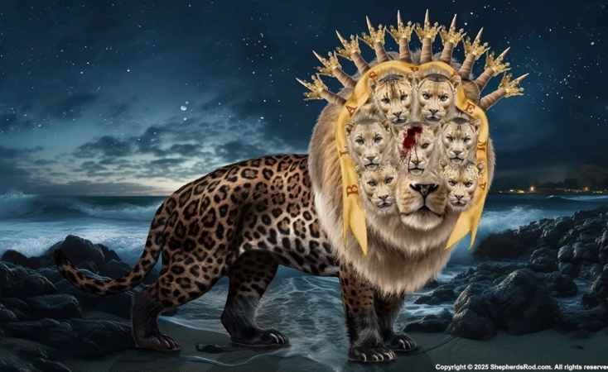
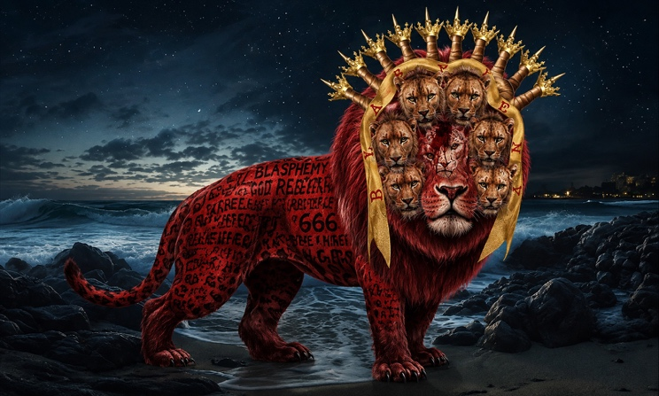
The beast represents the Antichrist and the final kingdom over which he rules.

Revelation 17:4 “The woman was dressed in purple and scarlet, and was glittering with gold, precious stones and pearls. She held a golden cup in her hand, filled with abominable things and the filth of her adulteries. 5 The name written on her forehead was a mystery:
BABYLON THE GREAT,
THE MOTHER OF PROSTITUTES
AND OF THE ABOMINATIONS OF THE EARTH.”

So right away we see that the woman and the beast are connected, but they are not the same thing.
The woman represents this corrupt religious system, while the beast represents the Antichrist and his political power. For a time, they cooperate with each other. The woman rides the beast, meaning that this religious system is supported by political power.
Notice the appearance of the woman. She is dressed in purple and scarlet; colors associated with wealth, royalty and splendor. She is glittering with gold, precious stones and pearls. She looks magnificent. She looks impressive. She looks successful.
But then John sees what is inside the cup she is carrying.
It is a golden cup, but it is “filled with abominable things and the filth of her adulteries.”
Outwardly she is beautiful, but inwardly she is corrupt. What appears glorious to the world is disgusting in the sight of God. Even (especially) when clothed in opulence, pride and power, yet rejecting the truth of God.
And then John sees the name written on her forehead: “Babylon the Great, the Mother of Prostitutes and of the Abominations of the Earth.”
BABYLON: Babylon was a massive and magnificent city, located in what is now modern-day Iraq, and was known throughout the ancient world for its splendor and power. It was the Babylonians who conquered Jerusalem, destroyed the Temple, and carried many of the people of Judah into captivity in the sixth century B.C., including Daniel, Shadrach, Meshach, and Abednego.
Revelation 17:6a “I saw that the woman was drunk with the blood of God’s holy people, the blood of those who bore testimony to Jesus.”
This is a horrifying picture. She has persecuted and killed those who remain faithful to Jesus, and she has done it so extensively that John describes her as intoxicated by their blood.
We have already seen this type of persecution throughout Revelation.
- Revelation 6 we saw the martyrs beneath the altar crying out to God.
- Revelation 7 we saw the great multitude who had come out of the Great Tribulation.
- Revelation 12:11 told us that the faithful overcame Satan “by the blood of the Lamb and by the word of their testimony; they did not love their lives so much as to shrink from death.” And
- Revelation 13 told us that those who refuse to worship the beast will face execution.
So this is not simply a harmless form of religious pluralism. This system becomes hostile toward anyone who insists that “Jesus alone is Lord”.
NOTE: Alarmingly this is true of certain parts of the world. It may be true here in America in the future.
And that has always been the problem for false religion and oppressive political systems. They can tolerate a Jesus who is “one option among many”. They can tolerate a Jesus whose words inspire people or who comforts the poor and needy. But the biblical declaration that “Jesus alone is Lord” becomes a problem, because if Jesus is Lord, then ever other religious figure is not.
When He says that He is the ONLY way, the ONLY truth, and the ONLY life, that directly opposes every other belief or religious system.

Revelation 17:6b-8 “When I saw her, I was greatly astonished. 7 Then the angel said to me: “Why are you astonished? I will explain to you the mystery of the woman and of the beast she rides, which has the seven heads and ten horns.
8 The beast, which you saw, once was, now is not, and yet will come up out of the Abyss and go to its destruction. The inhabitants of the earth whose names have not been written in the book of life from the creation of the world will be astonished when they see the beast, because it once was, now is not, and yet will come.”
John is overwhelmed by what he sees, and the angel tells him that he is going to explain the mystery. The attention now shifts from the woman to the beast.
The beast is described as one who “once was, now is not, and yet will come.” There seems to be a deliberate counterfeit here of the way God Himself is described earlier in Revelation as the One “who is, and who was, and who is to come.”
Remember: The Devil often imitates aspects of God, rather than oppose them, in an effort to draw people into deception.
Revelation 17:9-11 “This calls for a mind with wisdom. The seven heads are seven hills on which the woman sits. 10 They are also seven kings. Five have fallen, one is, the other has not yet come; but when he does come, he must remain for only a little while. 11 The beast who once was, and now is not, is an eighth king. He belongs to the seven and is going to his destruction.”
This is one of the more difficult passages in Revelation, and the angel himself warns us that it “calls for a mind with wisdom.” In other words, “look deeper than the surface of what has been written”.
The seven heads represent two things. They are seven hills, and they are also seven kings.
The reference to seven hills brings Rome to mind. Many scholars believe Revelation 17:9–11 clearly points to Rome because Rome was famously known as the “City of Seven Hills” long before Revelation was written. (120 years).
But like Babylon, Rome represents more than a city. It represents a powerful political empire with enormous religious influence.
At the time Revelation was written, the Roman Empire was the dominant power in the world John knew. Religion and government were closely connected, and emperor worship became a mandatory part of Roman rule. This created an obvious conflict for Christians who believed that Jesus alone is Lord.
Rome’s political and religious influence continued for centuries;
- Under Constantine, Christianity was legalized and eventually became closely connected with the Roman government.
- Centuries later, the Holy Roman Empire arose (under Charlemagne), and the Roman Catholic Church became an enormous religious and political power throughout Europe.
- During the Crusades and Inquisitions, political and religious power were sometimes combined with force and violence in the name of Christianity.
Eventually, Rome’s political power was divided and diminished. But Revelation seems to point toward something that will rise again. John describes the Beast as one who “once was, now is not, and yet will come.” This may point to a future revival of the kind of political and religious power once represented by Rome.

This is one reason “Preterism”, the belief that these prophecies were fulfilled in the early centuries, falls short. John does not simply describe something that had already happened or was happening in his own day. He says something “will come” which means ancient Rome was not the final fulfillment. It was a picture of something that will appear again in the last days.

Revelation 17:12-14 “The ten horns you saw are ten kings who have not yet received a kingdom, but who for one hour will receive authority as kings along with the beast. 13 They have one purpose and will give their power and authority to the beast. 14 They will wage war against the Lamb, but the Lamb will triumph over them because he is Lord of lords and King of kings—and with him will be his called, chosen and faithful followers.”
Now the angel explains the ten horns. They represent ten kings who have not yet received their kingdoms. That places these rulers in the future from John’s perspective.
They receive authority for what Revelation describes as “one hour.” That does not necessarily mean a literal sixty minutes. The point is that their time of power will be extremely brief compared with the everlasting kingdom of God.
These rulers eventually unite around one purpose and surrender their authority to the beast.
Think about what Revelation is describing here. Human history has been filled with kingdoms competing against kingdoms, nations fighting nations, rulers struggling for territory, wealth and authority. But near the end, these rulers become united.
And what ultimately unites them? Opposition to Jesus!
Verse 14 says, “They will wage war against the Lamb.”
There is something almost absurd about that sentence. The rulers of the earth gather together and imagine that they can wage war against the Lamb of God.
But the verse does not leave us waiting to find out what happens.
“The Lamb will triumph over them because - He is Lord of lords and King of kings.”
This is the final war, “Battle of Armageddon”, when Jesus returns in glory and conquers the nations that have gathered against Him.
This great and final conflict is prophesied throughout Scripture. Revelation 16 tells us that the kings of the whole world are gathered for battle at Armageddon. Revelation 19 shows us Jesus coming from heaven in glory to defeat the Beast, the kings of the earth, and their armies. And centuries earlier, Zechariah saw the same day coming.
Zechariah 14:
2 “I will gather all the nations to Jerusalem to fight against it; … 3 Then the Lord will go out and fight against those nations, as he fights on a day of battle. 4 On that day his feet will stand on the Mount of Olives, east of Jerusalem, …
8 On that day living water will flow out from Jerusalem, half of it east to the Dead Sea and half of it west to the Mediterranean Sea, in summer and in winter.
9 The Lord will be king over the whole earth. On that day there will be one Lord, and his name the only name.”
The nations gather. The armies assemble. The rulers of the earth unite against Him. But when Jesus comes, there is no question about the outcome. The Lamb will triumph, because He is Lord of lords and King of kings.
The world may appear to belong to the beast for a short time, but it actually belongs to the Lamb.
Last section:
Revelation 17:15-18 “Then the angel said to me, “The waters you saw, where the prostitute sits, are peoples, multitudes, nations and languages. 16 The beast and the ten horns you saw will hate the prostitute. They will bring her to ruin and leave her naked; they will eat her flesh and burn her with fire. 17 For God has put it into their hearts to accomplish his purpose by agreeing to hand over to the beast their royal authority, until God’s words are fulfilled. 18 The woman you saw is the great city that rules over the kings of the earth.” <>
Now the angel brings the interpretation together.
The waters represent peoples, multitudes, nations and languages. So there is no question that this system has worldwide influence.
But then something unexpected happens.
The beast turns against the woman. The same political power that supported this religious system now destroys it.
Why would the Antichrist destroy the very religious system that helped support his rise?
Because eventually he no longer needs it.
At first, this worldwide religious system appears to help unify people and support the political rise of the beast. But he does not want to share worship with anyone or anything else.
He wants worship directed toward himself.
Verse 18 finally identifies the woman as: Babylon, “the great city that rules over the kings of the earth.”

[Next Chapter: “The Finality of Babylon’s Doom”]

This chapter teaches us;
The kingdoms of this world rise and fall. Earthly kings may gather together in all their power, but Jesus remains on the throne.
He is the Lamb who was slain, the Lord God Almighty, the One who was, who is, and who is to come.
Revelation reminds us that no earthly kingdom, political power, or religious system can ever take His place or overcome His authority.

So our eyes are not to be fixed on False Religions, World Powers, Evil Leaders, or the political systems of this world. Our eyes are to remain fixed on Jesus.
“The Lamb who was slain, and the King who will reign!”
There is only one King of kings, and all blessing and honor, strength and glory and power belong to Him.
And when every earthly kingdom has fallen, every false system has been exposed and destroyed, and every rebellious power has been defeated, Jesus will still be reigning.
And with all creation we will stand in wonder and worship, praising the King of Kings, who alone is worthy: Holy, holy, holy is the Lord God Almighty, who was, and is, and is to come!

