Revelation 15 — The Song of the Overcomers
Revelation 15 is a short chapter—only eight verses—but it brings us to a major turning point in the book. We are approaching the end of the Tribulation. The Beast has risen to power, his image has been established, his mark has been imposed on everyone, and God's people have faced tremendous persecution. Now John is given another glimpse into heaven, and what he sees is very different than what is happening on earth.
That is one of the great gifts of Revelation. It allows us to see earthly events from heaven's perspective. On earth, the Beast appears powerful and God's people appear defeated. In heaven, the Beast is headed for judgment and the people he supposedly defeated are standing victoriously worshipping God.
The message of Revelation 15 is that evil may appear to win for a season, but Jesus has the final word and those who remain faithful to the Lamb are the true overcomers.
Revelation 15:1 “I saw in heaven another great and marvelous sign: seven angels with the seven last plagues—last, because with them God’s wrath is completed.”
Notice that the number seven appears throughout Revelation and repeatedly communicates completeness. We have seven churches, seven seals, seven trumpets, and now seven angels carrying seven final plagues. John specifically tells us why these plagues are called “last”: with them, God's wrath is completed.
That word is interesting. The Greek is etelesthē, from teleō, meaning “to complete” something, finish it, or bring it to its intended goal. If that sounds familiar, it should. When Jesus is on the cross in John 19:30 and says, “It is finished,” the word is tetelestai, from that same Greek verb. There is a wonderful truth connecting them: God finishes what He purposes to accomplish.
Jesus said something similar;
Matthew 5:18 “Until heaven and earth disappear, not the smallest letter, not the least stroke of a pen, will by any means disappear from the Law until everything is accomplished [completed].”

The Overcomers
Revelation 15:2 “And I saw what looked like a sea of glass glowing with fire and, standing beside the sea, those who had been victorious over the beast and its image and over the number of its name.”
We've encountered this sea before. In Revelation 4:6, in front of God's throne, John saw “what looked like a sea of glass, clear as crystal.” Revelation 15 appears to bring us back to that same heavenly scene, except now the sea is mingled with fire, which fits the context of the judgment that is about to come.
This should not be confused with the Lake of Fire. Revelation identifies the Lake of Fire very specifically later in chapters 19 and 20 as the place of final judgment. This is the glassy or crystal sea before God's throne.
From a pre-Tribulation perspective, these are believers who have come to faith in Messiah during the Tribulation. They have lived under the Beast's rule and refused to give him the allegiance he demanded. They would not worship the Beast, they would not worship his image, and they would not identify themselves with his name and number.
What makes this so striking is something we read two chapters earlier. Revelation 13:7 says that the Beast was given power “to wage war against God's holy people and to conquer them.” Yet here Revelation 15 says that these people were victorious over the Beast.
So who conquered whom?
From the perspective of earth, the Beast conquered them. He persecuted them, and many of them apparently lost their lives because they refused to worship him. But from heaven's perspective, they conquered him, because he was never able to gain what he really wanted: their worship and allegiance.
Revelation 12:11 “They triumphed over him by the blood of the Lamb and by the word of their testimony; they did not love their lives so much as to shrink from death.”
That is one of Revelation's most important definitions of what it means to overcome. Victory begins with the blood of the Lamb. It continues through the word of their testimony, and it expresses itself in a faithfulness to Jesus that cannot be coerced or intimidated away.
The Beast could threaten these believers, imprison them, exclude them from the economy, and even take their physical lives. What he could not do was make them stop belonging to Jesus.
There is something here for us even though we don't believe the Church is going to experience the Tribulation described in these chapters. The principle of faithfulness doesn't change. We tend to define victory by whether circumstances turn out the way we hoped. Revelation defines victory first by whether we remain faithful to the Lamb.
Sometimes faithfulness to Jesus may look unimpressive from the world's perspective. It may even look like we’re losing. But God evaluates things differently. Revelation 15 shows us people whom the world would have called “defeated”, but God calls them overcomers.

The Song of Moses and the Lamb
Revelation 15:3 “They held harps given them by God and sang the song of God's servant Moses and of the Lamb.”
This chapter is a “worship chapter” John tells us that these victorious believers are holding harps given to them by God. So, yes, there really are harps in heaven! We've already encountered them in Revelation 5:8 and Revelation 14:2, and here they appear again as instruments of worship.
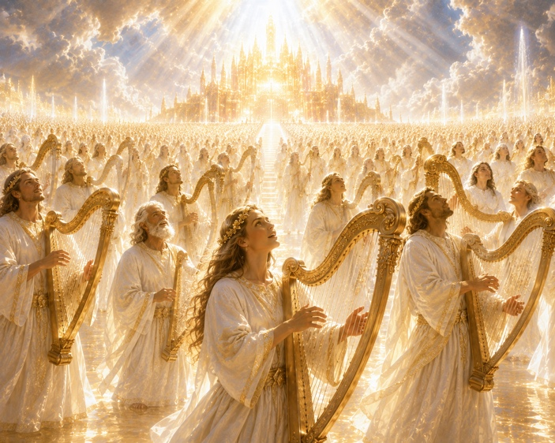
The song:
Revelation 15:3-4 “Great and marvelous are your deeds, Lord God Almighty. Just and true are your ways, King of the nations. Who will not fear you, Lord, and bring glory to your name? For you alone are holy. All nations will come and worship before you, for your righteous acts have been revealed.”
This is amazing worship!!!
Interestingly, although this is called the Song of Moses and the Lamb, the words are drawn from several places throughout the Hebrew Scriptures. We hear echoes of Psalm 111, Deuteronomy 32, Jeremiah 10, Psalm 86, and Psalm 98. It's as though the worshipers are gathering together the language of the Hebrew Scriptures and declaring that everything God has said about His righteousness, holiness, judgment, and ultimate rule over the nations is coming true.
Notice also what these believers are not singing about. After all the awful things they've experienced and endured, their song is not primarily about themselves. They aren't celebrating their courage or recounting everything they went through. Their attention is completely fixed upon the character of God. His deeds are marvelous, His ways are just, He alone is holy, and ultimately the nations will worship before Him.
That's important for us to note. Biblical worship doesn't ultimately leave us impressed with the music or the worshipers themselves. It leaves us impressed with God.

The Heavenly Tabernacle
Revelation 15:5 “After this I looked, and I saw in heaven the temple—that is, the tabernacle of the covenant law—and it was opened.”
Once again John uses language that should immediately sound “Jewish” to us: the temple, the tabernacle, the covenant and the law. All major components of the Hebrew scriptures.
Now John looks into heaven and sees the ultimate reality to which those earthly things pointed.
Hebrews 8:5 explains that the priests on earth served in “a sanctuary that is a copy and shadow of what is in heaven.” God told Moses to construct the Tabernacle according to the pattern shown to him on the mountain because the earthly sanctuary was teaching Israel something about a heavenly reality.
That helps us understand why Revelation is filled with Tabernacle and Temple imagery. The altar, incense, Ark, lamp imagery, priestly clothing, worship, and sanctuary are not random decorations John borrows from Judaism. They are part of the biblical story God has been telling from the beginning.
Here the heavenly sanctuary is opened because judgment is about to proceed from God's presence.
There is an important theological point here. The terrible judgments that are coming in Revelation 16 are not random natural disasters, nor are they the uncontrolled anger of an unpredictable deity. They proceed from the sanctuary of the holy and covenant-keeping God.
That is why the worshipers have just declared:
“Just and true are your ways.”
God's holiness and God's judgment, cannot be separated.
Remember God is love, His merciful kindness, and compassion are everlasting. This is true, even when His wrath and judgment are severe and at times even violent.
How can this be? How can He show both wrath and love in the same verses?
Note: God's wrath is not the opposite of His love. It is His holy response to all that opposes His goodness, His glory, and the people He loves.
[Example: My dad loved his garden and lawn, but especially his ornamental crabapple tree in the front yard. He cared for every part of it with meticulous attention. His garage was filled with every imaginable lawn and garden tool—spades, shovels, rakes, hoes, clippers, edgers, and pruning shears. Every tool had a purpose because every plant required different care.
One summer, his ornamental crabapple tree became covered with tent caterpillars. They devoured the leaves, damaged the bark, and built large web-like nests throughout the tree. Dad blasted them with a garden hose, but within days they were back, building even larger nests. That was enough! Those caterpillars invoked his wrath.
He walked into the garage and came back carrying a homemade torch—a mop handle with an old towel tied to the end, soaked in kerosene and set ablaze. One by one, he burned every nest, killing thousands of caterpillars. When he was finished, he took the garden hose and washed away what remained. As far as I know, they never returned.
Did my dad suddenly stop loving his tree, and begin to hate it because it was infested? No.
He exercised wrath because he loved the tree. His wrath was not directed against the tree; it was directed against the thing that was destroying the tree.]
This is how God responds to sin in the world here in Revelation, and this is why He brings for the final seven bowls of judgment upon the earth.

The Seven Angels and Seven Bowls are about to come out. (We will read about them in detail in Chapter 16);
Revelation 15:6 “Out of the temple came the seven angels with the seven plagues. They were dressed in clean, shining linen and wore golden sashes around their chests.”
Their clothing sounds familiar because in Revelation 1:13, when John first sees the glorified Jesus, He is wearing the same “uniform”, a golden sash around His chest. Here these angels emerge from God's sanctuary dressed in clean linen and golden sashes as holy servants commissioned to carry out His judgment.
Revelation 15:7 “Then one of the four living creatures gave to the seven angels seven golden bowls filled with the wrath of God, who lives for ever and ever.”
(In chapter 16 they pour them out upon the earth.) What Revelation 15 announces as approaching completion, Revelation 16 brings to its conclusion.
Revelation 15:8 “And the temple was filled with smoke from the glory of God and from his power, and no one could enter the temple until the seven plagues of the seven angels were completed.” <>
For anyone familiar with the Hebrew Scriptures, this is immediately recognizable.
- Exodus 40:34–35 — God's glory filled the Tabernacle so completely that even Moses could not enter.
- 2 Chronicles 7:1–2 — Fire came down from heaven, God's glory filled Solomon's Temple, and the priests could not enter.
- Isaiah 6:1–4 — Isaiah saw the Lord on His throne, and the Temple was filled with smoke.
Now John sees the heavenly reality behind all of those earlier manifestations. The sanctuary fills with smoke from the glory and power of God, and verse 8 concludes:
“and no one could enter the temple until the seven plagues of the seven angels were completed.”
At the most basic level, this continues the biblical pattern. Moses couldn't enter when God's glory filled the Tabernacle. The priests couldn't enter when God's glory filled Solomon's Temple. Now no one can enter the heavenly sanctuary while God's glory fills it.
What does this mean for us?
There will be moments in our own lives when obeying Jesus costs us something. There may be moments when doing what is right doesn't produce an immediate reward, when telling the truth makes life harder, when standing with Jesus puts us outside the cultural mainstream, or when prayers don't seem to be answered the way we expected.
Revelation reminds us that we should not measure the faithfulness of God—or the success of our own faithfulness—only by what we can see right now.
Earth does not have the final perspective. Heaven does.
That is why the Song of Moses becomes the Song of the Lamb. From Exodus to Revelation, it is one great story of a God who saves His people, keeps His Word, judges evil, and brings His purposes to completion.
One day the question will no longer be whether the Beast can be defeated. He will be gone. The kingdoms that opposed God will be gone. The suffering of God’s people will be over. The Antichrist, all evil, and even the Devil himself will be gone.
What will remain is the Lamb who bore the cross—the One before whom “all nations will come and worship”—and His redeemed people, worshiping the Lamb, JESUS!
His name is above every name, and is worthy of all praise, worthy of all devotion, worthy of all allegiance, worthy of all honor, worthy of all glory, worthy of all power, and worthy of all worship forever!

