JESUS REVELATION

Revelation 13

The Beast, the False Prophet, and the Mark
Last week in Revelation 12 we were introduced to one of the main characters in the final chapters of Revelation “the Dragon”. John removes all mystery concerning his identity when he writes,
Revelation 12:9 "The great dragon was hurled down—that ancient serpent called the devil, or Satan, who leads the whole world astray."
The Dragon is Satan himself. After losing the war in heaven, he is cast down to the earth and knows that "his time is short." Revelation 13 explains what Satan does during those final years before Jesus returns.
Revelation 12:11 “They triumphed over him by the blood of the Lamb and by the word of their testimony; they did not love their lives so much as to shrink from death.”
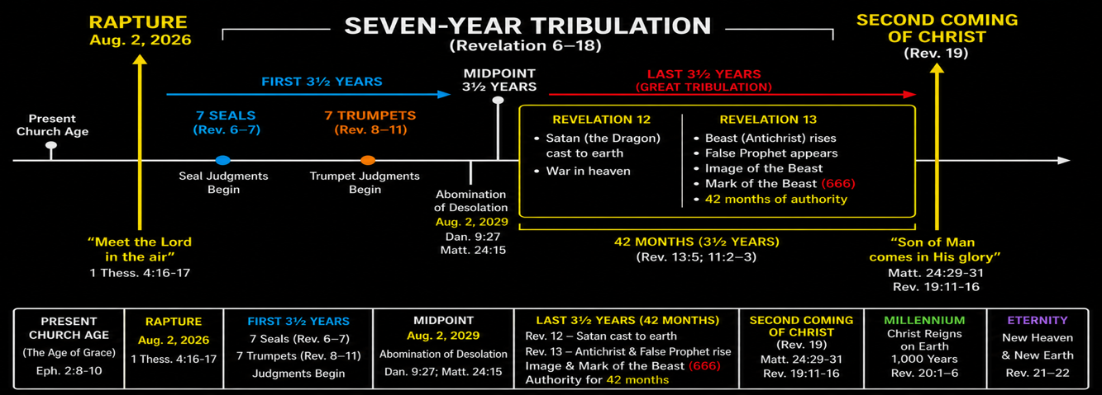
Let’s look at where we are end-times timeline.

Revelation 13 occurs during the last three-and-a-half years of the Tribulation, the period Jesus called "the Great Tribulation" (Matthew 24:21). Daniel refers to it as "a time, times and half a time." Revelation calls it 42 months.
Following the midpoint of the Tribulation, Satan is cast to the earth, the Antichrist rises to worldwide prominence, the False Prophet begins deceiving the nations, the Mark of the Beast is introduced, and persecution against God's people reaches its greatest intensity.

Comparison;
On June 10th, 2026 in an important playoff game, the NY Knicks trailed the San Antonio Spurs 76–49 at halftime, a 27-point halftime deficit. They fell behind by as many as 29 points early in the third quarter before rallying to win 107–106 on OG Anunoby's tip-in with 1.2 seconds remaining. It was the largest comeback in NBA Finals history.
If you wanted to watch a replay of the game, or if you wanted to tell a vivid account of what happened, you’d have to tell the whole story, including where it was at halftime, not just the ending. Revelation 13 is halftime. Revelation 19 is the final buzzer."
Chapter 13 is not written to answer all our eschatological questions about the future. It is written to prepare God's people to recognize deception and remain faithful to Jesus.
Let’s identify the major characters and items in this chapter.
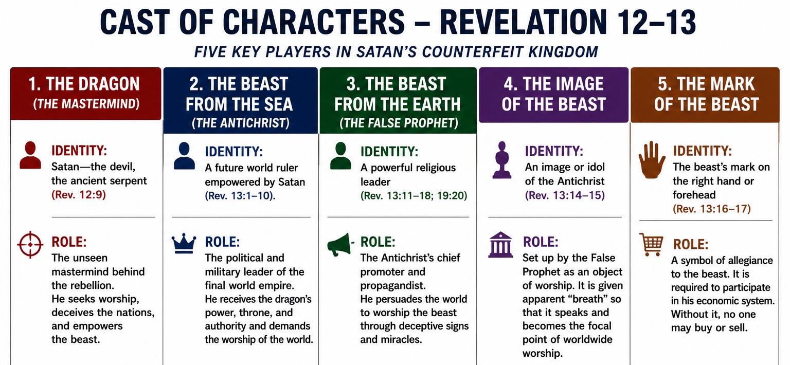

- First is the Dragon, who is Satan.
- Second is the Beast from the Sea, commonly called the Antichrist by futurist interpreters. He is a future world ruler empowered by Satan himself.
- Third is the Beast from the Earth, later identified as the False Prophet. His responsibility is to persuade the world to worship the first beast.
- Then there is the Image of the Beast, which becomes the focal point of worldwide false worship.
- Finally there is the Mark of the Beast, which identifies allegiance to the beast and becomes necessary for participation in the world's economic system.

The Beast from the Sea (The Anti-Christ)
Revelation 13:1 “The dragon stood on the shore of the sea.”
[I spent an evening hosting an event with Peter Yarrow, and Paul Stookey of PPM. I wanted so bad to ask them if this verse was what inspired them to write the classic folk song “Puff the Magic Dragon, who lived by the sea”, but I didn’t. I’m sure the answer was no, because Puff basically just frolicked in the Autumn Mist, and this dragon deceives all nations and unleashes unprecedented suffering upon the earth as he wages war against God and His people."]
Revelation 13:1-2 “The dragon stood on the shore of the sea. And I saw a beast coming out of the sea. It had ten horns and seven heads, with ten crowns on its horns, and on each head a blasphemous name.” ² The beast I saw resembled a leopard, but had feet like those of a bear and a mouth like that of a lion. The dragon gave the beast his power and his throne and great authority.”
So right away, we are given a description of what the beast looked like;
Are you ready to see it…?
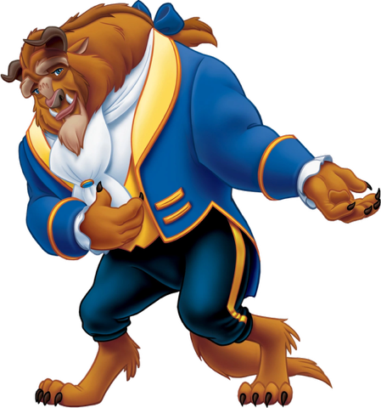
Actually, it’s more like this:
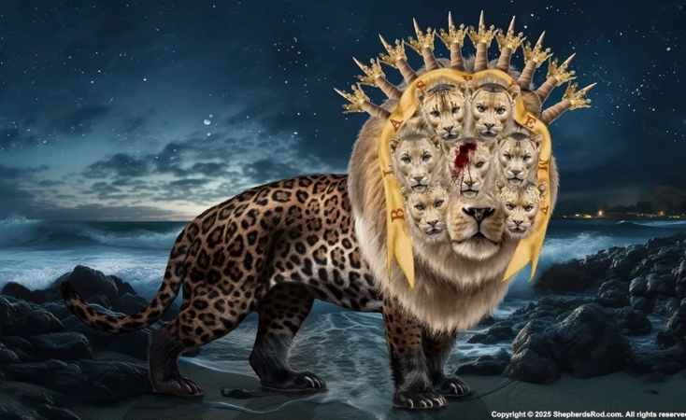

The beast is the Antichrist, and the horns, heads, crowns, and names are symbolic of kings and kingdoms explained later in Revelation. The ten horns represent ten kings who will share authority with the beast (Revelation 17:12). The seven heads represent both kings and kingdoms (Revelation 17:9–10).
The important point is that this beast represents enormous political authority and worldwide influence. The Dragon gives the Beast his power, his throne, and his authority. The Antichrist does not seize power by himself. His authority is satanically empowered.

Daniel Saw This Nearly 650 Years Earlier
Nearly 650 years before John wrote Revelation, Daniel saw a remarkably similar vision. Daniel chapter 7 describes four beasts. The first looked like a lion. The second resembled a bear. The third looked like a leopard. The fourth was unlike anything Daniel had ever seen—a terrifying beast with ten horns.
Revelation 13:3-4 “One of the heads of the beast seemed to have had a fatal wound, but the fatal wound had been healed. The whole world was filled with wonder and followed the beast. ⁴ People worshiped the dragon because he had given authority to the beast, and they also worshiped the beast and asked, “Who is like the beast? Who can wage war against it?”

The Fatal Wound?
There are several interpretations. Some believe this refers to a revived kingdom. Others see an allusion to the ancient Nero legend. But many believe this describes a “counterfeit resurrection”.
Notice the parallel. Jesus died. Jesus rose again. The world marveled.
Now the beast appears to suffer a mortal wound. He appears to recover. Again the world marvels, saying; “Who is like the Beast?”
This is eerily similar to an expression of worship found throughout the Hebrew scriptures; "Who is like You, O LORD?" It is a rhetorical question with the implied answer: "There is no one like God."
Interestingly, the name Michael (Hebrew: Mîkhāʾēl) literally means, "Who is like God?"
Words that belong only to God are now being given to the Beast!
Revelation 13:5–7 “The beast was given a mouth to utter proud words and blasphemies and to exercise its authority for forty-two months. ⁶ It opened its mouth to blaspheme God, and to slander his name and his dwelling place and those who live in heaven. ⁷ It was given power to wage war against God’s holy people and to conquer them. And it was given authority over every tribe, people, language and nation.”

The Authority of the Beast
Beginning in verse 5, John tells us what this world ruler will do during the final forty-two months before the return of Jesus.
Notice something that is repeated throughout this chapter.
- The Beast "was given" authority. (v.5)
- He "was given" a mouth. (v.5)
- He "was given" power. (v.7)
- He "was given" authority over every tribe, people, language and nation. (v.7)
Those words remind us that although Satan is powerful, he is never sovereign.
Just as Satan had to receive permission before testing Job, and just as he could do no more than God allowed, so it will be during the Tribulation. The Antichrist may appear to rule the world, but God still rules the universe.
It then says,
"It opened its mouth to blaspheme God, and to slander His name and His dwelling place and those who live in heaven."
The Antichrist's greatest sin is not merely political oppression. It is blasphemy.
Throughout history many rulers have demanded obedience. The Beast demands worship. He openly mocks God, rejects God's authority, and attempts to replace God with himself. What began in Satan's heart before the creation of mankind now reaches its fullest expression.
Verse 7 tells us something else that should not surprise us.
"It was given power to wage war against God's holy people and to conquer them."
Who are these "holy people"?
If the Church has already been raptured before the Tribulation, these are not the Church in the technical New Testament sense. Rather, they are men and women who come to faith in Jesus during the Tribulation. Through the ministry of the 144,000 (Rev. 7), the Two Witnesses (Rev. 11), the angel proclaiming the eternal gospel (Rev. 14:6–7), and the testimony of other believers, multitudes will trust in Jesus.
Then it says;
"And authority was given it over every tribe, people, language and nation."
This appears to describe a government with unprecedented global influence. How exactly that authority will be exercised, It doesn’t say. Possibly a single worldwide government or a coalition of nations under one dominant ruler.
The important point is that the Beast's influence extends farther than any previous empire in history. For the first time, the entire world is drawn together under one leader who openly opposes God.
Revelation 13:8 “All inhabitants of the earth will worship the beast—all whose names have not been written in the Lamb’s book of life, the Lamb who was slain from the creation of the world.”

This verse emphasizes that God's plan for the sacrifice of Jesus existed before creation. Jesus was not literally crucified at creation, but in God's eternal plan the cross was already determined

Revelation 13:9 “Whoever has ears, let them hear.¹⁰ “If anyone is to go into captivity, into captivity they will go. If anyone is to be killed with the sword, with the sword they will be killed.” “If anyone is to go into captivity, into captivity they will go. If anyone is to be killed with the sword, with the sword they will be killed.” This calls for patient endurance and faithfulness on the part of God’s people.”
Once again, we hear these important words; "Whoever has ears, let them hear."
Jesus often used those same words. Whenever He said them, He was calling people to more than hearing with their ears. He was calling them to respond with obedient hearts.
As if to say; "Pay attention.", "There is more being said in these verses than what you read at face value. Listen with your spirit, what is being said;
Revelation 2:7 “Whoever has ears, let them hear what the Spirit says to the churches”

It’s the Lord’s way of saying, “Open the ears of your heart,” (much like “the eyes of your heart.)” In other words, listen and read spiritually, hearing what is being said beyond the obvious.

Second Beast

Revelation 13:11 “Then I saw a second beast, coming out of the earth. It had two horns like a lamb, but it spoke like a dragon.”


Image of the Second Beast >>>

No, that’s famous YouTuber Jimmy Donaldson, a.k.a.“Mr. Beast”
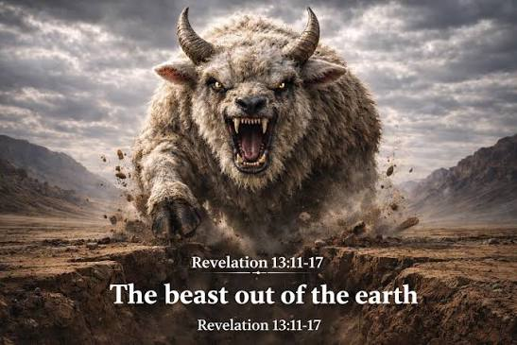
Image of the Beast from the earth…;

Revelation 13:12-15 “It exercised all the authority of the first beast on its behalf, and made the earth and its inhabitants worship the first beast, whose fatal wound had been healed. ¹³ And it performed great signs, even causing fire to come down from heaven to the earth in full view of the people. ¹⁴ Because of the signs it was given power to perform on behalf of the first beast, it deceived the inhabitants of the earth. It ordered them to set up an image in honor of the beast who was wounded by the sword and yet lived. ¹⁵ The second beast was given power to give breath to the image of the first beast, so that the image could speak and cause all who refused to worship the image to be killed.”
The Second Beast, or Beast from the Earth is called "the False Prophet." His primary role is religious deception.
If the Antichrist becomes the political leader of the world, the False Prophet becomes its religious leader. His job is to convince the world that the Beast deserves worship.

False Miracles
"And it performed great signs, even causing fire to come down from heaven to the earth in full view of the people."
Miracles by themselves do not prove that someone represents God.
In fact throughout Scripture, Old and New Testament false prophets are capable of performing counterfeit signs.

The Image of the Beast
"It ordered them to set up an image in honor of the beast..."
Throughout history God has forbidden the worship of idols. Now Satan does exactly the opposite. He commands the world to build one.
John goes on to say that the False Prophet gives apparent "breath" to the image so that it speaks and causes those who refuse to worship it to be killed.
Exactly how this occurs is not explained. Some understand this literally. Others believe advanced technology may somehow be involved.
Mark of the Beast
Revelation 13:16-18 “It also forced all people, great and small, rich and poor, free and slave, to receive a mark on their right hands or on their foreheads, ¹⁷ so that they could not buy or sell unless they had the mark, which is the name of the beast or the number of its name.
¹⁸ This calls for wisdom. Let the person who has insight calculate the number of the beast, for it is the number of a man. That number is 666.”<>
"What is the mark of the Beast?"
Over the years Christians have suggested everything from Social Security numbers to credit cards, barcodes, microchips, vaccines, artificial intelligence, digital currencies, and countless other possibilities.
The truth is this:
The Bible never tells us exactly what the mark looks like.
Instead, Revelation emphasizes that the mark represents allegiance.
Receiving the mark is an act of loyalty to the Beast and his kingdom.

The Number 666
Final verse,
"This calls for wisdom. Let the person who has insight calculate the number of the beast, for it is the number of a man. That number is 666."<>
This verse has generated enormous speculation. Books have been written. Names have been proposed. Predictions have come and gone.
Yet after two thousand years, no interpretation has gained universal acceptance. The Greek word translated "calculate" means to reckon or compute.
In the ancient world letters were often assigned numerical values. Many believe John's original readers may have understood something that is not yet obvious to us.
Some scholars point to Nero. Others believe 666 identifies the future Antichrist through a form of gematria.
Still others see the number symbolically. Throughout Scripture the number seven often represents completeness or perfection.
It’s important not to build our Faith in conjecture, but to distinguish between what Scripture says and what interpreters suggest.
Scripture clearly says 666 is the number of the Beast, and says; "This calls for wisdom."
Wisdom from the Holy Spirit gives us the ability to recognize truth, detect deception, and know how to respond in faithful obedience, regardless of what we are facing.

James 1:5 “If any of you lacks wisdom, you should ask God, who gives generously to all without finding fault, and it will be given to you.”

Close:
The same wisdom that John calls for during the Great Tribulation is the wisdom we need in our lives today. Wisdom to interpret the signs of the times. Wisdom to navigate the deception of this world. Wisdom to make godly choices for our lives, our families, and our future. And wisdom to recognize what God is doing in the world so that we can faithfully join Him in His work as we journey deeper into the last days.

