JESUS REVELATION

Follow The Lamb

Re-Introduction to Revelation:
Our Series: “Jesus Revelation” is based on the first verse in the Book of Revelation which says;
Revelation 1:1 “The revelation from Jesus Christ, which God gave him to show his servants what must soon take place.”
This final book of the Bible is a vivid and compelling study of what was, what is, and what is to come in the last days. The book is filled with symbolism and imagery, alongside literal history and prophecy encouraging us to beware, and be aware of the signs of the times. Not the easiest book to study, but maybe the most exciting!
Revelation is the name of the book (not Revelations), and was written by John, one of Jesus’ closest Apostles (brother of James, son of Zebedee), writing near the end of the first century (around A.D. 90–96) during the height of the Roman Empire.
By this point, all the other apostles had been martyred according to tradition, and the church had spread throughout the Roman Empire. John was the last survivor, exiled to the Island of Patmos where he received this “revelation:” and wrote it.
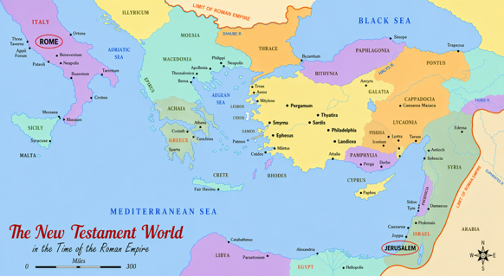
Because it is the “Revelation of Jesus Christ,” we look for Jesus’ message to us in every chapter. Some chapters are filled with heavenly worship and prophecy; others are filled with God’s wrath and apocalyptic judgment. All of it is the Word of God!
Remember it was written to the Seven Churches in Asia Minor during the end of the First Century, but it is also meant for readers through the centuries, and studied today to help us understand what was then, is now, and will be someday soon.

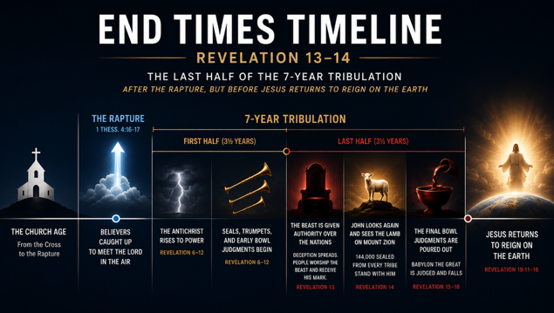
Here in these chapters, John is describing what will happen in the last half of the 7-years of Tribulation, after the Rapture, but before Jesus comes back to reign on the earth.
Last week Revelation 13 introduced us to Satan's counterfeit kingdom—the Dragon (Satan), the Beast from the Sea (The Antichrist – political leader), and the Beast from the Earth (the False Prophet – religious leader).
By the end of chapter 13, it almost seems as though evil has gained the upper hand. The Beast has been given authority over the nations, deception has spread throughout the earth, and nearly everyone on earth is worshipping the Beast and receiving his mark, while the small remnant who remain faithful to Jesus face persecution and even death. It seemed hopeless, as if the world would forever be ruled by Satan, and God’s people are defeated. The people of earth are devoted to Evil, and not to God.
But that is about to change in Chapter 14;
John begins the chapter with, "Then I looked..." (Rev. 14:1), and the scene changes dramatically. Instead of the Beast standing in apparent triumph, John sees the Lamb standing on Mount Zion with the 144,000, who bear the Father's name on their foreheads instead of the Beast's mark.
Revelation 14 is only a glimpse of what will come. There are still four more chapters of wrath and apocalyptic judgment to go, but what it does is it gives a preview or summary of the final victory. It’s like a movie whose director briefly shows scenes from the ending of a great war film before returning to the battle.
Before revealing the details of Jesus’ final victory over the Antichrist, John is given a preview of how it all ends: the Son of Man appears and God's righteous judgment falls. It's God's way of assuring His people that, no matter how dark the conflict becomes, the outcome has already been decided, Jesus wins!!!
When we get to Revelation 19, we will see the victory in full. It will reveal Jesus as the conquering King who defeats every enemy and establishes His everlasting Kingdom.
CHAPTER 14

Revelation 14:1 “Then I looked, and there before me was the Lamb, standing on Mount Zion, and with him 144,000 who had his name and his Father’s name written on their foreheads.”
After all the colossal despair John witnessed in chapter 13, he looks again and sees The Lamb (the same one who looked like He was slain) standing in victory on Mount Zion in Jerusalem, Israel.
John calls Jesus "the Lamb" throughout this book because he never wants us to forget who Jesus is. “The lamb who was slain to take away the sins of the world.”
Standing with Him are the same 144,000 Jewish believers from every tribe of Israel, first introduced in Revelation 7. God sealed them as servants, and now John sees them still standing with Jesus. They have come through the darkest period in human history without abandoning their faith, serving as a powerful testimony to God's protection and faithfulness to those who belong to Him.
This should encourage us, and every believer.

NOTE: Our world seems to change by the day. Governments rise and fall, cultures shift, and society's values continue to drift farther from God's truth. Yet one thing never changes: those who belong to Jesus are forever secure in His hands. As Jesus promised, "My sheep hear My voice...and no one will snatch them out of My hand" (John 10:27–28). No matter how uncertain the world becomes, our Savior remains faithful, and our future is secure in Him.

A Different Mark
Last week we spent a good deal of time discussing the Mark of the Beast (666). Chapter 14 immediately presents us with another mark.
Instead of a mark with the Beast's name, these believers have the “name of the Father” written upon their foreheads.
One group identifies itself with the Beast. The other belongs to the Lamb.
The Beast may claim authority over the world, but he can never claim ownership of God's people.

Revelation 14:2-4 “And I heard a sound from heaven like the roar of rushing waters and like a loud peal of thunder. The sound I heard was like that of harpists playing their harps. ³ And they sang a new song before the throne and before the four living creatures and the elders. No one could learn the song except the 144,000 who had been redeemed from the earth. ⁴ These are those who did not defile themselves with women, for they remained virgins.”
Like so many places in Revelation, John struggles to describe what he hears. It is as though every comparison falls short. Imagine trying to explain a symphony to someone who has never heard music. John reaches for the strongest images he knows—rushing water, thunder, beautiful instruments—but even those are only approximations.
The 144,000 sing a “new song” that no one else can learn?? (Give Dave a try…)
Throughout Scripture God's people often “sang” after experiencing His deliverance. Moses sang after Israel crossed the Red Sea. David frequently wrote about singing a new song unto the Lord. Worship has always been the natural response of hearts that have experienced God's faithfulness.

Following the Lamb

Revelation 14:4b-5 “They follow the Lamb wherever he goes. They were purchased from among mankind and offered as first fruits to God and the Lamb. ⁵ No lie was found in their mouths; they are blameless.”
"They follow the Lamb wherever He goes." That’s so beautiful.
[Very Different than Mary’s little lamb who followed her to school one day…and everywhere that Mary went, the lamb was sure to go (following her)] (That may in the Catholic Bible, JK) ]
"They follow the Lamb wherever He goes."
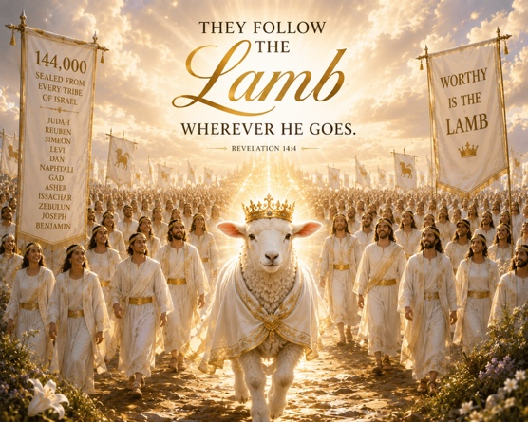
These believers lived during the darkest days the world will ever know. They faced pressure that most of us cannot imagine. Yet John doesn't describe them primarily by what they endured. He describes them by whom they followed.
I think that is a good reminder for us today.
Every generation faces different challenges. Our culture is changing rapidly, and there are days when it seems as though following Jesus becomes more difficult with each passing year. But our calling has never changed.
We are not called to follow the crowd, culture, political leaders, or influencers… We are called to follow the Lamb.

The Three Angels
One of the consistent themes throughout Scripture is that God warns before He judges. Noah preached while the ark was being built. Jonah warned Nineveh before God's judgment came upon that city. The prophets repeatedly called Israel to return to the Lord before the nation was carried into captivity. God is never under obligation to warn anyone, yet He repeatedly does so because He is patient and merciful. We see that happen here as well;
Revelation 14:6-7 “Then I saw another angel flying in midair, and he had the eternal gospel to proclaim to those who live on the earth—to every nation, tribe, language and people. He said in a loud voice, “Fear God and give him glory, because the hour of his judgment has come. Worship him who made the heavens, the earth, the sea and the springs of water.”
Worship the Creator of Heaven and Earth – There’s only One!
Revelation 14:6 is the only place in Scripture where the phrase "the everlasting gospel" appears. That's remarkable because Revelation is full of judgment, yet in the middle of it all, is an angel is proclaiming good news to: every nation, tribe, language, and people.

The Second Angel – Babylon Falls
Revelation 14:8 “A second angel followed and said, “‘Fallen! Fallen is Babylon the Great,’ which made all the nations drink the maddening wine of her adulteries.”
We'll spend much more time talking about what “Babylon” represents in chapters 17 and 18 because John devotes two full chapters to its destruction. For now, simply think of Babylon as mankind's organized rebellion against God. It represents a world system built on pride, materialism, false religion and the belief that humanity can flourish without its Creator.
One detail is easy to miss. The angel announces that Babylon has fallen, even though John hasn't yet described its destruction. Why? Because from God's eternal perspective, its defeat is already certain.

The Third Angel – A Strong Warning
Revelation 14:9 “A third angel followed them and said in a loud voice: “If anyone worships the beast and its image and receives its mark on their forehead or on their hand, ¹⁰ they, too, will drink the wine of God’s fury, which has been poured full strength into the cup of his wrath. They will be tormented with burning sulfur in the presence of the holy angels and of the Lamb. ¹¹ And the smoke of their torment will rise for ever and ever. There will be no rest day or night for those who worship the beast and its image, or for anyone who receives the mark of its name.”
John leaves no doubt about the seriousness of the decision facing those living during the Tribulation who took the “mark of the beast”. They receive “The wine of God’s fury!”
Throughout chapter 13 we saw people choosing the Beast because it seemed to offer security. They could buy and sell. They could participate in society. They could avoid persecution. But every decision has consequences.
The third angel reminds the world that rejecting Jesus has eternal consequences.
These verses are difficult to read because they speak about God's wrath. We don't enjoy talking about judgment, but neither should we ignore it. The same Bible that tells us that God is love also tells us what God demands. Those truths are not in competition with one another. In fact, they meet beautifully at the cross by Jesus’ blood.
Romans 5:9 “Since we have now been justified by his blood, how much more shall we be saved from God's wrath through him!”

Now A Word for Believers
After those sobering verses, John suddenly turns his attention back to believers.
Revelation 14:12 “This calls for patient endurance on the part of the people of God who keep his commands and remain faithful to Jesus.”
This is the same phrase used at end of chapter 13. “Patient Endurance”, (this is the secret to persevering through difficult moments.)
John then hears one final voice from heaven…
Revelation 14:13 “Then I heard a voice from heaven say, “Write this: Blessed are the dead who die in the Lord from now on.” “Yes,” says the Spirit, “they will rest from their labor, for their deeds will follow them.”
This is one of the most comforting promises in Revelation. Those who belong to Jesus and remain faithful to Him, even if they die for their faith, are blessed. Their suffering is over, they enter God's eternal rest, and the faithful lives they lived for Jesus will be remembered and rewarded by Him.
It is also the second of the “seven beatitudes” (“Blessed Are”), in Revelation and has been read at Christian funerals for centuries. It reminds believers that faithfulness, even unto death is rewarded with rest and eternal life.
WAR!
Did you ever notice how popular war movies are?
Some of the biggest blockbusters of all time are war movies: Saving Private Ryan, 'All Quiet on the Western Front', Dunkirk, Apocalypse Now, Lord of the Rings, ALL the Star Wars movies, the Marvel Avengers films, and countless others.
Despite their different settings—whether World War II, a galaxy far, far away, Middle-earth, or the Marvel Universe—they almost always follow the same basic storyline.
There are good guys and bad guys. At first, the bad guys seem to have the upper hand. The heroes are outnumbered, overwhelmed, and facing what appears to be certain defeat. Just when all hope seems lost, the good guys rally together, find unexpected courage, overcome impossible odds, and ultimately claim a hard-fought, often solemn, victory.
"The harvest of the earth" here in Revelation 14 is the victory scene that follows the war that has been raging throughout the previous three chapters.
The conflict in Revelation has already been going on. Evil has seemed to prevail, and God's people have endured tremendous opposition. Then, at the decisive moment, Jesus appears with His sickle in hand. Evil is brought to judgment, and the outcome is no longer in doubt. It is the triumphant conclusion of the great conflict between good and evil! It’s called;
“The Harvest of the Earth” (Warning: The victory bloodbath is about to begin.)
Revelation 14:14 “I looked, and there before me was a white cloud, and seated on the cloud was one like a son of man with a crown of gold on his head and a sharp sickle in his hand.” ¹⁵ Then another angel came out of the temple and called in a loud voice to him who was sitting on the cloud, “Take your sickle and reap, because the time to reap has come, for the harvest of the earth is ripe.” ¹⁶ So he who was seated on the cloud swung his sickle over the earth, and the earth was harvested.
¹⁷ Another angel came out of the temple in heaven, and he too had a sharp sickle. ¹⁸ Still another angel, who had charge of the fire, came from the altar and called in a loud voice to him who had the sharp sickle, “Take your sharp sickle and gather the clusters of grapes from the earth’s vine, because its grapes are ripe.” ¹⁹ The angel swung his sickle on the earth, gathered its grapes and threw them into the great winepress of God’s wrath. ²⁰ They were trampled in the winepress outside the city, and blood flowed out of the press, rising as high as the horses’ bridles for a distance of 1,600 stadia.<>
(Note: A horse's bridle is approximately 4 to 5 feet above the ground, 1,600 stadia is approximately 184 miles. So in modern terms, John describes blood flowing: About 4–5 feet deep for approximately 184 miles, not sure how wide, but, IMHO, that’s a lot of blood🩸.)
These final words give imagery of God’s wrath upon a world who is rejecting Him, worshipping the Antichrist, and killing believers is being symbolized by “trampling the grapes of wrath in a winepress”;
V.19 “[He] gathered its grapes and threw them into the great winepress of God’s wrath. ²⁰ They were trampled in the winepress outside the city,”
This winepress imagery appears in both Isaiah and Joel;
Isa. 63:3 "I have trodden the winepress alone... I trampled them in my anger and trod them down in my wrath."
Joel 3:12–13 "Put in the sickle, for the harvest is ripe. Come, tread, for the winepress is full; the vats overflow, for their wickedness is great."

It’s also the lyrics of the first verse of the “Battle Hymn of the Republic” written during the Civil War In 1861, by Julia Ward Howe;

Mine eyes have seen the glory of the coming of the Lord:

He is trampling out the vintage where the grapes of wrath are stored;

He hath loosed the fateful lightning of His terrible swift sword:

His truth is marching on! (Glory Hallelujah!)
Sometimes it may appear that evil is winning. The powers of the world seems unstoppable. Secular Culture looks overwhelming, pervasive and invincible. God’s people suffer. But don’t be deceived, appearances are not reality.
That is the great message of Revelation 14. We do not fight for the victory; we live in the certainty of Jesus' victory. The outcome has already been determined. Jesus Wins!
Ephesians 6:12 “ For our struggle is not against flesh and blood, but against the rulers, against the authorities, against the powers of this dark world and against the spiritual forces of evil in the heavenly realms.”
So when the battles of life seem overwhelming, remember that the final chapter has already been written.
“The Lamb who was slain, is the King who will reign!”
He will gather His people. He will judge evil. He will make all things right. The battle belongs to the Lord. Our calling is not to predict the day of His victory, or try to fight the battle without Him, but to remain faithful until it comes, following the Lamb wherever He goes.
Jesus spoke these words on the night before His crucifixion, just three days before He would rise from the dead, conquering sin and death and securing the greatest victory in history—the victory of eternal life. Knowing the suffering that lay ahead for both Himself and His followers, He left His disciples with this promise:
John 16:33 "These things I have spoken to you, that in Me you may have peace. In the world you will have tribulation; but be of good cheer, I have overcome the world."

