JESUS REVELATION - REVELATION 11

"Two Witnesses, The Kingdom, and the Temple"

In Chapter 10 John’s experience became “interactive”. He was no longer just reporting what he saw, he became a participant.

Rev. 10:10-11 “I took the little scroll from the angel’s hand and ate it. It tasted as sweet as honey in my mouth, but when I had eaten it, my stomach turned sour. ¹¹ Then I was told, “You must prophesy again about many peoples, nations, languages and kings.”
The prophet Ezekiel experienced a remarkably similar commission when God told him to eat a scroll containing His message before sending him to speak to Israel (Ezekiel 2:8–3:3). In both cases, eating the scroll symbolized receiving and internalizing God's Word before proclaiming it to others.
Chapter 10 also introduced the Seventh Angel with the Seventh Trumpet. He is about to blow it, but gives John the scroll instead. The seven Seals are complete, 6 of the 7 Trumpets have now been sounded, but the final trumpet will not sound until chapter 16. They reveal the seven bowls of wrath and God’s judgment. The next five chapters are a pause before that time.
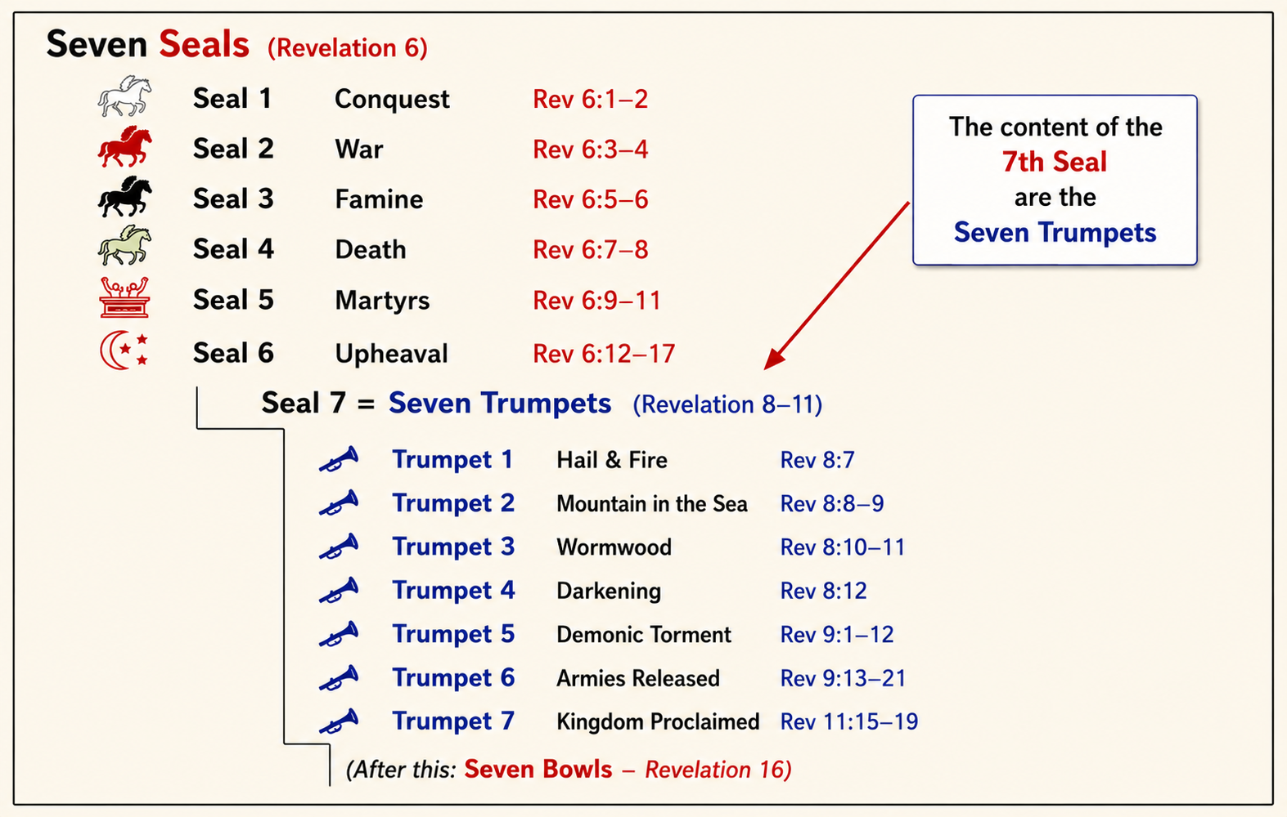
In Revelation 11 John is still involved in the vision, and is following the instructions of the voice from Heaven.
Revelation 11:1-2 “I was given a reed like a measuring rod and was told, “Go and measure the temple of God and the altar, with its worshipers. ² But exclude the outer court; do not measure it, because it has been given to the Gentiles. They will trample on the holy city for 42 months.”
Luke 21:24 “Jerusalem will be trampled on by the Gentiles until the times of the Gentiles are fulfilled.”
At first glance, this sounds like God is measuring a building. But throughout the Bible, measuring is never about figuring out dimensions—it's about ownership. In Ezekiel, God measures the Temple because it is holy and belongs to Him. In Zechariah, Jerusalem is measured as a sign of God's protection and presence. The same is true here. Notice John is told to measure not only the Temple and the altar, but also the worshipers. God is identifying those who belong to Him.
Then John is told to leave the outer court unmeasured because it will be trampled by the nations for forty-two months—the final three and a half years of the Tribulation. Even in this darkest period, God remains completely in control. Evil is allowed to go only as far as God permits. Before God pours out His judgments, He first marks out His own. He knows exactly who belongs to Him.
• First 3½ years -Ministry of the Two Witnesses (1,260 days)
• Second 3½ years (Great Tribulation) Gentiles trample the holy city (42 months)
NOTE: Revelation 11 is one of the strongest passages supporting both a future Israel and a future Temple. Here are the reasons:
- A Temple exists on earth. John is told to measure "the temple of God and the altar" (11:1). The context is earthly because the outer court is trampled by the Gentiles and the holy city (Jerusalem) is mentioned (11:2). This is not the heavenly temple of verse 19. It is an earthly temple in Jerusalem.
- Jerusalem still exists. The city is called "the holy city" (11:2), and later it is identified as the place "where also their Lord was crucified" (11:8). There is no doubt John is speaking about Jerusalem.
- Israel is still central to God's prophetic plan. The Temple, the holy city, and later the twelve tribes and the gathering at Armageddon all point to God's continuing dealings with Israel. Paul also teaches in Romans 11 that Israel's hardening is temporary and that God has not rejected His people.
- The Temple appears to be functioning. There is an altar and worshipers, implying an active place of worship.
Two Witnesses:
Revelation 11:3-6 “And I will appoint my two witnesses, and they will prophesy for 1,260 days, clothed in sackcloth.”
[“Can I get a witness? Or two? : ) ]
Revelation 11:4-6 “They are “the two olive trees” and the two lampstands, and “they stand before the Lord of the earth.” ⁵ If anyone tries to harm them, fire comes from their mouths and devours their enemies. This is how anyone who wants to harm them must die. ⁶ They have power to shut up the heavens so that it will not rain during the time they are prophesying; and they have power to turn the waters into blood and to strike the earth with every kind of plague as often as they want.”
God immediately follows the measuring of His people by raising up two extraordinary witnesses. For 1,260 days—the same three-and-a-half-year period—they boldly proclaim God's truth. They are clothed in sackcloth, the rough garment worn throughout the Old Testament as a symbol of mourning, humility, and repentance. Their message isn't one of comfort, but of conviction.
Like Noah before the flood, Jonah in Nineveh, John the Baptist, and Jesus Himself, they call people to repent before judgment falls. God also gives them supernatural protection. Fire proceeds from their mouths against those who seek to harm them, they shut up the sky so that no rain falls, turn water into blood, and strike the earth with plagues whenever they choose. Until God says their ministry is finished, no one can touch them. They are invincible until their assignment is complete.
Who are these two witnesses? Bible students have debated that question for centuries. Some point to Joshua and Zerubbabel because they are called the two olive trees in Zechariah 4. Others suggest Enoch and Elijah, since neither experienced death. But the strongest case seems to be Moses and Elijah. Malachi 4 mentions both Moses and Elijah together before the coming Day of the Lord.
They also appeared with Jesus at the Transfiguration, representing the Law and the Prophets. And the miracles performed by the two witnesses closely resemble those of Moses—turning water to blood and sending plagues—and Elijah—shutting the heavens so it would not rain. Scripture never identifies them by name, so we shouldn't be dogmatic. What is clear is this: God has never left the world without a witness. Before judgment comes, He always sends someone to proclaim His truth and call people to repentance.
Revelation 11:7-12 “Now when they have finished their testimony, the beast that comes up from the Abyss will attack them, and overpower and kill them. ⁸ Their bodies will lie in the public square of the great city—which is figuratively called Sodom and Egypt—where also their Lord was crucified. ⁹ For three and a half days some from every people, tribe, language and nation will gaze on their bodies and refuse them burial. ¹⁰ The inhabitants of the earth will gloat over them and will celebrate by sending each other gifts, because these two prophets had tormented those who live on the earth.¹¹ But after the three and a half days the breath of life from God entered them, and they stood on their feet, and terror struck those who saw them. ¹² Then they heard a loud voice from heaven saying to them, “Come up here.” And they went up to heaven in a cloud, while their enemies looked on.”
When their testimony is complete, the scene changes dramatically. For the first time in Revelation, the Beast steps onto the stage. We will learn much more about him in chapters 13 and 17, but here he makes his first appearance as the one empowered by Satan to wage war against God's people. Notice the timing: "When they have finished their testimony..." God doesn't allow the Beast to touch them until their assignment is complete. Not one day early. Not one day late. They were untouchable until God said, "Your work is finished." The same God who determined the length of their ministry also determined the day they would come home.
Why does the world hate these two men so intensely? Because they continually confront sin and call people to repentance. Their message exposes darkness, and people love darkness rather than light. When the witnesses are finally killed, the whole world erupts in celebration.
Note: Today, for the first time in history, with world-wide live video feeds, it is easy to understand how the whole world could watch this type of event in real time!
Interesting that their bodies are left in the street, people rejoice, exchange gifts, and celebrate what amounts to "Dead Prophet Day." Imagine Christmas—but celebrating the death of God's messengers instead of the birth of God's Son. But the world's hatred isn't ultimately directed at these two men. They are simply the messengers. The real hatred is toward the God they represent. Rejecting God's witnesses is another way of rejecting God Himself.
Note: When people direct hatred toward us for telling them God’s truth, Jesus told us, remember that their hatred is ultimately directed toward God.

Matthew 24:9 "Then you will be handed over to be persecuted and put to death, and you will be hated by all nations because of me."
Matthew 10:22 “And you will be hated by all for My name’s sake. But he who endures to the end will be saved.”
The Third “Woe”
Remember back in Chapter 8, the eagle flying around saying “Woe, Woe, Woe”. The woes were the judgment poured out by the 5th, 6th, and 7th trumpets. We’ve seen the 5th and 6th, we will soon see the seventh.
Revelation 11:13-14 “At that very hour there was a severe earthquake and a tenth of the city collapsed. Seven thousand people were killed in the earthquake, and the survivors were terrified and gave glory to the God of heaven. ¹⁴ The second woe has passed; the third woe is coming soon.”

When the two Witnesses ascend into heaven, a great earthquake strikes Jerusalem, destroying a tenth of the city and killing seven thousand people. Yet something remarkable happens: the survivors are filled with fear and give glory to the God of heaven.

The Seventh Trumpet (finally)

Revelation 11:15 “The seventh angel sounded his trumpet, and there were loud voices in heaven, which said: “The kingdom of the world has become the kingdom of our Lord and of his Messiah (Christ), and he will reign for ever and ever.”
When the seventh trumpet sounds, it does not immediately pour out judgment; it announces what is now certain: “The kingdom of the world has become the kingdom of our Lord and of his Messiah, and he will reign for ever and ever.”
This is one of those verses we need to slow down and hear. The world still looks rebellious. Evil still appears active. The Beast is still coming. The bowls are still ahead. But heaven speaks as though the victory has already happened.
Handel's famous Hallelujah Chorus begins with the announcement of the Seventh Trumpet in Revelation 11 and ends with the fulfillment of Christ's reign in Revelation 19. It opens with the words, "The kingdom of this world has become the kingdom of our Lord and of His Christ, and He shall reign for ever and ever"—taken directly from Revelation 11:15. Yet Jesus has not returned to earth. Heaven announces the coming kingdom before it is visibly established. Then, in Revelation 19, that announcement becomes reality as heaven bursts into four triumphant cries of "Hallelujah!"—a word found only chapter 19 of Revelation.
*PLAY: [Hallelujah Chorus verse – “Hallelujah!” - “The Kingdom of this world”…]
Revelation 19:6 “…Hallelujah! for the Lord God omnipotent reigneth."
Revelation 11:15b “…The kingdom of the world has become the kingdom of our Lord and of his Messiah (Christ), and he shall reign for ever and ever.”

The 24 Elders Worship Again:
Revelation 11:16-18 “And the twenty-four elders, who were seated on their thrones before God, fell on their faces and worshiped God, ¹⁷ saying: “We give thanks to you, Lord God Almighty, the One who is and who was, because you have taken your great power and have begun to reign. ¹⁸ The nations were angry, and your wrath has come. The time has come for judging the dead, and for rewarding your servants the prophets and your people who revere your name, both great and small, and for destroying those who destroy the earth.”
Once again just like in Chapters 4 and 5, the twenty-four elders fall on their faces before God because the King is about to take His rightful throne. Heaven rejoices because what the world has long resisted has finally become reality: the King has come, and His reign will never end.
Revelation 11:19 “Then God’s temple in heaven was opened, and within his temple was seen the ark of his covenant. And there came flashes of lightning, rumblings, peals of thunder, an earthquake and a severe hailstorm.” <>
The chapter closes with a breathtaking scene. The Temple in heaven is opened, and the Ark of the Covenant is seen inside. This is much more than heavenly scenery. The earthly Ark disappeared centuries before, and no one knows what became of it. But the real Ark, the heavenly reality that the earthly one pointed to, has always been safely in God's presence. The covenant was never lost because God has never forgotten His promises. Every promise He made to Israel, every promise He has made to His Church, remains secure. Then come the flashes of lightning, the rumblings, the thunder, the earthquake, and the great hailstorm—Revelation's way of announcing that history has reached another decisive turning point. The King is coming, His promises are certain, and His kingdom is near.
The day is coming when every other kingdom will disappear, every false ruler will be removed, every enemy will bow before the throne, and every believer will rejoice in the fulfillment of the great proclamation of Revelation 11:15: "The kingdom of the world has become the kingdom of our Lord and of His Messiah, and He shall reign for ever and ever."
That is where history is headed. More importantly, that is where your hope must rest. Not in the kingdoms of this world, but in the everlasting Kingdom of Jesus.
John 16:33 “These things I have spoken to you, that in Me you may have peace. In the world you will have tribulation; but be of good cheer, I have overcome the world.”
The book of Revelation is mostly about the days to come? What about now? How do we apply this to our lives this week, tomorrow?, today?? We need to remind ourselves of this, when the world seems overwhelming, and evil seems to have the upper hand. Don’t give up, don’t give in. You are part of the Kingdom of God, and of His Christ, and He Shall Reign Forever and ever!

