JESUS REVELATION

REVELATION 10

"Eat the Scroll"
The Revelation of Jesus Christ is final book of the Bible is a vivid and compelling study of what was, what is, and what is to come in the last days. The book is filled with symbolism and imagery, alongside literal history and prophecy, encouraging us to beware, and be aware of the signs of the times.
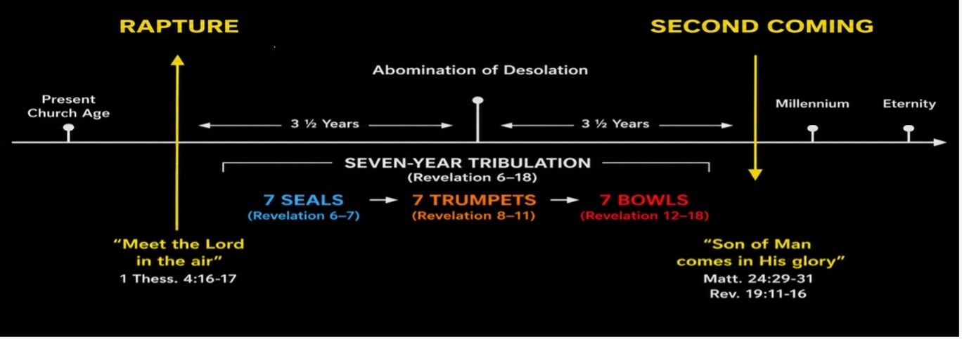
Revelation 10 comes during a pause between the 6th and 7th trumpet. It also marks the first time that John himself has gone from being an observer of the Revelation of Jesus Christ, to being given the task of “prophet”, given a word from the Lord, then told to speak it.
In other words, the experience became interactive, no longer is he seeing the vision like watching a movie, now he is part of the plot. Sort of like the movie Pleasantville, or Jumanji, where the characters were no longer playing a game or watching a movie, they became part of it.
There are only eleven verses in Revelation 10, but we’ll take them in three sections.
Revelation 10:1-11 “Then I saw another mighty angel coming down from heaven. He was robed in a cloud, with a rainbow above his head; his face was like the sun, and his legs were like fiery pillars. ² He was holding a little scroll, which lay open in his hand. He planted his right foot on the sea and his left foot on the land, ³ and he gave a loud shout like the roar of a lion. When he shouted, the voices of the seven thunders spoke. ⁴ And when the seven thunders spoke, I was about to write; but I heard a voice from heaven say, “Seal up what the seven thunders have said and do not write it down.”
So this mighty angel was holding a little scroll that obviously contained important information, and it’s possible that the “Seven Thunders” spoke that message out. John was about to do what he’d been doing all along “see, hear, and then write”. But this time a voice from heaven stopped him and said; “Seal up what the seven thunders have said and do not write it down.”
For the first time John is NOT writing down what he is witnessing, and is about to be invited into the apocalyptic adventure he is witnessing and recording. At this point the angel himself gave the play-by-play of what is happening, and about to take place.
Revelation 10:5-7 “Then the angel I had seen standing on the sea and on the land raised his right hand to heaven. ⁶ And he swore by him who lives for ever and ever, who created the heavens and all that is in them, the earth and all that is in it, and the sea and all that is in it, and said, “There will be no more delay! ⁷ But in the days when the seventh angel is about to sound his trumpet, the mystery of God will be accomplished, just as he announced to his servants the prophets.”
So when the seventh angel sounds his trumpet, the mystery plan of God given to his prophets will begin to be accomplished.
What Trumpet?, What prophets?
The "seventh angel" refers to the seventh trumpet angel, whose trumpet is finally sounded in Revelation 11:15, announcing that "the kingdom of the world has become the kingdom of our Lord and of His Messiah."
The "prophets" are the Old Testament prophets collectively, especially men like Daniel, Isaiah, Ezekiel, Joel, Zechariah, and Micah, who foretold God's ultimate victory over evil, the establishment of His everlasting kingdom, the reign of the Messiah, the restoration of His people, and His dwelling with them forever.
This amazing message may have been what was written in the little scroll and spoken by the seven thunders, but John will soon find out it is soon to be given to him to speak, write, and prophecy.
Revelation 10:8-11 “Then the voice that I had heard from heaven spoke to me once more: “Go, take the scroll that lies open in the hand of the angel who is standing on the sea and on the land.” ⁹ So I went to the angel and asked him to give me the little scroll. He said to me, “Take it and eat it. It will turn your stomach sour, but ‘in your mouth it will be as sweet as honey.’” ¹⁰ I took the little scroll from the angel’s hand and ate it. It tasted as sweet as honey in my mouth, but when I had eaten it, my stomach turned sour. ¹¹ Then I was told, “You must prophesy again about many peoples, nations, languages and kings.” <>
John took the open scroll from the hand of the angel, and likely was about to read it. The angel instructed him however, to eat it, actually EAT the scroll! So, he says; “I took the little scroll from the angel’s hand and ate it. It tasted as sweet as honey in my mouth, but when I had eaten it, my stomach turned sour.”
The scroll contained a message from God, and John was commanded to proclaim it. After eating the scroll, he was told, "You must prophesy again concerning many peoples, nations, languages and kings" (Revelation 10:11). The primary role of a prophet is not simply to predict the future, but to faithfully speak forth the Word of God. While prophecy often includes foretelling future events, it also involves declaring God's truth, calling people to repentance, offering encouragement, warning of judgment, and revealing His purposes. John had been observing God's visions, but now he was commissioned to proclaim God's message to the world.
Beginning in chapter 11 John begins to be part of the story, and reveals mysteries about the heavenly, the Two witnesses, and the Seventh Trumpet. He is given a word, a revelation, and a message and is faithful to deliver it.
Why was he told to eat the scroll, and why was it sweet to the taste and sour to the stomach?
This is not the first time a prophet was told to eat a scroll. The prophet Ezekiel experienced a remarkably similar commission when God told him to eat a scroll containing His message before sending him to speak to Israel (Ezekiel 2:8–3:3). In both cases, eating the scroll symbolized receiving and internalizing God's Word before proclaiming it to others. God's message had to become part of the prophet before it could be faithfully delivered. Just as Ezekiel was commissioned to declare God's Word to a rebellious nation, John was commissioned to "prophesy again concerning many peoples, nations, languages and kings" (Revelation 10:11), announcing God's message of both judgment and hope.
In both cases, they were given a message from God, and were told not only to hear or read the message, but to Eat the message!
Ezekiel 3:3 “Then [God] said to me, “Son of man, eat this scroll I am giving you and fill your stomach with it.” So I ate it, and it tasted as sweet as honey in my mouth.”
Rev 10:9 “So I went to the angel and asked him to give me the little scroll. He said to me, “Take it and eat it. It will turn your stomach sour, but ‘in your mouth it will be as sweet as honey.
[When you really feel that God gave you a message, you need to completely accept it, live it, internalize it, and make it part of you. Just like when I feel that God gave me a word to preach, I need to own it, exemplify it, and EAT IT : ) ]
The symbolism is not difficult to understand. God's Word is never intended merely to pass through Jour hands. It is to become part of our lives. Before we can faithfully proclaim God's message to the nations, we first have to fully believe it ourselves.
We are not called simply to read God's Word or to study it academically. We are called to internalize it, allowing it to shape our thoughts, our attitudes, our convictions, and our lives. The message we proclaim should first have transformed us.
(we don’t have the option to act as a postal carrier or simply a messenger service when we preach the gospel. We need to believe it, and live it ourselves or we are not fully conveying the spiritual power that we are meant to carry and transfer.
John discovers that the angel's words are exactly true. The scroll is wonderfully sweet in his mouth, but after he swallows it, it becomes bitter in his stomach.
What do you think this meant?
I know for me, that when I get a message from God to give to others, via either a sermon, a song, an article, a book, a post, or a conversation, it “tastes sweet”, it almost feels like when you eat too much buttercream icing and get that “Cloying” sensation. (Cloying is an adjective that means Excessively sweet, rich, or sentimental). But if the word I am given is weighty, controversial, or perhaps not pleasant, then the feeling I get is sort of like “butterflies in my stomach” and is unpleasant until I speak it out.
It’s worse if you try to contain it.
For Jeremiah, it was even more severe “Fire in His bones”, He was given a message by God for the king and the people (which was not pleasant). They would beat him up, put him in chains, or throw him into a well so he tried to contain it, keep it to himself, and stay silent, but that wouldn’t do…
Jeremiah 20:9 “Then I said, “I will not make mention of Him, Nor speak anymore in His name.” But His word was in my heart like a burning fire Shut up in my bones; I was weary of holding it back, And I could not.”
The word of God must be PREACHED, sometimes it feels sweet, sometimes it feels bitter. But once we are given the message, we must live it, internalize it, and speak it out.

Friday night on the boardwalk:

How about us? What has Jesus asked us to do?

Preach the Gospel
Mark 16:15 "Go into all the world and preach the gospel to all creation."

Be My Witnesses
Acts 1:8 "But you will receive power when the Holy Spirit comes on you; and you will be my witnesses in Jerusalem, and in all Judea and Samaria, and to the ends of the earth."

Make Disciples
Matthew 28:19–20 "Therefore go and make disciples of all nations, baptizing them in the name of the Father and of the Son and of the Holy Spirit, and teaching them to obey everything I have commanded you."
(…whether they agree with it or not )

