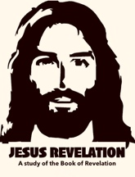
JESUS REVELATION - REVELATION 7 “Salvation belongs to our God”
This final book of the Bible is a vivid and compelling study of what was, what is, and what is to come in the last days. The book is filled with symbolism and imagery, alongside literal history and prophecy encouraging us to beware, and be aware of the signs of the times.
In previous chapters John was given access to the “Throne room of Heaven” and witnessed the great worship around the throne. God was on the throne, holding a scroll with 7 seals, which the Lamb opened and revealed God’s judgement.

In the final verses of chapter 6, all the Kings of the earth, and everyone in their kingdoms try to run and hide from the wrath of God;
Revelation 6:17 “For the great day of their wrath has come, and who can withstand it?”<> ???
Answer: Those who are covered by the blood of the Lamb and sealed by God can withstand that day.
1.Ready Yourselves, 2. Tell the World about Him, and 3. Be Faithful. Jesus is coming!
Rev. 22:12 “Look, I am coming soon! My reward is with me,”
Now we come to Revelation 7, which occurs between the opening of the sixth and seventh seals. Before the seventh seal introduces the trumpet judgments, God pauses the action to reveal the sealing of the 144,000 and a great multitude standing before His throne. But first let’s take a look at the eschatological timeline so we know where we are at in terms of the succession of events.
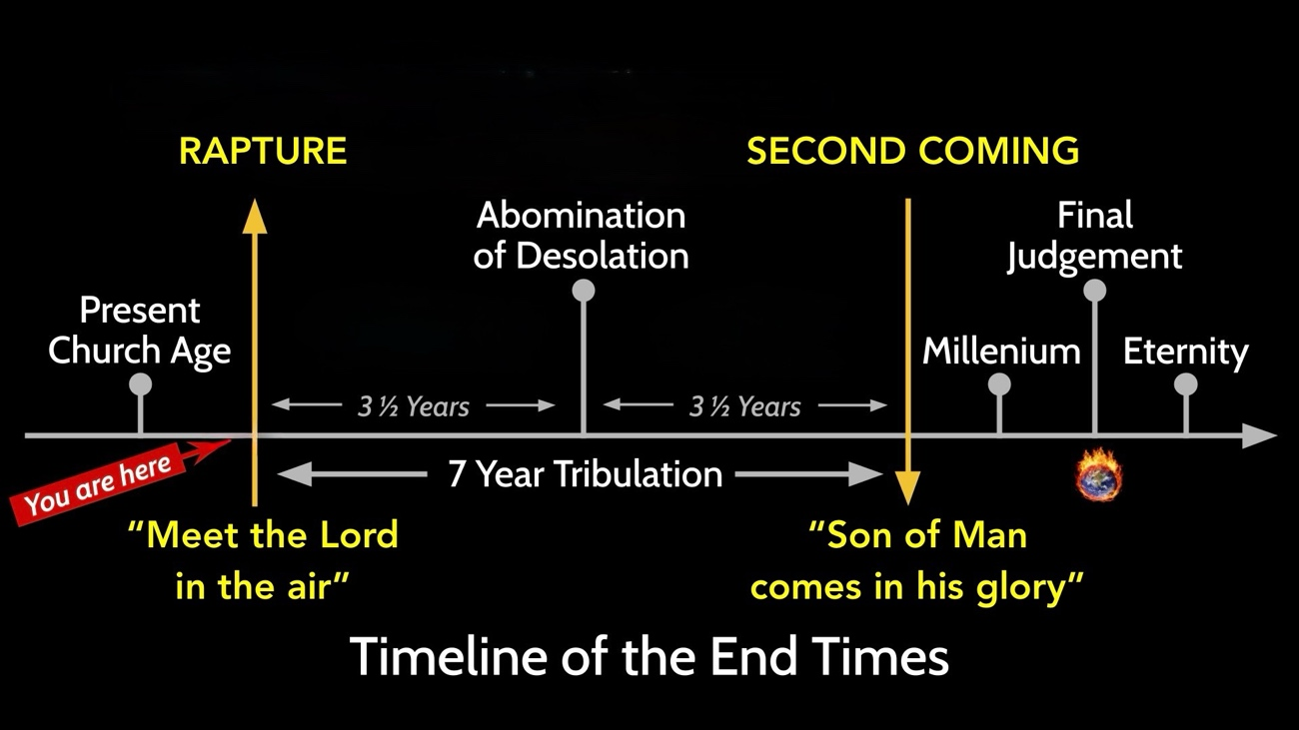
- Present Church Age – The current era between Jesus’ first coming and His return, when the gospel is preached to all nations.
- Rapture – The catching up of believers to meet the Lord in the air (1 Thessalonians 4:16–17).
  - “Meet the Lord in the Air” – A phrase in 1st Thess. describing believers being gathered to Jesus at His coming. (Harpazo)
- 7-Year Tribulation – A future period of unprecedented judgment, deception, and suffering on the earth, often associated with Daniel’s 70th week (Daniel 9:27).
- First 3½ Years – The opening half of the Tribulation, characterized by increasing turmoil and the rise of the Antichrist.
- Abomination of Desolation – A sacrilegious act in a rebuilt temple that marks a major turning point in the Tribulation, Antichrist desecrates the temple and demands to be worshiped. (Matthew 24:15; Daniel 9:27).
- Last 3½ Years – Often called the “Great Tribulation,” a period of intense persecution and divine judgment (Matthew 24:21).
- Second Coming – Jesus’ visible return to earth in power and glory to defeat evil and establish His kingdom (Revelation 19).
  - “Son of Man Comes in His Glory” – Jesus’ own description of His triumphant return as King and Judge (Matthew 24:30).
- Millennium – The 1000-year reign of Jesus on earth described in Rev. 20:1–6.
- Final Judgment – The judgment of all unbelievers before the Great White Throne (Revelation 20:11–15).
(Note: This timeline reflects the classic premillennial, pre-tribulation interpretation of end-times prophecy. Other Christians place the rapture at different points in the Tribulation or understand some of these events differently.)
So hypothetically, IF JESUS COMES BACK TODAY, June 14th 2026…
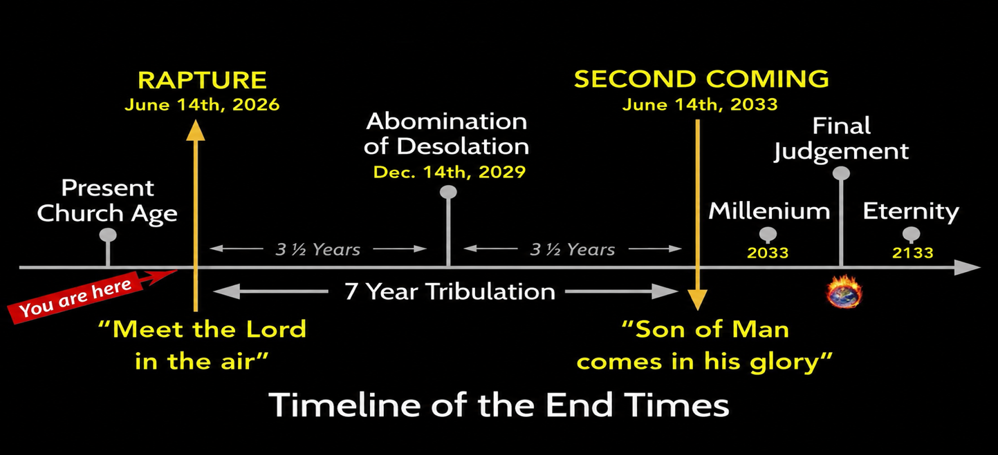
NOTE: 2033 is exactly 2000 years from when Jesus said He would return in glory! (just saying…)
REVELATION 7
Revelation 7:1-3 “After this I saw four angels standing at the four corners of the earth, holding back the four winds of the earth to prevent any wind from blowing on the land or on the sea or on any tree. 2 Then I saw another angel coming up from the east, having the seal of the living God. He called out in a loud voice to the four angels who had been given power to harm the land and the sea: 3 “Do not harm the land or the sea or the trees until we put a seal on the foreheads of the servants of our God.”
After the first six seals (the Four Horsemen, The martyrs, and the Signs in the earth and skies, Four angels held back the elements and a fifth angel put a seal on those who are called “servants of our God”.
Revelation 7:4-8 “Then I heard the number of those who were sealed: 144,000 from all the tribes of Israel.
- From the tribe of Judah 12,000 were sealed,
- from the tribe of Reuben 12,000,
- from the tribe of Gad 12,000,
- from the tribe of Asher 12,000,
- from the tribe of Naphtali 12,000,
- from the tribe of Manasseh 12,000,
- from the tribe of Simeon 12,000,
- from the tribe of Levi 12,000,
- from the tribe of Issachar 12,000,
- from the tribe of Zebulun 12,000,
- from the tribe of Joseph 12,000,
- from the tribe of Benjamin 12,000.”
The 144,000 of Revelation 7 are a mysterious select group of Israelite servants of God, sealed for a special end-times mission. They are separated into the 12 ancestral tribes of Israel (named for the sons of Jacob/Israel).
Many believe they serve as Jewish evangelists during the Tribulation. In Revelation 14, they are seen later as faithful, preserved, and victorious, standing with the Lamb.
NOTE: Jehovah's Witnesses believe the 144,000 are a literal group of anointed Christians who go to heaven to rule with Christ, while the "great crowd" of believers will live forever on a paradise earth.
Revelation 7:9-10 “After this I looked, and there before me was a great multitude that no one could count, from every nation, tribe, people and language, standing before the throne and before the Lamb. They were wearing white robes and were holding palm branches in their hands. 10 And they cried out in a loud voice: “Salvation belongs to our God, who sits on the throne, and to the Lamb.”
Who are these? We will find out later in this chapter that these are believers who came out of the Great Tribulation. In a pre-tribulation framework, these are those who were not believers when the rapture took place, but came to faith during the seven years and were likely persecuted, imprisoned, or even martyred for their faith.
This is also a beautiful picture of the unity that is experienced when we leave “the physical” and enter into “the spiritual”. They come from a variety of nations, tribes, peoples, and languages, yet they do not wave national flags or wear distinctive cultural garments. They are all clothed alike in white robes and carry palm branches, much like those who shouted, “Hosanna!” when Jesus entered Jerusalem.
As they enter heaven, they leave behind the distinctions and divisions that once characterized life on earth and are welcomed into the throne room in the unity of the Spirit and with one voice. As Paul describes it;
1st Corinthians 12:13 “For we were all baptized by one Spirit so as to form one body, whether Jews or Gentiles, slave or free, and we were all given the one Spirit.”
This multitude may look a lot like those whom we will one day see in heaven. They come from every nation, tribe, people, and language, but they do not stand before the throne as nations, races, cultures, or social classes. They stand as one redeemed people.
Their physical bodies have been left behind, and what stands before the throne is the redeemed spirit and soul, united in worship before God.
Their earthly origins are remembered as past, but their current identity is found in the unity of the Spirit.
Revelation 7:11-12 “All the angels were standing around the throne and around the elders and the four living creatures. They fell down on their faces before the throne and worshiped God, 12 saying: “Amen! Praise and glory and wisdom and thanks and honor and power and strength be to our God for ever and ever. Amen!”
Notice that regardless of what is happening on the earth (destruction, devastation, apocalyptic judgement), worship continues around the throne throughout these chapters, all with similar expressions of adoration and praise:
- “Holy, holy, holy is the Lord God Almighty, who was, and is, and is to come.”
- “You are worthy, our Lord and God, to receive glory and honor and power.”
- “Worthy is the Lamb who was slain. To receive power and wealth and wisdom and strength and honor and glory and praise.”

And now, as we have just read:
“Salvation belongs to our God, who sits on the throne, and to the Lamb”, Praise and glory and wisdom and thanks and honor and power and strength be to our God for ever and ever. Amen!”
This helps us remember that whatever happens in our lives, whatever we go through, or whatever takes place upon the earth, God is not shaken, nor is He diminished in glory. He remains on the throne, His Kingdom has no end, and His worship continues forever.
Revelation 7:13-14 “Then one of the elders asked me, “These in white robes—who are they, and where did they come from?” 14 I answered, “Sir, you know.” And he said, “These are they who have come out of the great tribulation; they have washed their robes and made them white in the blood of the Lamb.”
So these are the great multitude from every nation, tribe, people and language who were not raptured before the seven years, but were saved during it, and endured, persevered, and remained faithful during the great tribulation and now receive their reward.”
Revelation 7:15-17 “Therefore, “they are before the throne of God and serve him day and night in his temple; and he who sits on the throne will shelter them with his presence. 16 ‘Never again will they hunger; never again will they thirst. The sun will not beat down on them,’ nor any scorching heat.17 For the Lamb at the center of the throne will be their shepherd; ‘he will lead them to springs of living water.’ ‘And God will wipe away every tear from their eyes.’”<>
The chapter closes with “The Lamb will be their Shepherd”, a beautiful welcome to those who possibly rejected Jesus all their lives, but came to faith and endured the Great Tribulation, suffering in the very ways Jesus warned that they would at the hands of the devil and evil people:
• Intense persecution
• Betrayal by others
• Arrest and imprisonment
• Inability to buy or sell
• Social isolation and rejection
• Tribulation and suffering
• Martyrdom for their faith in Jesus

But now they are welcomed into the very throne room of God and rewarded with:
• Shelter in God's presence
• No more hunger
• No more thirst
• No more scorching heat
• Springs of living water
• Every tear wiped away by God
This serves as a reminder that Jesus never abandons us, His people. He sees every hardship we face; every rejection, every injustice, every tear, and but also every act of faithfulness. Though His people may suffer for a season, we are never forgotten.
The same Jesus who warned them of persecution, also promised to “shelter them with his presence” and personally wipe away every tear from their eyes.
WHAT ABOUT NOW?
Many of us are facing trials and hardships right now! Some need the tears wiped from our eyes even today. We have enemies, adversaries, health challenges, financial stress, very difficult circumstances, even internal conflicts within our minds and emotions that we sometimes can’t even define but we know that they are real.
Even if you are not experiencing any of these things right now, you have real spiritual adversaries dispatched against you and the devil who hates you.
It’s so comforting to know that “he who sits on the throne will shelter them with his presence” (v. 15). His presence means that He is with us!
He promised us "As I was with Moses, so I will be with you; I will never leave you nor forsake you.” He WAS, WILL BE, and IS STILL on the throne and has authority over all things!
Jesus said;
John 16:33 “These things I have spoken to you, that in Me you may have peace. In the world you will have tribulation; but be of good cheer, I have overcome the world.”
This means though we may still face challenges and hardships, sometimes even circumstances that seem too much for us to bear, …He is with us through each of them, giving us peace, comfort, and the strength to endure. I promise you that this is true, and anyone who has lived though very difficult times, and was forced to lean on God’s presence, will tell you the same thing!

Psalm 46 declares the comforting truth that the “Lord of Hosts” is with us!

"LORD of Hosts" - the Commander of Heaven's Armies!

(The sovereign God who rules over angels, nations, kings, and all the powers of heaven and earth.)

Psalm 46 is only 11 verses, but let its words comfort and empower you. It reminds us that God gives us refuge and strength to face whatever we face now, and in the days to come!
Psalm 46
¹“God is our refuge and strength, A very present help in trouble.
² Therefore we will not fear, Even though the earth be removed,
And though the mountains be carried into the midst of the sea;
³ Though its waters roar and be troubled, Though the mountains shake with its swelling.
⁴ There is a river whose streams shall make glad the city of God,
The holy place of the tabernacle of the Most High.
⁵ God is in the midst of her, she shall not be moved; God shall help her, just at the break of dawn.
⁶ The nations raged, the kingdoms were moved; He uttered His voice, the earth melted.
⁷ The Lord of hosts is with us; The God of Jacob is our refuge.
⁸ Come, behold the works of the Lord, Who has made desolations in the earth.
⁹ He makes wars cease to the end of the earth; He breaks the bow and cuts the spear in two; He burns the chariot in the fire.
¹⁰ Be still, and know that I am God; I will be exalted among the nations,
I will be exalted in the earth!
¹¹ The Lord of hosts is with us; The God of Jacob is our refuge.”

###

