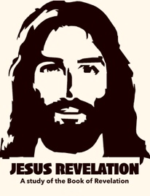
JESUS REVELATION “REVELATION 6 - OPENING THE SIX SEALS”
This final book of the Bible is a vivid and compelling study of what was, what is, and what is to come in the last days. The book is filled with symbolism and imagery, alongside literal history and prophecy encouraging us to beware, and be aware of the signs of the times.
In previous chapters John was given access to the Throne room of Heaven and witnessed the great worship around the throne. God was on the throne, holding a scroll with 7 seals, but a voice said no one is worthy to open the seals and look inside..,

Revelation 5:4-5 “⁴ I wept and wept because no one was found who was worthy to open the scroll or look inside. ⁵ Then one of the elders said to me, “Do not weep! See, the Lion of the tribe of Judah, the Root of David, has triumphed. He is able to open the scroll and its seven seals.”
John said; “I wept and wept because no one was found who was worthy…”
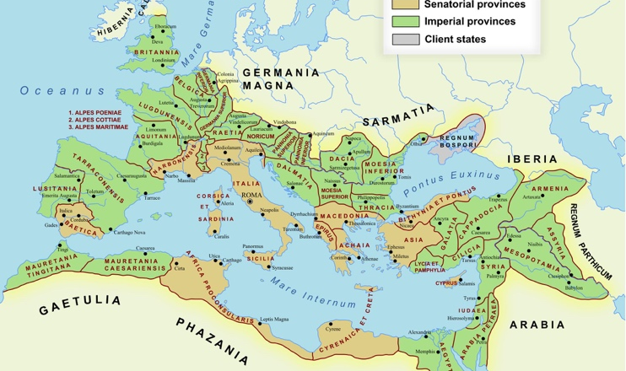
He was weeping because, if no one opens the scroll, then evil continues unchecked. Sin remains unresolved. Justice never comes. The world is doomed and redemption never comes.
Remember this was written during a time of trans-continental tribulation. All the apostles except John, along with thousands of other believers in Jesus had been ruthlessly slaughtered. The Roman Empire was at its height in terms of power and control of most of the civilized world.
The scroll contained God’s solution for bringing justice to the world in the future, but for the moment, no one could open it and set it into motion…But then one of the elders speaks hope into the moment:
“Do not weep! See, the Lion of the tribe of Judah, the Root of David, JESUS! has triumphed… and is able to open the scroll and its seven seals”
Chapter 6 – The Scrolls are Opened, “Here Come The Horsemen”
Chapter 6 begins when the Lamb starts opening the first six seals, including the “Four Horsemen”. Everything that follows proceeds from the authority of the Lamb. The chapter gives symbolic descriptions of “the wrath of him who sits on the throne and the wrath of the Lamb!” (v.16)

Revelation 6:1-2 “I watched as the Lamb opened the first of the seven seals. Then I heard one of the four living creatures say in a voice like thunder, “Come!” ² I looked, and there before me was a white horse! Its rider held a bow, and he was given a crown, and he rode out as a conqueror bent on conquest.”

John sees the Lamb open the first seal. One of the living creatures calls out with a voice like thunder, and John sees a white horse. The rider carries a bow, is given a crown, and rides out as a “conqueror bent on conquest”.
- The rider has a bow and receives a crown. Then goes forth conquering.

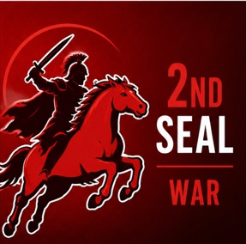
John does not identify the rider here. Throughout church history believers have understood this rider in very different ways. Some say A military power, others say the Anti-Christ, others say it’s Jesus Himself because in Revelation 19 Jesus actually does show up on a white horse. What John does emphasize in these verses is conquest and authority. The rider advances across the earth and carries out his mission; “conquest”.
Revelation 6:3-4 “When the Lamb opened the second seal, I heard the second living creature say, “Come!” ⁴ Then another horse came out, a fiery red one. Its rider was given power to take peace from the earth and to make people kill each other. To him was given a large sword.”

The Lamb opens the second seal. John hears the second living creature speak, and another horse appears. This horse is fiery red. Its rider is given power to take peace from the earth so that people kill one another. A large sword is given to him.
- Peace is removed., Violence follows., People kill one another.

The text connects the rider directly to the removal of peace. Once peace is gone, bloodshed spreads across the earth. Notice; This is the opposite of the Prince of Peace (Sar Shalom), who came to being us peace. John continues to remind us that these events unfold in God’s plan.
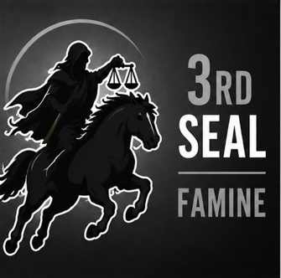
Revelation 6:5-6 “When the Lamb opened the third seal, I heard the third living creature say, “Come!” I looked, and there before me was a black horse! Its rider was holding a pair of scales in his hand. ⁶ Then I heard what sounded like a voice among the four living creatures, saying, “Two pounds of wheat for a day’s wages, and six pounds of barley for a day’s wages, and do not damage the oil and the wine!”
When the Lamb opens the third seal. John sees a black horse. The rider is holding a pair of scales in his hand.
Then John hears a voice announcing the price of wheat and barley.

The scales suggest measurement and rationing. The prices indicate scarcity. A worker's daily wage purchases only a small amount of food showing hardship and economic distress.

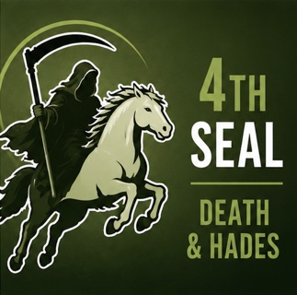
John does not explain every detail. He simply reports what he hears and sees. The overall impression is that basic necessities become difficult to obtain for common people, but the wealthy (represented by oil and wine), are still provided for; “do not damage the oil and the wine!”
Revelation 6:7-8 ^{7 “}When the Lamb opened the fourth seal, I heard the voice of the fourth living creature say, “Come!” ⁸ I looked, and there before me was a pale horse! Its rider was named Death, and Hades was following close behind him. They were given power over a fourth of the earth to kill by sword, famine and plague, and by the wild beasts of the earth.”

The Lamb opens the fourth seal. John sees the final horse, a pale horse. This rider is identified for us. His name is Death, and Hades follows close behind him.

Unlike the previous riders, John leaves no question about this one's identity. “Death, who is given license to kill over a fourth of the earth by; sword, famine, plague, and the wild beasts of the earth.

The progression of the Four Horsemen is;
- Conquest, 2. Violence, 3. Scarcity, 4. Death

Note: The consequences become increasingly severe. (The coming 5th and 6th seals are different than the first four);
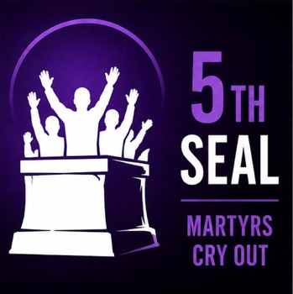
Revelation 6:9-11 “When he opened the fifth seal, I saw under the altar the souls of those who had been slain because of the word of God and the testimony they had maintained. ¹⁰ They called out in a loud voice, “How long, Sovereign Lord, holy and true, until you judge the inhabitants of the earth and avenge our blood?” ¹¹ Then each of them was given a white robe, and they were told to wait a little longer, until the full number of their fellow servants, their brothers and sisters, were killed just as they had been.”

The scene now changes. John is no longer looking at events on the earth. He looks into heaven and sees “under the altar” the souls of those who had been slain because of the Word of God and the testimony they had maintained.

These are people who were faithful to God and lost their lives because of it.

They are crying out for justice on the earth and are given white robes and told to wait until the full number has joined them.

They cry out, asking how long it will be before God judges those responsible for the evil in the world, and brings justice.
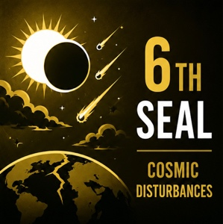
Remember, these seals represent God's wrath (judgment upon evil). But the story is not over in this chapter. The sixth seal is about to be opened, and God's purposes are still unfolding. Even the seventh and final seal in chapter 8 is not the end. It brings about silence in heaven, before the next phase of judgment unfolds through the “seven trumpets”.
Revelation 6:12-14 “I watched as he opened the sixth seal. There was a great earthquake. The sun turned black like sackcloth made of goat hair, the whole moon turned blood red, ¹³ and the stars in the sky fell to earth, as figs drop from a fig tree when shaken by a strong wind. ¹⁴ The heavens receded like a scroll being rolled up, and every mountain and island was removed from its place.”

The sixth seal brings about a great earthquake. The sun turns black, the moon turns blood red, the stars fall, the sky vanishes like a scroll being rolled up, and every mountain and island is moved from its place.

The language is dramatic and apocalyptic, drawing on imagery found throughout the Old Testament prophets to describe the terror and magnitude of the “Day of the Lord”.

Examples:
- Joel 2:31 "The sun will be turned to darkness and the moon to blood before the coming of the great and dreadful day of the Lord."
- Isaiah 13:9-10 "See, the day of the Lord is coming... The stars of heaven and their constellations will not show their light. The rising sun will be darkened and the moon will not give its light."
- Isaiah 34:4 "All the stars in the sky will be dissolved and the heavens rolled up like a scroll; all the starry host will fall like withered leaves from the vine."

In the final verses of chapter 6, all the Kings of the earth, and everyone in their kingdoms try to run and hide from the wrath of God;
Revelation 6:15-17 “Then the kings of the earth, the princes, the generals, the rich, the mighty, and everyone else, both slave and free, hid in caves and among the rocks of the mountains. ¹⁶ They called to the mountains and the rocks, “Fall on us and hide us from the face of him who sits on the throne and from the wrath of the Lamb! ¹⁷ For the great day of their wrath has come, and who can withstand it?”<>

They call to the mountains and rocks and ask to be hidden from the face of the One seated on the throne and from the wrath of the Lamb.

Notice that they recognize the throne, the Lamb, and that these events are connected to God's judgment. There is no mistake about who it is who it is who has authority over heaven and earth.

The chapter closes with a question: "For the great day of their wrath has come, and who can withstand it?”

The answer is “those who belong to the Lord” and is described in the chapters that follow…

So… what does all this mean???

Who are the riders of the four horses, and what is meant by each of the first six seals?

As with many aspects of biblical prophecy, sincere Christians have reached different conclusions. While we should hold our convictions, we should also approach these passages with humility. Much of eschatology involves interpreting passages, symbols, timing, and events that have not yet been fully revealed.

Interpretations of Revelation tend to fall into three primary camps:

PRETERIST, HISTORICIST, and FUTURIST

Preterist – Teaches that most of Revelation was fulfilled in the first century, particularly in connection with the fall of Jerusalem and the Roman Empire.

This view gained some traction because many dramatic events occurred in the first century, including the fall of Jerusalem, the destruction of the Temple, and a series of major earthquakes. Preterists often point to these events, along with the eruption of Mount Vesuvius in AD 79, which destroyed the Roman city of Pompeii, as examples of the kind of upheaval described in apocalyptic literature.

The problem is that much of what we have just read in chapter 6, and much of what we will read in the rest of Revelation, does not appear to have been fulfilled in the first century. The scope of these events seems far greater, pointing to a time of worldwide judgment that is still future.

Historicist – Revelation unfolds throughout the course of church history, with its visions corresponding to major events across the centuries.

According to this view, the seals, trumpets, and bowls are not confined to the first century, nor are they entirely future. Instead, they describe the long sweep of history from the time of the apostles until the return of Jesus.

Many believe that these seals were set forth on the earth only in part, but will be in released full measure at the end of days.

Jesus said: "As it was... so it will be." Matthew 24 & Luke 17

Historicists often connect the seals to major historical developments:
- Conquest (1st seal) – The expansion of the Roman Empire.
- War – (2nd seal) All of Europe was consumed with war. Internal conflicts, invasions, and fall of Rome led directly into what has traditionally been called the Dark Ages.
- Famine – (3rd seal) The economic hardship, scarcity, and instability of the Dark Ages.
- Death –(4th seal) The Bubonic Plague and other devastating pandemics that claimed millions of lives.
- Martyrs – (5th seal) Christians persecuted and killed throughout history, whether by pagan Rome, Islamic conquerors, corrupt religious systems, or hostile governments.
- Signs in the Heavens – (6th seal) Some historicists connect this to modern warfare that shakes the earth and creates the image of the sun turning black, the moon turning to blood red, the stars falling, the sky vanishes like a scroll, and every mountain and island is moved from its place. Through modern aircraft, missiles, bombs, and even nuclear weapons.

The strength of this view is that it attempts to connect Revelation to the entire history of the church. The challenge is that different historicist interpreters often identify the symbols with different historical events taking place in just select parts of the world not the whole earth, making it difficult to arrive at a consistent interpretation.

Futurist – Teaches that most of Revelation, especially chapters 4–22, is still awaiting fulfillment. The seals, trumpets, bowls, the rise of the Antichrist, the return of Jesus, and the thousand-year reign are all understood as future events.

This is the view held by most premillennial and dispensational evangelicals today.

As we continue, I will primarily approach these seals from a futurist perspective, while recognizing that thoughtful believers have understood them differently. I do so primarily because of Jesus' teaching about the end times in Matthew 24;
Matthew 24:3 “As Jesus was sitting on the Mount of Olives, the disciples came to him privately. “Tell us,” they said, “when will this happen, and what will be the sign of your coming and of the end of the age?”
He then gives his most detailed and direct teaching about the last days which I believe closely parallels the sequence of the seals in Revelation 6.
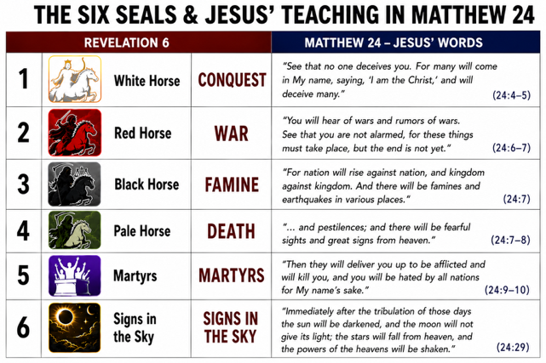
While the two passages are not identical, the similarities are striking. Jesus describes a sequence of deception, war, famine, death, persecution, and cosmic disturbances that closely mirrors what John sees as the Lamb opens the seals.

After this Jesus tells them…
Matt 24:30-32 “Then will appear the sign of the Son of Man in heaven. And then all the peoples of the earth will mourn when they see the Son of Man coming on the clouds of heaven, with power and great glory. ³¹ And he will send his angels with a loud trumpet call, and they will gather his elect from the four winds, from one end of the heavens to the other. “Now learn this lesson from the fig tree: As soon as its twigs get tender and its leaves come out, you know that summer is near.”
It’s possible that those of us who are Futurists, are starting to become “Presentists” because we it seems that many of these things are beginning to take place before our eyes. Each day the news, and world events seem to resemble much of what we see in Revelation.
So, how do we respond???
If we have truly given our lives to Jesus and made Him our Lord, we have nothing to fear. Jesus uses the phrase in Luke “Occupy ‘til I come”, meaning just do all the things God has given you to do, and when He returns, you will be found to be “faithful”!
Jesus promised that He would return for His people. He told His disciples, "I will come back and take you to be with me that you also may be where I am" (John 14:3).
For those who belong to Him, His return is not a cause for fear, but a reason for hope and joyful anticipation. He tells us to prepare in three important ways:
- Be ready — live watchfully and spiritually prepared, not distracted or complacent, because we do not know the day or hour He is coming.
- Remain faithful — Live your life with patient endurance, showing love, obedience, and integrity in the face of pressure and persecution.
- Tell others — faithfully proclaim the gospel of the kingdom to everyone.
Ready Yourselves, Tell the World about Him, and Be Faithful
Rev. 22:12 “Look, I am coming soon! My reward is with me,”

