______________________________________________________________________
North Shore Fellowship
1390 NJ-36, Suite 106 Hazlet, NJ 07730
1-862-309-2232
www.northshorenj.org
admin@northshorenj.org

For important church updates and to join our church email list,
please send your name to: info@northshorenj.org

LEAD PASTOR: Pastor Raphael Giglio raphael@northshorenj.org

CONNECTIONS PASTOR: Pastor Bill Asay billy@northshorenj.org

ASSISTANT PASTOR: Pastor Brian Higgins brian@northshorenj.org

CHURCH ADMINISTRATOR: Melissa Balsamello melissa@northshorenj.org

CHILDREN’S MINISTRY: Michelle Hackworth michelle@northshorenj.org

WORSHIP MINISTRY TEAMS: Aly Giglio aly@northshorenj.org
Dave DiPietro worship@northshorenj.org
Rob Paoletti worship@northshorenj.org
Jon Cunningham worship@northshorenj.org
ELDERS:
Charlie Avery, Bill Higgins Sr., & Rob Paoletti elders@northshorenj.org
____________________________________________________________________

GIVING
Tax-deductible donations, tithes, and offerings can be made at services, online, via QR code, or through the mail. If giving cash, please use an offering envelope and print your full name if you would like a year-end tax record.

Give using our safe and secure QR Code:
Scan to Give: 

Give online: northshorenj.org and click GIVE

Giving link: https://giving.servantkeeper.com/NorthShoreFellowshipOfTheCMA

Mail to Give: North Shore Fellowship 1390 NJ-36, Suite 106 Hazlet, NJ 07730

MISS A SERMON?
Recordings/ videos of all of our past sermons are available at: www.northshorenj.org
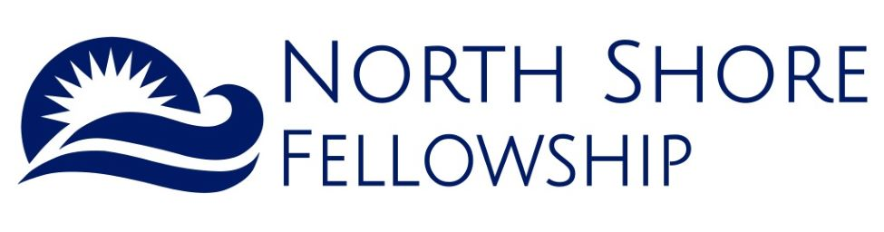

We are so glad you decided to worship, fellowship, and hear God’s Word with us today!

Our hope is that if you are seeking a church home in which to grow and serve, that you will consider being part of our fellowship.

If you have not made a commitment to Jesus as Lord, why not make today your special day and give your life to Him? We would be glad to speak and pray with you about anything on your heart.

Send prayer requests anytime to: prayer@northshorenj.org

www.northshorenj.org

www.facebook.com/northshorenj.org
 northshorefellowship

North Shore Fellowship is a Mission of the Christian and Missionary Alliance
cmalliance.org
Welcome to North Shore Fellowship!

HAPPY MOTHER’S DAY!!

5/10/26

Baby Bottle Boomerang: Take a Baby Bottle on your way out to collect coins, etc., to support the ministry and mission of Solutions Health and Pregnancy Center! Baby Bottles can be returned through Father’s Day!

SUNDAYS
SERVICE TIMES: 10:00 AM and 11:30 AM
North Shore Fellowship’s Upper Room Auditorium, Airport Plaza
1390 Rt. 36 Suite 106, 2nd Floor, Hazlet

ONLINE WORSHIP SERVICE – 9:00AM
- FACEBOOK facebook.com/northshorenj.org
- YOUTUBE Click on YouTube link on www.northshorenj.org

Join us next week 5/17 for a free Fellowship Meal following second service, generously donated by DiAntonio’s Catering.

CHILDREN’S MINISTRY – During Sunday services
Children’s check-in begins at start of service before worship.
SERVE WITH US! Looking for helpers to assist in the Toddler Room and Children’s Ministry once per month or more, one or both services.
See Ms. Michelle for more info. or email: michelle@northshorenj.org

SUNDAY MORNING PRAYER MEETING - 9:00 AM to 9:45 AM Weekly
Suite 105 – Across from the Upper Room.
Pop in to pray ANYTIME between 9:00 AM to 9:45 AM. For info. email Charles Avery/ cavery@me.com

MONDAYS
Women’s Monday Night Study on Zoom – Weekly through 5/25
7:00 PM – 8:00 PM All women are welcome!
For info and Zoom code contact Lisa Geene / lisageene@gmail.com
Study: The King is Coming (John Bevere)
This video Bible study explores Jesus’ teachings about the “signs” that will precede his second coming and explains what it means to live with a watchful, prepared heart.
TUESDAYS
Women’s In-Person Bible Study - 10:00AM
Topic: Prayers in the Bible Held @ the Upper Room
To register or for info. email: Lynne McCabe / lynne.mccabe54@aol.com

WEDNESDAYS
5/27 - North Shore Homeschool Group
Final meeting before summer - 1:00PM to 3:00PM Held at the Upper Room
Please join us for our final homeschool mission lesson with games, craft, and snack
For info. contact Becky / jonahkicks@gmail.com or Daniella / Dankings@aol.com

Save the Dates! Homeschool Mom’s Summer Bible Study
Every Wednesday in June and July – Held in Union Beach 10:30AM to 1:00PMA Bible Study for Mothers Who Homeschool - Kids are always welcome!
For more info. and to sign up: Becky Joyce / jonahkicks@gmail.com

THURSDAYS
Marriage Ministry – 5/14 Held @ The Upper Room.
The NSF Marriage Ministry invites all married and soon-to-be-married couples. To register or for more info. email: marriageministrynf@gmail.com

FRIDAYS
Youth Group – For 6th to 12th grade 7:30PM to 9:00PM
- 6/5 - Final Youth Group at the Upper Room before summer
- 6/12 - Youth Group Campout - Register with Pastor Brian for details
Send name, cell, and email to register: Pastor Brian Higgins / brian@northshorenj.org Updates and other meet-ups/ events will be shared .

SATURDAYS
5/30- North Shore Fellowship Coffeehouse Presents: A Night of Worship
Final Coffeehouse before the summer- Held in the Upper Room – 7:00PM
All are welcome for a time of fellowship, worship, coffee and snacks!

Men’s Breakfast – 5/16/26 at 9:00AM Free! - Held at the Upper Room.
Men, join us for a time of fellowship, food, worship, and a testimony!
No registration needed. For more info email Charlie Avery / cavery@me.com

Women’s Breakfast – 6/6/26 at 9:00AM – Held at the Upper Room.
For women (13 years and older.) Fellowship, breakfast, worship and a testimony!
Women, please prepare to register. The link to RSVP is coming soon.

Join our email list for church updates, send name to: info@northshorenj.org

