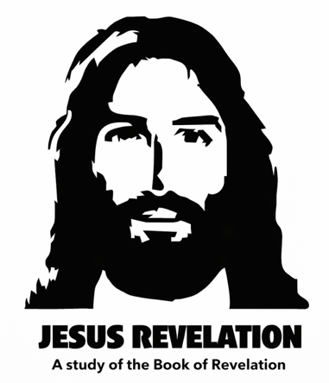
“WAS, IS, and IS TO COME”
REVELATION 1
Our Series: “Jesus Revelation” is based on the first verse in the Book of Revelation which says;
Revelation 1:1 “The revelation from Jesus Christ, which God gave him to show his servants what must soon take place.”
This is the final book of the Bible and speaks about the last days and God’s judgment upon the earth. It begins with Jesus’ messages to the seven churches in Asia Minor, which can also serve as archetypes of the church today. It continues with God’s wrath and judgment poured out upon the earth in a dramatic, apocalyptic fashion, and concludes with Jesus ruling and reigning over a new heaven and a new earth.
It is a vivid and compelling study of what was, what is, and what is to come in the last days. The book is filled with symbolism and imagery, alongside literal history and prophecy. It has baffled readers and theologians for centuries, yet it has also encouraged countless Christians to beware, and be aware of the signs of the times.
Revelation is the name of the book (not Revelations), and was written by John the Apostle (brother of James, son of Zebedee), writing near the end of the first century (around A.D. 90–96) during the reign of the Roman Emperor Domitian.
By this point, all the other apostles had been martyred according to tradition, and the church had spread throughout the Roman Empire. Roman Emperor and pagan worship was becoming more enforced, and to confess “Jesus as Lord” was a political crime. John after being captured and tortured for his faith, was exiled on Patmos, prison island in the Aegean Sea. It there that John received one of the most expansive visions in all of Scripture.
This book is addressed to seven real churches in Asia Minor (what we would call modern-day western Turkey), an important Roman province filled with major cities, trade routes, and strong cultural influence. These churches were in influential, pagan, economically active regions along a circular Roman road route in Asia minor.
Throughout the book however, we see John receive messages and vision, and prophecies that contain many significant numbers, elements, and images. It’s important not to make the mistake than others have committed in becoming dogmatic and overly opinionated about what is meant to be a “concealed mystery”. The phases “for him who has ears to hear”, and “This calls for a mind with wisdom.” appear throughout the book to remind us that there is more truth hidden in the messages of Revelation than initially meets the eye. [example WWII prophets]
Because it is the “Revelation of Jesus Christ,” we will look for Jesus’ message to us in every chapter. Some chapters are filled with heavenly worship; others are filled with God’s wrath and judgment.
Because it is the Word of God, it is “living and active” (Heb. 4:12), it will not return void (Isa. 55:11), and it is useful for teaching, rebuking, correcting, and training in righteousness (2 Tim. 3:16). So let’s buckle our seatbelts and prepare for an exciting adventure as we study the book of Revelation!

REVELATION 1
Revelation 1:1 “The revelation from Jesus Christ, which God gave him to show his servants what must soon take place.”
- “The revelation from Jesus Christ” – The Jesus Revelation (not just from John)
- “which God gave him” – Given directly by God
- “to show his servants” – To “reveal” to “us”
- “what must soon take place” — meaning the prophetic clock had begun, and these events could commence and begin rolling out at any moment.
Revelation 1:1b-2 “He made it known by sending his angel to his servant John, ² who testifies to everything he saw—that is, the word of God and the testimony of Jesus Christ.”
- John testified to what was revealed to him by an angel.
- He “bore witness” to the Word of God and to the testimony given by Jesus Christ. (Bore witness = to testify truthfully from firsthand knowledge.)
Revelation 1:3 “Blessed is the one who reads aloud the words of this prophecy, and blessed are those who hear it and take to heart what is written in it, because the time is near.
We will read the entire book of Revelation aloud over the course of the series (so we’ll be blessed), and we will take it to heart, because the time is nearer now than ever before in history!

Greetings:
Revelation 1:4b-5 “John, To the seven churches in the province of Asia:
Grace and peace to you from him who is, and who was, and who is to come, and from the seven spirits before his throne, ⁵ and from Jesus Christ, who is the faithful witness, the firstborn from the dead, and the ruler of the kings of the earth.”
Jesus is described in many ways throughout the book of Revelation, as are angels, spirits, and even God Himself. But the phrase “who is, and who was, and who is to come” appears several times in Revelation to describe God’s eternal nature—past, present, and future. That’s why you’ll see three categories of prophecy in the book: PAST, PRESENT, and FUTURE—and God is in all of them.

(Note that later in the book, something fascinating happens: the phrase drops “who is to come” and simply says “who is, and who was,” because at that point, He will have already come.)

Revelation 1:5b-6 “To him who loves us and has freed us from our sins by his blood, and has made us to be a kingdom and priests to serve his God and Father—to him be glory and power for ever and ever! Amen.”

This is an important label that God gave His people in the Torah;

Exodus 19:6 “You shall be to me a kingdom of priests and a holy nation.”
Revelation contains more Old Testament reference than any other book in the New testament. God originally said this to Israel at Mt. Sinai, while they were still a nation of freed slaves; They were meant to: Represent God to the nations, Mediate His presence, and Live “set apart” (different from other peoples).
Revelation 1:7 “Look, he is coming with the clouds,” and “every eye will see him,
even those who pierced him”; and all peoples on earth “will mourn because of him.” So shall it be! Amen.”

Once again, this shows us very clearly that the Revelation of Jesus is consistent with Jesus’ other teachings and messages, and that He came to “fulfill” not abolish the Tanakh (the law and the prophets). The reference to “coming on the clouds” has to do with Jesus’ Return is straight out of the book of Daniel;

Daniel 7:13 “In my vision at night I looked, and there before me was one like a “son of man”, coming with the clouds of heaven.”

And the “mourning of Him who they’ve pierced” is one of the most direct Old Testament prophecies pointing to Jesus as Messiah;

Zech 12:10 “They will look on me, the one they have pierced, and they will mourn...”
Jewish people are awaiting their Messiah to come for the first time. Many will be surprised and weep when He comes, because it is Jesus, the one they have pierced!

Revelation 1:8 “I am the Alpha and the Omega,” says the Lord God, “who is, and who was, and who is to come, the Almighty.”
This is a message directly from God to His people. Again, consistent, not a departure, with His Old Testament identity;
Alpha and Omega - the first and last letters of the Greek alphabet

Isaiah 44:6 “I am the first and I am the last; apart from me there is no God.”

“The Almighty” – “El Shaddai” the all-powerful, all-sufficient One.

John’s Vision of Christ
Revelation 1:9 “I, John, your brother and companion in the suffering and kingdom and patient endurance that are ours in Jesus, was on the island of Patmos because of the word of God and the testimony of Jesus.”
John was banished to the prison Island of Patmos when he was about 75–85 years old. He was likely the last living apostle and had been arrested and exiled by the Romans for preaching the word of God and testifying that Jesus is Lord.
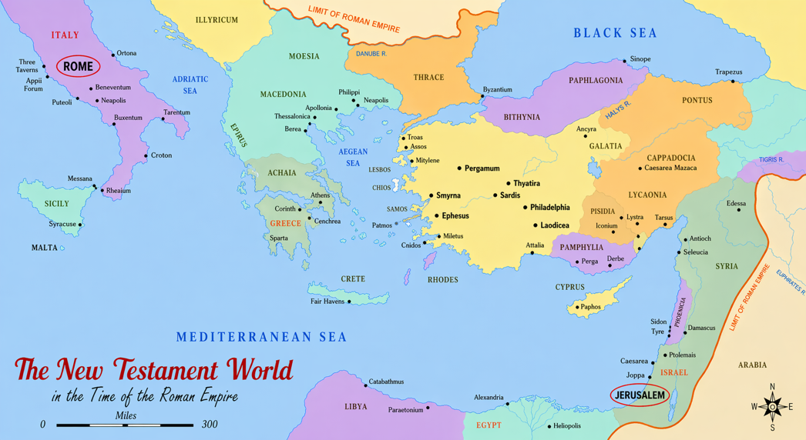
Revelation 1:10 “On the Lord’s Day I was in the Spirit, and I heard behind me a loud voice like a trumpet, ¹¹ which said: “Write on a scroll what you see and send it to the seven churches: to; Ephesus, Smyrna, Pergamum, Thyatira, Sardis, Philadelphia and Laodicea.”
John was “in the Spirit” on the Lord’s Day (possibly Sunday, maybe Sabbath – Saturday), but likely in deep prayer and meditation when he heard a command to “write a scroll” and send it to the “seven churches” of Asia Minor. These weren’t originally John’s churches, many were influenced by Paul, but by the time Revelation was written, they were in John’s region and under his pastoral oversight.
JESUS REVEALED:
Revelation 1:12 “I turned around to see the voice that was speaking to me. And when I turned I saw seven golden lampstands, ¹³ and among the lampstands was someone like a son of man, dressed in a robe reaching down to his feet and with a golden sash around his chest. ¹⁴ The hair on his head was white like wool, as white as snow, and his eyes were like blazing fire. ¹⁵ His feet were like bronze glowing in a furnace, and his voice was like the sound of rushing waters. ¹⁶ In his right hand he held seven stars, and coming out of his mouth was a sharp, double-edged sword. His face was like the sun shining in all its brilliance.”
John saw the risen glorified Jesus here about 60 years after the Resurrection. Many of his features are similar to references in the Old Testament, including;
Daniel 7:9 “ and the Ancient of Days took his seat. His clothing was as white as snow; the hair of his head was white like wool. His throne was flaming with fire,”

Ezekiel 43:2 “His voice was like the roar of rushing waters…”
The golden lampstands are like the menorahs (menorot) of the Temple, but instead of one lampstand, John sees seven, representing the seven churches, each bearing the light of God’s presence.
Revelation 1:17 “When I saw him, I fell at his feet as though dead. Then he placed his right hand on me and said: “Do not be afraid. I am the First and the Last. ¹⁸ I am the Living One; I was dead, and now look, I am alive for ever and ever! And I hold the keys of death and Hades.”
John is so scared he fell down as if he was dead. Anyone would be. By then Jesus did something very personal to John, He placed His right hand on him and comforted, encouraged, and reassured him that He is Alive forever though He was once dead.
Remember, John had a very personal relationship with Jesus when he was a young man. John was part of Jesus’ inner circle. He reclined next to Jesus at the Last Supper, referred to himself as the disciple whom Jesus loved, and Jesus entrusted His mother Mary to John while He was on the cross. Now Jesus was glorified in power, authority, and majesty, yet He still placed His nail-scarred hand on John as a personal gesture of love.
He told John that he has conquered death and the grave. He holds the keys of death and Hades.”
- Death = the reality of physical death
- Hades = the realm of the dead (the place where the dead go), not final judgment. (that happens in chapter 20).

Revelation 1:19 “Write, therefore, what you have seen, what is now and what will take place later. ²⁰ The mystery of the seven stars that you saw in my right hand and of the seven golden lampstands is this: The seven stars are the angels of the seven churches, and the seven lampstands are the seven churches.” <>

The “mystery of the stars and lampstands” is that they are messenger angels, and churches. The seven churches in Revelation depicted here as lampstands, were real, historical churches. They are sort of “archetypes” of the church today, because they represent the struggles and strengths of every church since that time. The next two chapters deal specifically with their strengths and flaws. The “angels” are God’s heavenly messengers and warriors that still exist, but are rarely acknowledged.
Jesus specifically instructs John;
Rev. 1:19 “ “Write, therefore, what you have seen, what is now and what will take place later.”
This is the key to understanding Revelation. What Was, What IS, and What is to come. This makes total sense from a God who is described as, and who says;
“I am …“who is, and who was, and who is to come,” (verse 4 & 8)
So, we need to be mindful of these three categories (Jack Hibbs says three buckets);
- What Was
- What Is
- What is to come

All of what we read will fall into one of these categories and it will help us to understand the more difficult verses.
- WHAT WAS: Much of what is referenced is from Old Testament times, with a heavy emphasis on the prophets (Daniel, Ezekiel, Moses).

- WHAT IS: For John is was the heavy persecution and martyrdom of the church including all his fellowship apostles and the pervasive power of evil over the earth.

- WHAT IS TO COME: Ultimately, after global conflict and tribulation, Jesus will conquer victoriously and reign over all ethe earth, sending the Devil to eternal damnation.
So, as we proceed deeper into this study, how should this make us feel?; scared, nervous, bewildered, frightened? NO!
We can be Joyful, confident, and even cheerful! Jesus said;
John 16:33 “These things I have spoken to you, that in Me you may have peace. In the world you will have tribulation; but be of good cheer, I have overcome the world.”
All authority on heaven and earth belongs to Jesus and as His people, it is given to us as well as we live, move, and speak in Jesus’ name.
Nothing happens unless God makes it happen, or lets it happen, and everything He does, He does out of love, because “God is love”.
So let’s be encouraged and hold unswervingly to the anchor of hope that we have in Jesus, and encourage each other to do the same as we see the Day drawing nearer.
Heb 10:23 “Let us hold unswervingly to the hope we profess, for he who promised is faithful. ²⁴ And let us consider how we may spur one another on toward love and good deeds, ²⁵ not giving up meeting together, as some are in the habit of doing, but encouraging one another—and all the more as you see the Day approaching.”

<>

