TO FULFILL WHAT WAS SPOKEN
Matthew 25 – The Sheep and the Goats
Matthew 24 & 25 are “The Olivet Discourse”, Jesus’ eschatological teachings about the End Times.
He mentioned in the first part of the teaching;
Matthew 24:3,15 ³ Now as He sat on the Mount of Olives, the disciples came to Him privately, saying, “Tell us, when will these things be? And what will be the sign of Your coming, and of the end of the age?” …
“…when you see the abomination of desolation spoken of by the prophet Daniel, standing in the holy place (let the reader understand).”
This is some of the actual prophecy that Jesus is referring to;
Daniel 9:26-27 “…And till the end of the war desolations are determined. ²⁷ Then he shall confirm a covenant with many for one week; But in the middle of the week He shall bring an end to sacrifice and offering. And on the wing of abominations shall be one who makes desolate”.”
Many scholars believe that there as Three Desolations of the Temple prophesied in Daniel;

A pattern of desolation that repeats, intensifies, and culminates.
- 167 BC — a foreshadowing
- 70 AD — a nearer fulfillment
- Future — a final fulfillment

Luke 21:24 “And they shall fall by the edge of the sword, and shall be led away captive into all nations: and Jerusalem shall be trodden down of the Gentiles, until the “times of the Gentiles” be fulfilled.”
Romans 11:25 “I do not want you to be ignorant of this mystery, brothers and sisters, so that you may not be conceited: Israel has experienced a hardening in part until the “full number of the Gentiles” has come in.”
The whole teaching that Jesus gives in His “Olivet Discourse”, is about the final years leading into the Tribulation, and then into His millennial Kingdom.
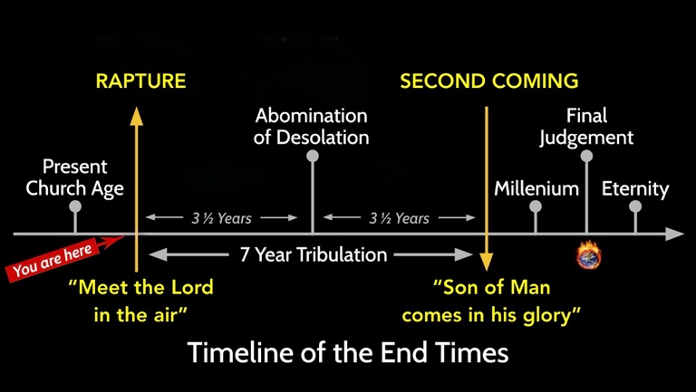
Those of us who hold to a pre-tribulation rapture understand Jesus’ return in two stages: first, He comes to gather His people; then, after the seven-year tribulation, He returns visibly in glory.
The “Sheep and the Goats” teaching, takes place after the 2nd Coming, when He “comes in glory”.

When will all this take place? We don’t know, only God Himself knows.
Matt 24:36 “But about that day or hour no one knows, not even the angels in heaven, nor the Son, but only the Father.”

Matthew 25 (pt. 3) - The Sheep and the Goats
This is the third and last part of the Olivet Discourse, and Jesus final teaching in Matthew. Although it’s often called the “parable” of the sheep and the goats, it is not really a parable. There is no “kingdom of heaven is like…”, and no fictional story. It’s a “comparison”, he compares “the nations” to sheep and goats.
IT’S IMPORTANT TO REMEMBER, that the message of this teaching is NOT a call to “Salvation by works”. Some teach this section as if doing “Random acts of kindness, (feeding the poor, visiting the sick and imprisoned etc.) or not doing them, is the deciding factor for us to get into heaven or be sent to hell. If that were the case, Jesus would have suffered and died for nothing!
This is about judgment when the Son of Man comes in glory...
Note: In this section of the Discourse; Jesus refers to himself as “The Son of Man”, a “Shepherd”, “the King”, “Lord”, and refers to God as “My Father”.
Matthew 25:31 “When the Son of Man comes in his glory, and all the angels with him, he will sit on his glorious throne.”
[see timeline: “When the Son of Man comes in his glory, and sits on His glorious throne.”]
Matthew 25:32 “All the nations will be gathered before him, and he will separate the people one from another as a shepherd separates the sheep from the goats. ³³ He will put the sheep on his right and the goats on his left.”
“Nations” is a key word here because it tells us exactly who Jesus is speaking about.
“NATIONS” = “ETHNE” = “GOYIM”
In the Old Testament, the world was divided into two covenantal groups: #1. Israel, the people of God, and #2. “the nations” (goyim), everyone else.
1. Israel - The covenantal people of God.
2. The Nations (goyim/ethne), Everyone else. Those who were NOT the covenantal people of God.
These “Nations” (sheep and goats) are people who are NOT considered to be the covenantal people of God.
Matthew 25:34-36 “Then the King will say to those on his right, ‘Come, you who are blessed by my Father; take your inheritance, the kingdom prepared for you since the creation of the world. ³⁵ For I was hungry and you gave me something to eat, I was thirsty and you gave me something to drink, I was a stranger and you invited me in, ³⁶ I needed clothes and you clothed me, I was sick and you looked after me, I was in prison and you came to visit me.’
He points out how “the righteous” responded to Him when he was in need, (with these six needs); Hungry, thirsty, stranger, needed clothes, sick, in prison.
Matthew 25:37-39 “Then the righteous will answer him, ‘Lord, when did we see you hungry and feed you, or thirsty and give you something to drink? ³⁸ When did we see you a stranger and invite you in, or needing clothes and clothe you? ³⁹ When did we see you sick or in prison and go to visit you?’
Interestingly, those on His right asked “when”? In other words, when did we help YOU? They did not seem to recall ever helping Jesus with anything, or any time He was in need.
Matthew 25:40 “The King will reply, ‘Truly I tell you, whatever you did for one of the “least of these brothers and sisters of mine”, you did for me.’
The word used here for brothers and sisters (brethren) is adelphōn.
New Testament meaning of adelphōn.;
“Biological brother”, “Fellow Israelite”, “Fellow believer”
The word also shows up as “Adelphia” (brotherhood).
[That’s where the name Philadelphia comes from, “city of brotherly love” ]
So, if “the nations” are Gentiles, and “these brothers and sisters of mine” are distinguished from them, then “my brothers and sisters” (brethren) likely refers to His ethnic relations, and those who do the will of His father, in other words Jewish people, and believers in the Messiah. In the tribulation, both Jewish people, and believes will experience severe persecution. Some will help them, some will not.
Jesus is clearly identifying with these so much so, that anything done to them, is reckoned as being done to Him.
Matthew 25:41-43 “Then he will say to those on his left, ‘Depart from me, you who are cursed, into the eternal fire prepared for the devil and his angels. ⁴² For I was hungry and you gave me nothing to eat, I was thirsty and you gave me nothing to drink, ⁴³ I was a stranger and you did not invite me in, I needed clothes and you did not clothe me, I was sick and in prison and you did not look after me.’ ⁴⁴ “They also will answer, ‘Lord, when did we see you hungry or thirsty or a stranger or needing clothes or sick or in prison, and did not help you?’
Interestingly, they also call Him Lord. But they refuse to help those in need, because in their minds, there was no connection to those who are suffering and Jesus Himself.
Matthew 25:45-46 “He will reply, ‘Truly I tell you, whatever you did not do for one of the least of these, you did not do for me.’ ⁴⁶ “Then they will go away to eternal punishment, but the righteous to eternal life.” <>
In this judgement period, Jesus shows mercy to those who showed his “Adelphon” (brethren) mercy, and punishment who refused to do so.
Example: In the Hiding Place, the Ten Boom family courageously helped the Jewish people who were being targeted by the Nazi’s. There were however in the Netherlands who refused to help them because they considered them “enemies of Jesus” and “Christ Killers” and not those. This type of Antisemitism exists now, and will continue into the end times. It’s important for us to not just speak against it but act accordingly. God says; “I will bless those who bless you, and whoever curses you I will curse” (Gen. 12:3)

“Let us never forget, as we look upon the Jew, that he is the brother of Jesus of Nazareth, and has given to us our precious Savior and dearest Friend.”
(AB Simpson)
Once again, the “Sheep and the Goats” is not a call for us to “do random acts of Kindness to strangers to secure our salvation”, but a glimpse of how the Lord regards the treatment of those who he calls “brethren” when He comes in glory.

Question: Why did both the sheep and goats call Him “Lord”, but have very different responses?

Jesus talked about this early in Matthew.

Matthew 7:21 “Not everyone who says to me, ‘Lord, Lord,’ will enter the kingdom of heaven, but only the one who does the will of my Father who is in heaven. ²² Many will say to me on that day, ‘Lord, Lord, did we not prophesy in your name and in your name drive out demons and in your name perform many miracles?’ ²³ Then I will tell them plainly, ‘I never knew you. Away from me, you evildoers!’”

Yes, as Jesus prophesied, there will be false teachers, false prophets, and false Messiahs who will come claiming that they are doing miracles in Jesus’ name, but He will send them away saying “I never knew you!”

You will know them by their fruits, not their ‘signs and wonders’.

What about us? How will people know that we are truly His disciples?

John 13:34-35 “A new command I give you: Love one another. As I have loved you, so you must love one another. ³⁵ By this everyone will know that you are my disciples, if you love one another.”

Not just “by our love”,… but by our love for one another. Again, “random acts of love and kindness for strangers and those we do not know”, even our enemies is good. It’s even encouraged throughout the gospels, but our love toward one another, (the least of these His brethren) is how everyone will know we are His disciples.

[ I recently spoke to a guy who wanted to let me know of an issue in the church where someone needed a costly medical device that they couldn’t afford. He said that once the need was known, some brothers in the church went ahead and ordered it, paid for it themselves, and did not want anyone to know who did it, just that the need was met.]

This is exactly what Jesus was talking about in “Love one another”. This type of love is contagious and magnetic. When those outside the church see it, they desire it and “want in”, because we are made for this type of love, this is the love of God, and the world does not offer it.
This is what it was like in the early church. They took care of one another, shared together, ate together, worshipped together, loved one another, and sold what they had and gave to one another. Outsiders saw this, and “wanted in”, that’s how the early church grew. That’s how all churches should grow.

Paul speaks emphatically in the last chapter of Galatians about this;
Galatians 6:9-10 “Let us not become weary in doing good, for at the proper time we will reap a harvest if we do not give up. ¹⁰ Therefore, as we have opportunity, let us do good to all people, especially to those who belong to the family of believers.”

Closing:
Let's do good things for as many people as we are able to, but ESPECIALLY to, and for, those in the family of believers, and the least of Jesus’ brothers and sisters, and let’s do all we can to love one another as He has loved us! <>

