TO FULFILL WHAT WAS SPOKEN
Matthew 25: “THE OLIVET PARABLES”
The signs of; wars and rumors of wars, Nation rising against nation, and kingdom against kingdom, and famines and earthquakes in various places have been occurring since the time of Jesus, just as He said they would. What is unique in the modern era is not their existence, but their global scale, impact on all of society, and constant immediate visibility.
In the modern age, we see all these things happening at levels never seen before in history. The increase of knowledge, communication and globalism, has given way to an increase in wickedness that former generations would be appalled at.
Then He tells us of one last sign before “the end will come”;
Matthew 24:14 “And this gospel of the kingdom will be preached in the whole world as a testimony to all nations, and then the end will come.”
Because of recent technologies, very soon the whole world will be able to see, and hear the gospel, and with the advances in AI, they can hear it in their native languages.
--------------------------
Olivet Parables - Parable #1 The 10 Virgins
Matthew 25
Mattew 25:1-13 “At that time the kingdom of heaven will be like ten virgins who took their lamps and went out to meet the bridegroom. 2 Five of them were foolish and five were wise. 3 The foolish ones took their lamps but did not take any oil with them. 4 The wise ones, however, took oil in jars along with their lamps. 5 The bridegroom was a long time in coming, and they all became drowsy and fell asleep. 6 “At midnight the cry rang out: ‘Here’s the bridegroom! Come out to meet him!’ 7 “Then all the virgins woke up and trimmed their lamps. 8 The foolish ones said to the wise, ‘Give us some of your oil; our lamps are going out.’
9 “‘No,’ they replied, ‘there may not be enough for both us and you. Instead, go to those who sell oil and buy some for yourselves.’ 10 “But while they were on their way to buy the oil, the bridegroom arrived. The virgins who were ready went in with him to the wedding banquet. And the door was shut. 11 “Later the others also came. ‘Lord, Lord,’ they said, ‘open the door for us!’ 12 “But he replied, ‘Truly I tell you; I don’t know you.’ 13 “Therefore keep watch, because you do not know the day or the hour.”
When Jesus tells the parable of the ten virgins, He is drawing from a wedding custom everyone in His audience would have understood. In Jewish weddings, the bridegroom would arrive at an unexpected hour to collect his bride and begin the celebration. The bridesmaids were expected to be ready whenever he came, sometimes waiting late into the night. All ten virgins in the story are invited, all are waiting, all have lamps, and all grow tired during the delay. At first glance, they look exactly the same. The only difference is that five bring extra oil and five do not. The delay exposes what is real. When the cry goes out at midnight, only those who prepared ahead of time are ready to go in with the bridegroom. What they lacked could not be borrowed or fixed at the last moment.
Jesus is teaching that His return will involve waiting, and that waiting tests what kind of faith we actually have. The problem is not that the foolish virgins wanted to be there or believed the bridegroom would come. The problem is that they assumed readiness instead of preparing for it. Jesus ends by calling His listeners to live prepared lives, knowing that He will return, but not knowing when, and understanding that what we cultivate while we wait matters when the moment finally arrives.

Olivet Parable #2 - The Parable of the Bags of Gold
Matthew 25:14-30 “Again, it will be like a man going on a journey, who called his servants and entrusted his wealth to them. 15 To one he gave five bags of gold, to another two bags, and to another one bag,[a] each according to his ability. Then he went on his journey. 16 The man who had received five bags of gold went at once and put his money to work and gained five bags more. 17 So also, the one with two bags of gold gained two more. 18 But the man who had received one bag went off, dug a hole in the ground and hid his master’s money.
19 “After a long time the master of those servants returned and settled accounts with them. 20 The man who had received five bags of gold brought the other five. ‘Master,’ he said, ‘you entrusted me with five bags of gold. See, I have gained five more.’
21 “His master replied, ‘Well done, good and faithful servant! You have been faithful with a few things; I will put you in charge of many things. Come and share your master’s happiness!’

22 “The man with two bags of gold also came. ‘Master,’ he said, ‘you entrusted me with two bags of gold; see, I have gained two more.’
23 “His master replied, ‘Well done, good and faithful servant! You have been faithful with a few things; I will put you in charge of many things. Come and share your master’s happiness!’
24 “Then the man who had received one bag of gold came. ‘Master,’ he said, ‘I knew that you are a hard man, harvesting where you have not sown and gathering where you have not scattered seed. 25 So I was afraid and went out and hid your gold in the ground. See, here is what belongs to you.’
26 “His master replied, ‘You wicked, lazy servant! So you knew that I harvest where I have not sown and gather where I have not scattered seed? 27 Well then, you should have put my money on deposit with the bankers, so that when I returned I would have received it back with interest.
28 “‘So take the bag of gold from him and give it to the one who has ten bags. 29 For whoever has will be given more, and they will have an abundance. Whoever does not have, even what they have will be taken from them. 30 And throw that worthless servant outside, into the darkness, where there will be weeping and gnashing of teeth.”
In this parable, Jesus describes a man who goes on a journey and entrusts his servants with his wealth while he is gone. This was a familiar situation in the ancient world, where a master might leave for an extended time and expect trusted servants to manage his affairs. Each servant is given a different amount, not because the master is unfair, but because he knows their abilities. The key point is that every servant is trusted with something. Two of the servants immediately put what they were given to work and produce more. One servant, however, is afraid. He does nothing with what he received and simply hides it to avoid risk. When the master returns after a long time, he asks each servant to give an account of what they did during his absence.
Jesus’ point is that faithfulness is shown by action during the waiting, not by inactivity or fear. The servants who are praised are not praised for having more than others, but for using what they were given. The servant who is condemned is not punished for losing anything, but for refusing to act at all. His fear leads him to misunderstand the master and to choose safety over obedience. This parable teaches that while Jesus is away, His followers are expected to live engaged, active lives, using what God has entrusted to them for His purposes.
This is how Jesus expects us to live. Investing all that he’s given us, (our talents, our resources, our time, our energy, etc., into His Kingdom
He has already told us about these things in Matthew;
Matt 22:37-38 “Jesus replied: “‘Love the Lord your God with all your heart and with all your soul and with all your mind.’ This is the first and greatest commandment.”

Matthew 16:25 “For whoever wants to save their life will lose it, but whoever loses their life for my sake will find it.”
Matthew 6:33 “But seek first the kingdom of God and his righteousness, and all these things will be added to you.”
Here in His end-times teaching, He is telling us that our obedience is not just about us, it’s about the furtherance and fruitfulness of the Kingdom of God.
Sometimes the Lord asks us to invest time into His kingdom, when it’s inconvenient (like the Good Samaritan), or give to Him beyond what we think is our ability (like the widow of Zarephath giving to Elijah), or serve Him in ways that are uncomfortable or even difficult (like Paul going to Jerusalem and subjecting himself to “bond and affliction”).
[ Story of a friend, a leader from the metro district, He made a statement that he will always give God his “yes”. I saw him in Ohio. He has a great job and is being used by the Lord, but he sorely misses his home, his family, and his former position. He knows however, that this is what he needed to do to invest “his talents” where they would result in the greatest increase.]
“To whom much is given, much is required” (Luke 12:48)
Remember, these parables are all part of “The Olivet Discourse”, Jesus’ eschatological teachings about the End Times.
He mentioned in the first part of the teaching;
Matthew 24:3,15 ³ Now as He sat on the Mount of Olives, the disciples came to Him privately, saying, “Tell us, when will these things be? And what will be the sign of Your coming, and of the end of the age?” …
“…when you see the abomination of desolation spoken of by the prophet Daniel, standing in the holy place (let the reader understand).”
This is some of the actual prophecy that Jesus is referring to;
Daniel 9:26-27 “²⁶ “And after the sixty-two weeks. Messiah shall be cut off, but not for Himself; And the people of the prince who is to come
Shall destroy the city and the sanctuary. The end of it shall be with a flood,
And till the end of the war desolations are determined. ²⁷ Then he shall confirm a covenant with many for one week; But in the middle of the week
He shall bring an end to sacrifice and offering. And on the wing of abominations shall be one who makes desolate”.”
Many scholars believe that there as Three Desolations of the Temple prophesied in Daniel;
A pattern of desolation that repeats, intensifies, and culminates.
- 167 BC — a foreshadowing
- 70 AD — a nearer fulfillment
- Future — a final fulfillment
This is often called prophetic telescoping or typological fulfillment.
It’s important to know that much has been fulfilled and much is being fulfilled to prepare for the imminent coming of the Lord.
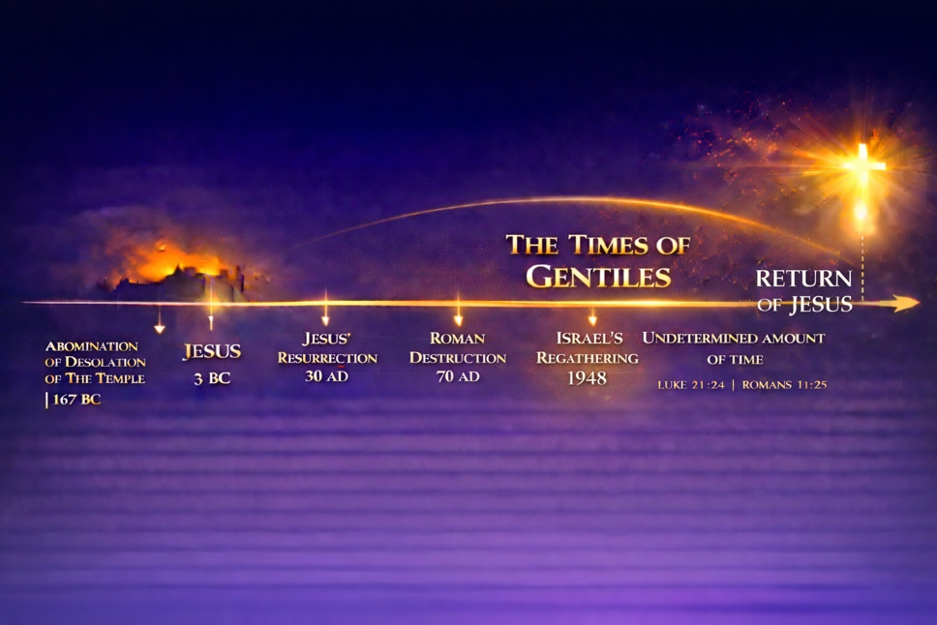
Luke 21:24 “And they shall fall by the edge of the sword, and shall be led away captive into all nations: and Jerusalem shall be trodden down of the Gentiles, until the “times of the Gentiles” be fulfilled.”
Romans 11:25 “I do not want you to be ignorant of this mystery, brothers and sisters, so that you may not be conceited: Israel has experienced a hardening in part until the “full number of the Gentiles” has come in.”
When will all this take place? We don’t know, only God Himself knows.
Matt 24:36 “But about that day or hour no one knows, not even the angels in heaven, nor the Son, but only the Father.”
[ Be careful of becoming dogmatic in your eschatology, especially regarding times or dates. Many notable teachers have made this mistake. If I was a Bible Teacher during WWII, I would likely have taught things that turned out to be wrong.]
We DO know that now we are in the “Church Age”. (We are only 7 years away from the 2000 yr. mark since Jesus died and rose again). The Lord is delaying His return until all who would believe are given a chance to come in.
It is like a “grace period” of a bank loan, you should have already made the Payment, but the bank gives you a little more “grace time”. We don’t know when the “Grace Period” of planet Earth will end.
***(It’s like the rental car bus that I missed.) : )
Luke 19:12-13 ¹² Therefore He said: “A certain nobleman went into a far country to receive for himself a kingdom and to return. ¹³ So he called ten of his servants, delivered to them ten minas, and said to them, ‘Do business till I come.” (occupy ‘til I come).
So what do we do?
- “Ready Yourselves” – Make sure that you are truly a follower of Jesus. You do that by fully putting your trust in Him and believing His Word.

- “Be His Witnesses” – Make sure the people in your life have heard the gospel, and perhaps even understand the ramifications of rejecting Jesus in the Last Days.
- “Occupy until He comes” - “Do business until I come”

God wants us to live our lives, raise our families, and pursue our calling and our profession as we work toward the objectives of the Kingdom of God.

As we honor God in our daily lives by reflecting the love and glory of Jesus, many will come to know Him and be saved. As we go about our days, preaching the gospel, being His witnesses, and making disciples; many will come to believe upon Jesus and be saved.

This is what it means to “Occupy until He comes, and do His business”. <>

