TO FULFILL WHAT WAS SPOKEN
“WHO DO YOU SAY I AM?”
Matthew 16:1-4 “The Pharisees and Sadducees came to Jesus and tested him by asking him to show them a sign from heaven. ² He replied, “When evening comes, you say, ‘It will be fair weather, for the sky is red,’ ³ and in the morning, ‘Today it will be stormy, for the sky is red and overcast.’ You know how to interpret the appearance of the sky, but you cannot interpret the “signs of the times”. ⁴ A wicked and adulterous generation looks for a sign, but none will be given it except the sign of Jonah.” Jesus then left them and went away.”
“Red Sky at Night, Sailor’s delight, Red Sky at morning, sailor’s warning.”
[The proverb is based on real atmospheric science:
- Weather systems generally move west to east in the mid-latitudes.
- A red sunset means dry, stable air is moving in from the west → good weather coming.
- A red sunrise means that stable air has already passed and moisture is moving in from the west → storm system approaching.
So the saying is actually meteorologically accurate much of the time.]
You can predict the weather, but you’re blind to the greatest revelation God has ever given. The signs of the Messiah are everywhere, yet you demand more. The only sign left is My resurrection, (the sign of Jonah). Jesus in the tomb for 3 days, as Jonah was in the belly of the great fish.
Matthew 12:40 “For as Jonah was three days and three nights in the belly of a huge fish, so the Son of Man will be three days and three nights in the heart of the earth.”
Interesting that He compares Himself to Jonah who was sent to Ninevah, not because they deserved it, but because of God’s “compassion”.

The Yeast of the Pharisees and Sadducees
Matthew 16:5-12 “When they went across the lake, the disciples forgot to take bread. ⁶ “Be careful,” Jesus said to them. “Be on your guard against the yeast of the Pharisees and Sadducees.”
⁷ They discussed this among themselves and said, “It is because we didn’t bring any bread.”
⁸ Aware of their discussion, Jesus asked, “You of little faith, why are you talking among yourselves about having no bread? ⁹ Do you still not understand? Don’t you remember the five loaves for the five thousand, and how many basketfuls you gathered? ¹⁰ Or the seven loaves for the four thousand, and how many basketfuls you gathered? ¹¹ How is it you don’t understand that I was not talking to you about bread? But be on your guard against the yeast of the Pharisees and Sadducees.” ¹² Then they understood that he was not telling them to guard against the yeast used in bread, but against the teaching of the Pharisees and Sadducees.”

“Yeast of the Pharisees and Sadducees”

When Jesus warned His disciples, “Be on your guard against the yeast of the Pharisees” (Matthew 16:6), He was speaking about something far deeper than bread.

In Jewish life, leaven (chametz) was a powerful symbol. A tiny pinch would spread through the entire dough until everything was affected. That’s why during Passover every trace of chametz had to be removed — it represented anything that corrupts, spreads, and takes over.

Jesus used this familiar image to teach them that certain ideas, wrong beliefs, false assumptions, pride, arrogance, hypocrisy, or distorted views of God and His word can act just like yeast.

They start small, almost invisible, but they grow quietly until they shape your entire outlook, your decisions, your faith, even your relationship with God.

This is why it’s so important to know the Lord and understand His word.

Eph. 5:15-17 “Be very careful, then, how you live—not as unwise but as wise, ¹⁶ making the most of every opportunity, because the days are evil. ¹⁷ Therefore do not be foolish, but understand what the Lord’s will is.”

God wants you to be wise, and to know what His will is for you. But first you must know Him, and know who He really is.

Trip to Caesarea Philippi - [MAPS]
- World Map


- Map of Arab World

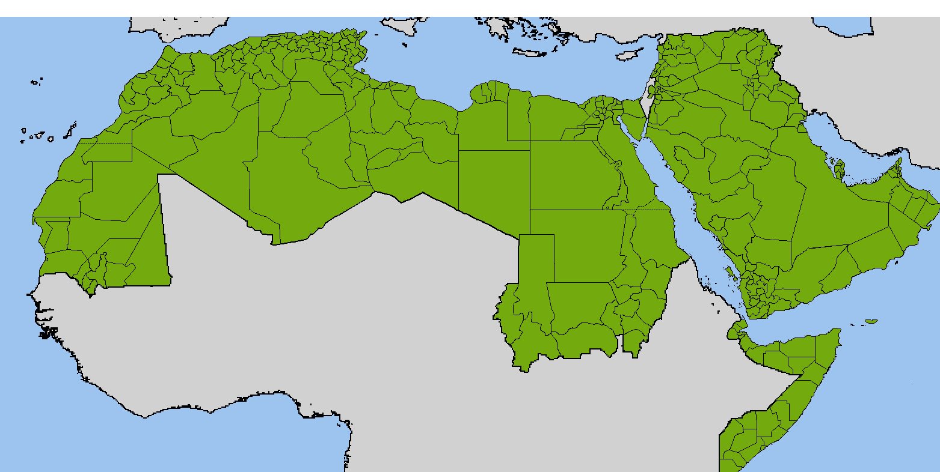
- Map of Israel

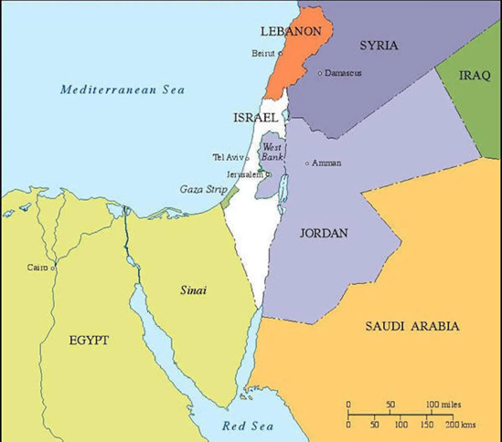
- Caesarea Phillipi

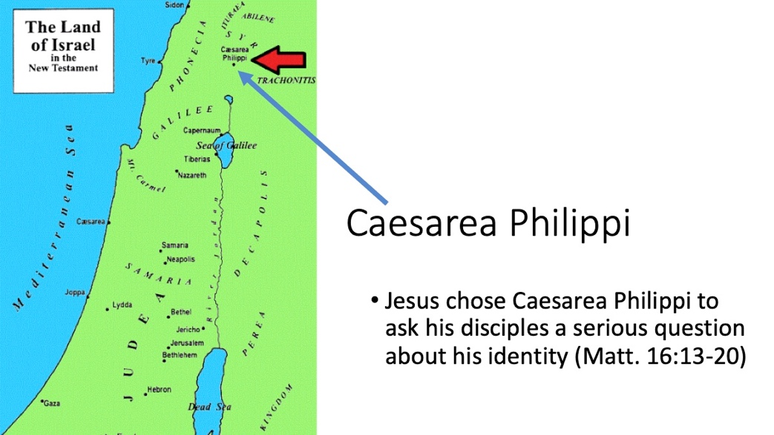

Matthew 16:13-14“When Jesus came to the region of Caesarea Philippi, he asked his disciples, “Who do people say the Son of Man is?”
¹⁴ They replied, “Some say John the Baptist; others say Elijah; and still others, Jeremiah or one of the prophets.”
When the disciples said; “Some say John the Baptist.” This was remarkable not only because John had already been beheaded, but because Herod himself had spread the rumor that Jesus was John come back from the dead (see Matthew 14:1–2).
John and Jesus preached the same fiery message of repentance, confronted corrupt leaders, and carried the same unmistakable authority from God. So even though John was dead, many people—superstitious, fearful, and spiritually confused—thought that perhaps Jesus must be John resurrected, returning with even greater power.
Others said He was Elijah, and this guess made more sense from a biblical standpoint. Israel had long expected Elijah to return before the Messiah’s arrival.
Malachi 4:5 (the last verses of the Old Testament), “Behold, I will send you Elijah the prophet before the coming of the great and awesome Day of the LORD.”
John the Baptist fulfilled this prophecy when he came to prepare the way of the Lord;
Luke 1:17 (John the Baptist would go forth); “in the spirit and power of Elijah.”
Matt 11:14 “if you are willing to accept it, he is the Elijah who was to come.”
Then Jesus asked them the big question…
Matthew 16:15-16 “But what about you?” he asked. “Who do you say I am?”
¹⁶ Simon Peter answered, “You are the Messiah, the Son of the living God.”
This is such an important moment in the entire journey of Jesus and the Apostles. Peter spoke a truth that, although it was prophesied about Jesus long ago, had not been publicly professed by any of the Apostles up until now. They knew He was sent by God, a prophet, a teacher (rabbi), and a miracle worker. But the idea that He was THE Messiah, THE son of the Living God, had not yet been revealed to any of them.
When Jesus heard Peter proclaim; “You are the Messiah, the Son of the living God.”, He got very excited and immediately rejoiced, praising Peter for receiving this revelation, and celebrating the fact that they were finally hearing directly from God!
Matthew 16:17“Jesus replied, “Blessed are you, Simon son of Jonah, for this was not revealed to you by flesh and blood, but by my Father in heaven.”
In other words, He didn’t learn this from someone else, he got a direct download from God!
Matthew 16:18-19 “And I tell you that you are Peter, and on this rock I will build my church, and the gates of Hades will not overcome it. ¹⁹ I will give you the keys of the kingdom of heaven; whatever you bind on earth will be bound in heaven, and whatever you loose on earth will be loosed in heaven.”
Jesus told Simon that he would be called “Peter” (which means rock), “On this rock I will build My church,” meaning that the church would be built not on him personally, but on the truth Peter had just declared—that Jesus is the Messiah, the son of the Living God. Peter became the first to preach the gospel after the resurrection, the first to open the kingdom to both Jews and Gentiles, and God worked miracles (including a resurrection) through him as confirmation of that calling.
When Jesus said, “the gates of Hades will not overcome it,” He meant that death and the powers of evil could never destroy the church He was building. And when He promised the “keys of the kingdom” and the authority to “bind” and “loose,” He was giving Peter—and later all the apostles—the responsibility to teach, declare, and apply God’s truth with power on earth just as it is in heaven.
Matthew 16:20 “Then he ordered his disciples not to tell anyone that he was the Messiah.”
Why? This is because He knew that when word got out about this, it would expedite His death at the hands of the Pharisees. He wanted to wait until Passover for that to take place.

Jesus reveals the deeper plan of the cross and resurrection
Matthew 16:21 “From that time on Jesus began to explain to his disciples that he must go to Jerusalem and suffer many things at the hands of the elders, the chief priests and the teachers of the law, and that he must be killed and on the third day be raised to life.”
Jesus was so excited that they were getting direct downloads of truth from Heaven, that he felt they were ready to be exposed to the deeper plan of what must come about. He told them that He must;
- go to Jerusalem
- suffer many things at the hands of the elders, the chief priests and the teachers of the law,
- that he must be killed
- on the third day be raised to life.
This was much different than what they were likely expecting a Messiah to say. They wanted Him to god to Jerusalem, restore the powerful throne of David, Kick out the Herods and the Romans and rule the world. Instead he was elaborating on suffering and being killed. (Peter didn’t like that!)
Matthew 16:22 “Peter took him aside and began to rebuke him. “Never, Lord!” he said. “This shall never happen to you!”
(Note: It’s never a good idea to rebuke Jesus for anything.)
Matthew 16:23 “Jesus turned and said to Peter, “Get behind me, Satan! You are a stumbling block to me; you do not have in mind the concerns of God, but merely human concerns.”
Peter went from being “Elated” by Jesus praising him a few seconds ago, to “Deflated by being chastised by Jesus and called Satan.” (Elated – to – Deflated).
Why was Jesus so harsh on Peter?
Because what He put forth in the plan He revealed to them, was that He was about to do the most important thing anyone has ever done in the entire history of the Universe. Jesus told them he was about to die and rise again.
Peter tried to block Him from doing that, so Jesus chastised him for it.
Peter was simply looking at things not from God’s perspective, but from merely man’s perspective.
Jesus was showing them that He is willing to deny Himself, and lose His life for the sake of God’s kingdom, and that each of them must do the same.
Matthew 16:24-28 “Then Jesus said to his disciples, “Whoever wants to be my disciple must deny themselves and take up their cross and follow me. ²⁵ For whoever wants to save their life will lose it, but whoever loses their life for me will find it. ²⁶ What good will it be for someone to gain the whole world, yet forfeit their soul? Or what can anyone give in exchange for their soul? ²⁷ For the Son of Man is going to come in his Father’s glory with his angels, and then he will reward each person according to what they have done. ²⁸ “Truly I tell you, some who are standing here will not taste death before they see the Son of Man coming in his kingdom.” <>
This is a warning that we can all come away with. Sometimes we try to preserve ourselves, or try to gain all we can in the world, and ignore God’s will for our lives. We can easily become just Peter, of who Jesus said; “you do not have in mind the concerns of God, but merely human concerns.”
We have to be willing to allow Jesus to ask US the same question He asked Peter,
“But what about you?” he asked. “Who do you say I am?”
and allow the answer to come not from “flesh and blood”, but by our Father in Heaven.
God is not just a means to an end who helps us attain our selfish goals, or achieve our personal agenda. He is not a “Santa Claus” or a “genie in a bottle” that we can use to gain everything we want in the whole world.
He is the God of the Universe, the Creator of Heaven and Earth.
But He also is the God who loves us;
- The God who Provides for us!
- The God who Protects us!
- The God who Heals us!
- The God who Redeems us!
- The God who Saves us!
And the God who is our Heavenly Father and knows each of us by name.
If you are stuck on a preconceived, or inaccurate view of who God is, ask Him to reveal Himself to you and show you who he is, and what He wants to do in your life. Then be willing to take up your cross and follow Him.
Remember He is a God who Loves us and sent His son to die for us!
He tells us;

Jeremiah 31:3 “I have loved you with an everlasting love; I have drawn you with unfailing kindness.”

Then shows us;
Romans 5:8 “But God demonstrates His own love for us in this: While we were still sinners, Christ died for us.”

