The Hebrew Roots of Christianity - Part 2

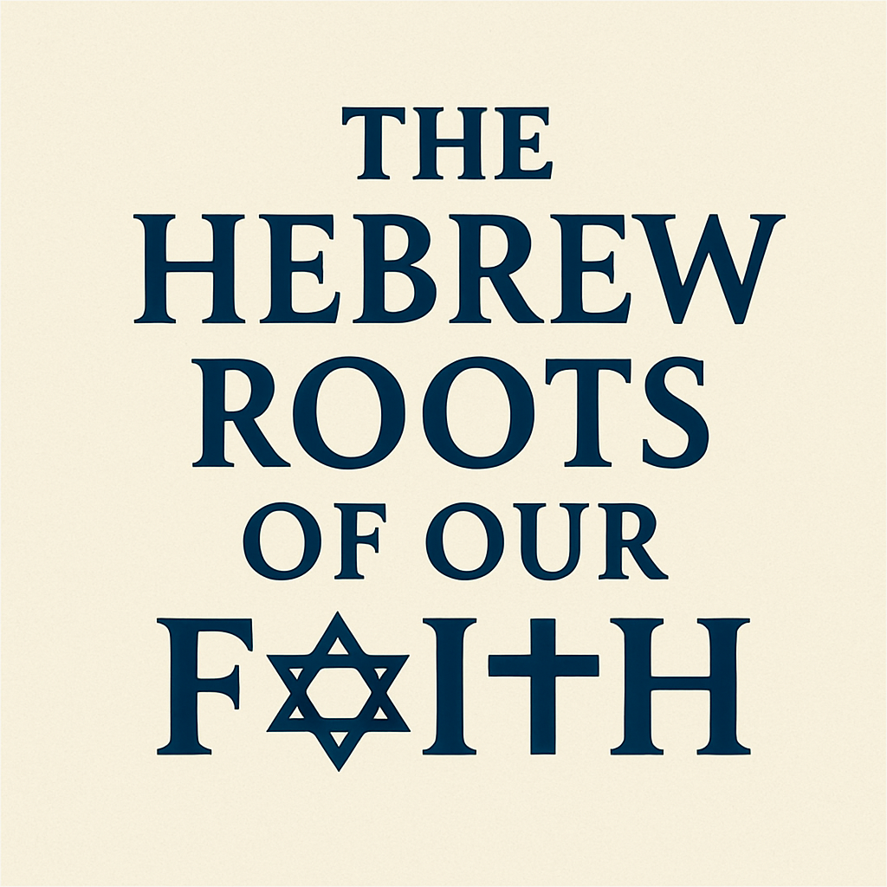

The entire Bible, and our Faith is built upon a formidable foundation of Hebrew Roots. All of the Patriarchs and Prophets, every Word and story, and each person listed in the Hebrew Scriptures is an important part of what we call “Christianity”.

Studying “Hebrew Roots” is the most thorough way to understand both the New Testament (Brit Hadasha), and the Old Testament (The Tanakh, or Hebrew Scriptures).

As a student of the Bible, it’s like a mechanic looking under the hood or chassis of a car, and not just the body and interior.

In our study we will explore the Hebrew roots of our faith from both a New Testament and Old Testament perspective. We will look at the Jewishness of Jesus, the apostles, and the 1st century church. We will see how Jesus fulfilled all the Hebrew prophecies having to do with Messiah, and became the light of the World, so that ALL People can be reconciled into relationship with God through Him.

Previous Session: The Jewishness of Jesus the Messiah - “Yeshua HaMashiach”

By calling him “Jesus Christ” (Messiah), we affirm that Jesus is the “Son of God”, “THE Lord”, “the Savior”, and “THE Messiah”. He fulfilled ALL the Hebrew Messianic prophecies that were expected of Messiah. Things He said, Who He was, what He did, one-by-one checking off the criteria that the scripture required of Messiah. The only way He could be who He is, and His death and Resurrection could have any meaning, is if He was first and foremost – The Jewish Messiah!
Hebrew Lesson:
"Kumi ori, ki va orech”

Isaiah 60:1 "Arise, shine, for your light has come,

We’ve already studied the Jewishness of Jesus, highlighting how He himself was born and raised in an observant Jewish home and how He fulfilled all the requirements of being the Jewish Messiah, from the Hebrew Scriptures.

What about His apostles, and the Early Church?
“The early Church was not birthed as a Gentile institution but grew out of Jewish soil, with Jewish believers, worshipping the Jewish Messiah.” Chuck Smith, (Foundations of the Word)
- THE APOSTLES

What about the apostles? Were they a diverse group of believers from all walks of life?
No, they were all Jewish men like Jesus, of similar age and geographic location (Galilee);
Just as Jesus was not just a random person of no specific race or creed, neither were His Twelve Apostles. Each one was a Jewish young man who grew up in a Torah-observant household, observing the feasts, and awaiting the Messiah.
Apostle’s Names and Identities:

- Peter (Shimon Kepha) – Galilean fisherman, Torah-observant Jew, leader among the apostles.
“Surely not, Lord!” Peter replied. “I have never eaten anything impure or unclean” Acts 10

- James (Yaakov) – Son of Zebedee Brother of John, called “James the Just” for his devout observance of the Law. (Not James Jesus’ half-brother, he came after this James was killed by Herod in Acts 12.)

- John (Yochanan) – Son of Zebedee, brother of James, observant Jew, author of the Gospel and Revelation, close to the Temple culture.

- Andrew (Andreas) – Brother of Peter, likely studied under “John the Baptist” (who was possibly an Essene Jew); devout Jew from Galilee.

- Philip (Philippos) – Greek name but very Jewish (John 1:45–46 to Nathaniel “We have found the one whom Moses wrote about…”); familiar with Torah.

- Bartholomew (Nathanael) – Called “an Israelite indeed” by Jesus (John 1:47).

- Matthew (Levi) – A tax collector, but identified by his Hebrew “priestly” name; left profession to follow Jesus.

- Thomas (Toma) – Name rooted in Aramaic/Hebrew, called “Didymus” (twin); devout Jew. The first person recorded in Scripture to say, "My Lord and my God!"

- James the Less – Son of Alphaeus, traditional Jewish identity.

- Simon the Zealot – Member of a Jewish nationalist movement before following Jesus.

- Thaddeus (Judas son of James) – A disciple with traditional Jewish roots.

- Judas Iscariot – Also a Jew from Judah; his betrayal does not negate his Jewishness.

THE APOSTLES AFTER THE ASCENSION when Jesus left them:
After Jesus ascended in Acts 1, the apostles were gathered together in Jerusalem as He had told them.
Acts 1:4 “He gave them this command: ‘Do not leave Jerusalem, but wait for the gift my Father promised, which you have heard me speak about.’”
In Acts chapter 2, “it happened”, the Holy Spirit was poured out at Pentecost, the Hebrew holiday of Shavuot that celebrates “the giving of the law”.

Pentecost = 50 days
Shavuot 7 weeks / “Feast of Weeks”

In the Bible: 50 days from the Sabbath following Passover (7 Sabbaths or weeks)
In the Christian Religion: 50 days after Easter (counting the Omer…….)

The Biblical Feasts: (Lev 23)
- Pesach, (Passover)
- Unleavened Bread,
- First fruits,
- Shavuot, (Pentecost)
- Rosh Hashanah ,
- Yom Kippur,
- Succoth (Feast of Tabernacles)

Why were they celebrating a Hebrew Feast AFTER Jesus came and fulfilled the law?
Didn’t the early church “Jettison their Jewishness” after becoming followers of Jesus?

No, they were all in Jerusalem for Pentecost (Shavuot), In fact that’s why they were there, because all Jewish men were required to be there each year for the holiday under Jewish law.
This one was different, however. The Holy Spirit fell in a powerful way on this particular annual Pentecost (Shavuot) celebration, and they were filled with power and boldness!

Select Verses from Acts 2:

Acts 2:1-4 “When the day of Pentecost came, they were all together in one place. ² Suddenly a sound like the blowing of a violent wind came from heaven and filled the whole house where they were sitting. ³ They saw what seemed to be tongues of fire that separated and came to rest on each of them. ⁴ All of them were filled with the Holy Spirit and began to speak in other tongues^{[a]} as the Spirit enabled them.”

Acts 2:5 “Now there were staying in Jerusalem God-fearing Jews from every nation under heaven.”

Acts 2:14 “Then Peter stood up with the Eleven, raised his voice and addressed the crowd: ‘Fellow Jews and all of you who live in Jerusalem, let me explain this to you; listen carefully to what I say.’”

Acts 2:22–24 “Fellow Israelites, listen to this: Jesus of Nazareth was a man accredited by God to you by miracles, wonders and signs...
This man was handed over to you by God’s deliberate plan... and you, with the help of wicked men, put him to death... But God raised him from the dead...”

Acts 2:36 “Therefore let all Israel be assured of this: God has made this Jesus, whom you crucified, both Lord and Messiah.”

Acts 2:37 “When the people heard this, they were cut to the heart and said to Peter and the other apostles, ‘Brothers, what shall we do?’”

Acts 2:38 “Peter replied, ‘Repent and be baptized, every one of you, in the name of Jesus Christ for the forgiveness of your sins. And you will receive the gift of the Holy Spirit.’” [Ruach HaKodesh – Holy Spirit]

Acts 2:41 “Those who accepted his message were baptized, and about three thousand were added to their number that day.”

After Pentecost, instead of doing away with their Jewishness and starting a separate religion (called Christianity). They continued in their Jewishness having the completion of Messiah and the fulfillment of prophecy (Joel 2) upon them.
In fact, the first thing they did in the chapter after Pentecost (Acts 2), is go right back to the temple to pray, as they normally would (Acts 3)

Acts 3:1-2 “One day Peter and John were going up to the temple at the time of prayer—at three in the afternoon. ² Now a man who was lame from birth was being carried to the temple gate called Beautiful, where he was put every day to beg from those going into the temple courts...”
Even as the church began to grow and expand, and the well-known Pharisee named Saul of Tarsus became a follower of Jesus and a leader in the church, they STILL were considered a “sect” of Judaism.

(I think if you got in a time-machine and were able to go back to the 1st century to visit the Apostles, to fellowship with them and see what they were like Peter, James, John, Matthew, even Paul, you would come back and say, “they were very very “Jewish”! Because they were!)

Here’s what they did AFTER receiving the Holy Spirit at Pentecost.
- Acts 2:46 “Every day they continued to meet together in the temple courts.”
- Acts 18:21 “I must by all means keep this coming feast in Jerusalem; but I will return again to you, God willing.”
- Acts 20:6 “But we sailed from Philippi after the Feast of Unleavened Bread, and five days later joined the others at Troas.”
- Acts 20:16 “Paul had decided to sail past Ephesus… in order to be in Jerusalem for the day of Pentecost, if possible.”

The early church was a movement made up of Messianic Jews operating within Judaism. It was made up of predominantly ethnic Jews, which were recognized not as a new religion “Christianity” but as the Nazarenes Sect of Judaism.

PAUL
Saul of Tarsus, later known as Paul, was a devout Pharisee, a Hebrew of Hebrews from the tribe of Benjamin. He saw the early followers of Yeshua as a dangerous sect, and he was determined to stamp it out. With the full authority of the high priest, he set out for Damascus to arrest believers there.

But on his way, he had an encounter with Jesus;

Acts 9:3-5 “As he neared Damascus on his journey, suddenly a light from heaven flashed around him. 4 He fell to the ground and heard a voice say to him, “Saul, Saul, why do you persecute me?” 5 “Who are you, Lord?” Saul asked. “I am Jesus, whom you are persecuting,” he replied.”

He immediately became an ardent follower of Jesus, and leader in the early church!
Toward the end of Acts, when Paul was arrested in Jerusalem, Tertullis, the lawyer for the High Priest Ananias who was bringing charges against Paul, was speaking to Felix the Roman Governor? He was trying to explain who Paul was, and describe the movement of believers in Jesus, he called them “A sect of Judaism”, which is what it started out as, long before it was called Christianity.

Acts 24:5 "We have found this man to be a troublemaker, stirring up riots among the Jews all over the world. He is a ringleader of the Nazarene sect.”
This verse is late in Acts, but records one of the earliest understandings of how society regarded the first century church. They were called the “sect of the Nazarenes.” This term was used to describe followers of Jesus within Judaism — not outside of it. They were a recognized (though controversial) Jewish movement.
The early church was considered a “sect of Judaism”, they were not the only “sect” however, there were many diverse sects of Judaism in that time;
Here is a list of the popular Jewish sects at the time of Jesus, and the Early Church;
1. Pharisees
Beliefs: Torah plus oral tradition (later Mishnah); belief in resurrection, angels, and the afterlife.

2. Sadducees
Beliefs: Only Torah as authoritative; denied resurrection, angels, and spirits.

3. Essenes
Beliefs: Separatist, apocalyptic, purist community; awaited two Messiahs (priestly and kingly).

4. Zealots
Beliefs: Radical nationalism; believed in overthrowing Rome through violence.

5. Herodians
Beliefs: Politically supportive of Herod’s dynasty; Hellenized Jews loyal to Rome.

6. Hellenists
Identity: Greek-speaking Jews influenced by Greek culture and philosophy.

7. Gnostics
Beliefs: Secret knowledge (gnosis) leads to salvation; matter is evil, spirit is good.

And finally… “Us”;

8. Nazarenes – A new sect of thousands of Jews who believed Jesus of Nazareth was the Messiah. The early church was known as “Nazarenes”, this movement eventually became known as “Christians”.
Acts 11:26 “The disciples were called Christians first at Antioch.”
But that didn’t mean they “jettisoned one religion and began another one”.
“Christian”, which means “of the Christ”, and is the same as “Messianic” which means “of the Messiah”.
Remember: “Christ” (Greek) / “Messiah” (Hebrew) = Same word (I prefer Messiah)
It’s very clear that the men and woman of God in both the Old and New testament were all Torah-observant Jews who adhered to the law, and “kept the feasts”.
It’s very important, however, that we, like those early Jewish believers, know that we are under no obligation to keep the feasts or follow the Hebraic law in order to gain or secure our salvation.
Jesus told us that He came to Fulfill the law (not abolish the Law), and He offered us a New Covenant of grace through faith.
Matt 5:17 “Do not think that I have come to abolish the Law or the Prophets; I have not come to abolish them but to fulfill them.”

Jesus fulfilled the law through His death on the cross.
*** IMPORTANT*** Please understand that I, in no way teach that adherence or even observance of the law is required by the believer for salvation. I do, however, believe that there is great richness in understanding the Feasts of the Lord and the Hebrew foundation of our faith.
We see all throughout the New Testament that Jewish believers, while no longer bound by the law for forgiveness of their sins, continued to honor, observe and measure their seasons according to “Appointed Times”, known as “Hebrew Feasts”. (Passover, Feast of Tabernacles, etc. ...)

Yeshua HaMashiach—Jesus the Messiah—is not just the Savior of individuals; He is the ‘light of the world’ and fulfillment of every promise God made to Israel and to those who would come to the ‘light”- His Jewishness isn’t a side detail—it’s at the root of the Gospel. The promised plan always was However, that He would be a blessing to ALL the people of the earth, Jew and Gentile alike. That’s what Jesus did then, and offers now.

"Kumi ori, ki va orech”
Isaiah 60:1 "Arise, shine, for your light has come,

Full verse:

Isaiah 60:1-3 “Arise, shine; For your light has come! And the glory of the Lord is risen upon you. ² For behold, the darkness shall cover the earth, and deep darkness the people; But the Lord will arise over you, And His glory will be seen upon you.
³ Gentiles shall come to your light, And kings to the brightness of your rising.”

