The Hebrew Roots of Christianity - Part 1

_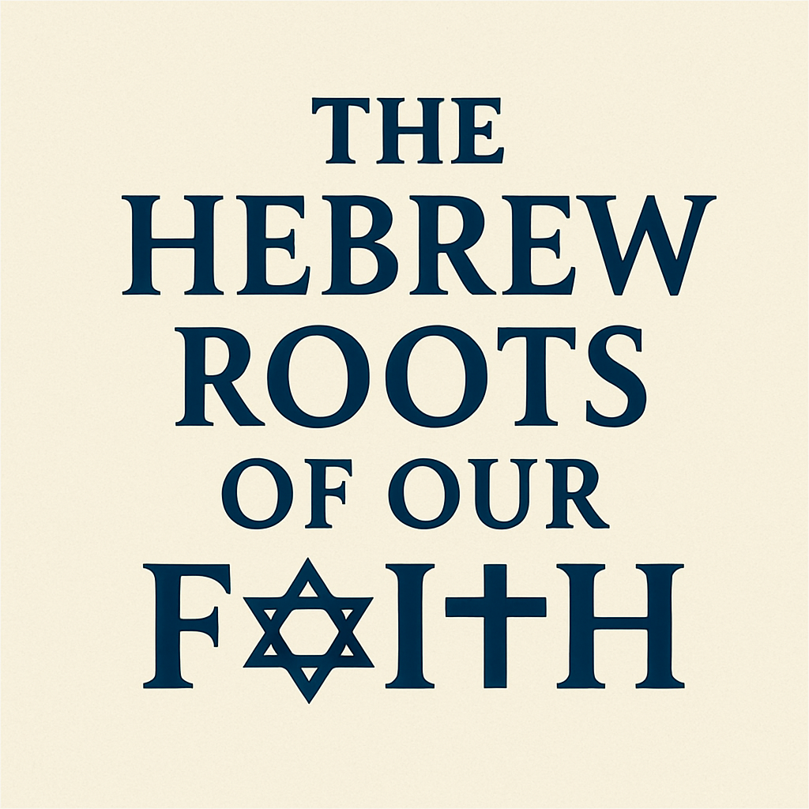_

The entire Bible, and our Faith is built upon a formidable foundation of Hebrew Roots. All of the Patriarchs and Prophets, every Word and story, and each person listed in the Hebrew Scriptures is an important part of what we call “Christianity”.

Studying “Hebrew Roots” is the most thorough way to understand both the New Testament (Brit Hadasha), and the Old Testament (The Tanakh, or Hebrew Scriptures).

As a student of the Bible, it’s like a mechanic looking under the hood or chassis of a car, and not just the body and interior.

It’s like an architect, or Structural Engineer looking at the foundation and infrastructure of a home and not just the walls, doors, and aesthetics.

Sadly many Christians, and even churches, ignore or disregard “Hebrew Roots” to their own peril. If you can imagine it’s like having a beautiful fruit-tree in your yard, but deciding to remove the roots, because they get in the way of the lawn or patio. The tree would not remain fruitful, and would probably not survive.

In our study we will explore the Hebrew roots of our faith from both a New Testament and Old Testament perspective. We will look at the Jewishness of Jesus, the apostles, and the 1st century church. We will see how Jesus fulfilled all the Hebrew prophecies having to do with Messiah, and became the light of the World, so that ALL People can be reconciled into relationship with God through Him.

HEBREW LESSON: “Yeshua HaMashiach”
The Hebrew name and title for “Jesus the Messiah” or “Jesus Christ” in English.

- The Jewishness of Jesus

If someone were to ask you who it is that you worship. You’d probably say “Jesus”.
If they ask why Him? What makes him so special? What did He do or say that makes you worship Him?

The answer can’t just be that;
- “He was a good man who died at the hands of evil men”
- “He cared about the needy and oppressed”
- “He was a 1st century peacemaker that stood up to the pharisees.”
- He was a “Radical Revolutionary” who just taught the world to “love one another”.
You would have to answer in theological terms like
…Because he is the “Son of God”, “The Lord”, or even “the Messiah”. You may even say that it’s because He died on the cross, or rose again, in fulfillment of scripture…
They may then ask “why is that important, and what Scripture” … then what would you say???

Sooner or later, you will have to come to explain the “HEBREW ROOTS OF CHRISTIANITY” to them. You’d need to be able to present the truth that all of Christianity is built upon the foundations of the Hebrew faith, and that everything we believe about Jesus is rooted in Judaism, and the promises given to the Children of Israel.

[Story: Atheist asked me what I believe and why? This person was Scandinavian, grew up with no religion, but was intelligent and studied “world religions” in college. When I told her I believe in the one true God, and that He sent His son Jesus to die for our sins, she said “Oh so your religion is based on Judaism!”. I said no, I’m Christian. She said that all the concepts I put forth are Jewish; “one true God”, the concept of sin, sacrifice for sins, etc., these are not Hindu, Buddhist, Muslim, or some indigenous tribal beliefs, these are all Jewish concepts. I said, Ok, yes, I’m Jewish…a completed Jew.
When my grandfather became a believer after 70 years of Judaism, He didn’t just say “I’m a Christian, he said “I’m a completed Jew”]

How about if someone asked you;

“If Jesus waited until our time period to come to earth, and live His life among us now instead of 2,000 years ago, where would He be born, and what would He be like?”

- Would He be born in one of the poorest areas of India, and life like Mahatma Ghandi?
- Would He be born in a war-torn oppressed African village, and rise up to bring them justice and freedom?
- Would He be born in America and live as a Hippie on a Hillside, leading a commune of people who spread “peace and love”?

The answer is pretty simple. He would be none of those things and people;
He would definitely be an Orthodox (adherent) Jew, who was born in Israel and lived His entire life traveling mostly between Jerusalem and Galilee.

How do we know this? Because if He was truly the Messiah, He would need to fulfill specific “Messianic Prophecies”, like ‘being born in Bethlehem, but hailing from Nazareth’. He would need to be from a Jewish family whose ancestry is from Judah. He would need to do much of His ministry in and around Jerusalem, and would need to be so entrenched in the strictest sect of Judaism, that every aspect of his Kosher lifestyle would be scrutinized and called into question.

The truth is that Jesus, and all of His apostles, were very very Jewish. They were not just nominally Jewish, or simply ethnically Jewish, they were “First Century Torah-observant (Orthodox) Jews” who worshiped and offered sacrifices at the actual Temple in Jerusalem. [Much like what we see in The Chosen, but probably moreso.]

By calling him “Jesus Christ”, we affirm that Jesus is the “Son of God”, “the Lord”, “the Savior”, and “the Messiah”. But how often do we consider that Jesus’ first and foremost identity was as the Jewish Messiah?

Understanding Jesus in His Jewish context doesn’t diminish His universality—it enhances it. It roots our faith in God’s covenant promises and shows that the New Testament is not a departure from the Old Testament, but its fulfillment.

- Jesus Is the Jewish Messiah - “Yeshua HaMashiach”

How many know that Christ is not Jesus’ last name. He didn’t have a last name; He was just Jesus of Nazareth.
Christ was His title and means “Messiah”.
“Christ” is the Greek-based version of the Hebrew-based word “Messiah”.
The word "Messiah" comes from the Hebrew word "Mashiach" (מָשִׁיחַ), which means "Anointed one."

So, when you use the name; “Jesus Christ”, you are saying that “Jesus is the long-awaited Hebrew Messiah, ‘The Anointed One’”, it’s the English version of the Greek “Jesu-Christos”, or the Hebrew “Yeshua Ha Mashiach”.
SO next time you say "Jesus Christ," know that you are saying "Jesus the Messiah"—Jesus, the “Anointed One – The Holy One of Israel”.

The concept of "Messiah" refers to Jewish prophecy which looked forward to a future ultimate "Anointed One"—a deliverer from the line of David who would restore Israel, bring justice, and usher in God's kingdom (see Isaiah 9:6–7, Jeremiah 23:5–6, Daniel 7:13–14).

Jesus fulfilled ALL the Messianic Prophecies that were written about Messiah, INCLUDING making a way for Gentiles “Non-Jews” to receive Him as Messiah as well.

From the moment Jesus was born He lived a typical Jewish life;
- He grew up as a Faithful son of Joseph and Mary in the Jewish community of Nazareth.
- Raised in a Kosher home,
- Celebrated all the Hebrew Feasts, (Including Chanukah)
- Was “Bar-Mitzva’d” in Jerusalem at age 12,

All along the way, he also did something else…He fulfilled ALL the Hebrew Messianic prophecies that were expected of Messiah. Things He said, Who He was, what He did, one-by-one checking off the criteria that the scripture required of Messiah.

Matt. 5:17 ““Do not think that I have come to abolish the Law or the Prophets; I have not come to abolish them but to fulfill them.”

Here are just some of the ways He did;

- 🔹 Born of a Virgin
Prophecy: Isaiah 7:14 – “The virgin will conceive and give birth to a son and will call him Immanuel.”

- 🔹 Born in Bethlehem
Prophecy: Micah 5:2 – “But you, Bethlehem Ephrathah... out of you will come for me one who will be ruler over Israel...”

- 🔹 From the Tribe of Judah
Prophecy: Genesis 49:10 – “The scepter will not depart from Judah... until he to whom it belongs shall come...”

- 🔹 Called Out of Egypt
Prophecy: Hosea 11:1 – “Out of Egypt I called my son.”

- 🔹 Preceded by a Messenger
Prophecy: Isaiah 40:3 – “A voice of one calling: ‘In the wilderness prepare the way for the LORD...’”

- 🔹 Ministry in Galilee
Prophecy: Isaiah 9:1–2 – “...in the future he will honor Galilee of the nations... The people walking in darkness have seen a great light...”

- 🔹 Entered Jerusalem on a Donkey
Prophecy: Zechariah 9:9 – “See, your king comes to you... riding on a donkey...”

- 🔹 Betrayed for 30 Pieces of Silver
Prophecy: Zechariah 11:12–13 – “...they paid me thirty pieces of silver... and threw them to the potter...”
- 🔹 Silent Before His Accusers
Prophecy: Isaiah 53:7 – “...he did not open his mouth...”

- 🔹 Pierced Hands and Feet
Prophecy: Psalm 22:16 – “They pierce my hands and my feet.”

- 🔹 Cast Lots for His Clothing
Prophecy: Psalm 22:18 – “They divide my clothes among them and cast lots for
- 🔹 Given Vinegar to Drink
Prophecy: Psalm 69:21 – “...they gave me vinegar for my thirst.”

- 🔹 None of His Bones Broken
Prophecy: Psalm 34:20 – “...he protects all his bones, not one of them will be broken.”

- 🔹 Buried in a Rich Man’s Tomb
Prophecy: Isaiah 53:9 – “He was assigned a grave with the wicked, and with the rich in his death...”

- 🔹 Resurrection from the Dead
Prophecy: Psalm 16:10 – “...you will not abandon me to the realm of the dead, nor will you let your faithful one see decay.”

- Jesus Lived and Ministered as “a Jew”

Jesus was very Jewish, as were ALL his apostles. Not only was he Jewish, but he was such an fully-adherent (Orthodox) Jew that:

- He was called upon to speak in the synagogue (Luke 4)

Luke 4:16–21 “16 He went to Nazareth, where he had been brought up, and on the Sabbath day he went into the synagogue, as was his custom. He stood up to read, 17 and the scroll of the prophet Isaiah was handed to him. Unrolling it, he found the place where it is written: 18 “The Spirit of the Lord is on me, because he has anointed me to proclaim good news to the poor. He has sent me to proclaim freedom for the prisoners and recovery of sight for the blind, to set the oppressed free, 19 to proclaim the year of the Lord’s favor.” 20 Then he rolled up the scroll, gave it back to the attendant and sat down. The eyes of everyone in the synagogue were fastened on him. 21 He began by saying to them, “Today this scripture is fulfilled in your hearing.”
- Jesus is in His hometown synagogue in Nazareth, where He had grown up.
- He reads from Isaiah 61, a messianic prophecy that spoke of the anointed one who would bring liberation, healing, and hope.
- Then He declares something stunning: “Today this scripture is fulfilled in your hearing.”
— In other words, “I am the one Isaiah was talking about.”

- He was called “Rabbi whom God has sent to teach us” by a well-known Pharisee (Nicodemus in John 3 - “Nic at Night”)

John 3:1–2 “Now there was a Pharisee, a man named Nicodemus who was a member of the Jewish ruling council. He came to Jesus at night and said, “Rabbi, we know that you are a teacher who has come from God. For no one could perform the signs you are doing if God were not with him.”
- "Rabbi": Nicodemus, a leader among the Jews, addresses Jesus with respect, using the Jewish term for teacher or master, showing that Jesus was seen as a legitimate religious authority—even by some Pharisees.
- "We know...": This implies that others among the religious leaders recognized that Jesus’ teaching and miracles were divinely empowered, even if they didn’t publicly admit it.
- "A teacher who has come from God": Nicodemus acknowledges that Jesus is more than just wise—He is divinely sent, fulfilling prophecies such as
Deuteronomy 18:15 “The Lord your God will raise up for you a prophet like me from among you...”
- "For no one could perform the signs...": This confirms that Jesus’ miracles were seen as evidence of God's presence and favor (see John 2:23)
Nicodemus' words in John 3:2 reveal that Jesus was widely recognized, even by Jewish leaders, as a divinely sent teacher (Rabbi)—not just a miracle worker, but someone with authority from God. His teaching and signs pointed unmistakably to His Messianic role.
- He was NOT a “Mumar” (one who forsakes the Jewish law). After he was arrested, the chief priests and the whole Sanhedrin tried to find any fault with him or His adherence to Jewish law and found nothing.

Mark 14:55–59 “The chief priests and the whole Sanhedrin were looking for evidence against Jesus so that they could put him to death, but they did not find any. Many testified falsely against him, but their statements did not agree. Then some stood up and gave this false testimony against him: “We heard him say, ‘I will destroy this temple made with human hands and in three days will build another, not made with hands.’” Yet even then their testimony did not agree.”

They arrested him anyone and sentenced Him to His death on a Roman cross.

His last Supper was a Passover Seder

Jesus was a fully adherent Jew, celebrated all of the Hebrew Feasts including Passover. His “Last Supper” was actually a Passover Seder (the ceremonial meal celebrated on Passover).

This one was different. This time he added new meaning to the “Bread and the wine”
Luke 22:14-20 “14 When the hour had come, Jesus reclined at the table with His apostles. 15 And He said to them, “I have eagerly desired to eat this Passover with you before My suffering. 16 For I tell you that I will not eat it again until it is fulfilled in the kingdom of God.”17 After taking the cup, He gave thanks and said, “Take this and divide it among yourselves. 18 For I tell you that I will not drink of the fruit of the vine from now on until the kingdom of God comes.” 19 And He took the bread, gave thanks and broke it, and gave it to them, saying, “This is My body, given for you; do this in remembrance of Me.” 20 In the same way, after supper He took the cup, saying, “This cup is the new covenant in My blood, which is poured out for you.”
He took the cup and gave thanks, gave it to his disciples and aid, this cup is the New Covenant of my blood which is shed for you and for all men for forgiveness of sins. In so often as you take this bread, and take this cup, do it in remembrance of me…

With that, he shared the “Cup of Redemption” with his disciples, the very next day, He died on the cross for the sins of the world.
Jesus death on the Cross brought us eternal life, ONLY because He was truly the Messiah, the Holy One of Israel. If He wasn’t, we’d still be lost in our sins. <>

