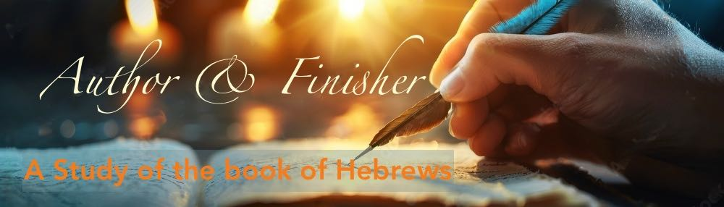

HEBREWS 9 – “More Perfect Tabernacle”

We recently visited the historic site of the revolutionary war encampment Jockey Hollow in Morristown. This was the site where 10,000 troops endured one of the harshest winters in history with primitive shelter, little to no food supply, and very little clothing and shoes. In fact it is said that when they began to starve they boiled their shoes and ate the shoe leather. They’d rather walk in the snow and ice barefoot than die of starvation. The most common medical procedure was barbaric amputation, which was done in cases of frostbite, infection, or gunshots wounds.

It was a time when New Jersey was under constant siege from the British, and all able-bodied men were required to enlist in the militia. Many died from starvation, the harsh elements, or were killed in battle. Being an American then required an enormous amount of hardship and sacrifice, but that was the price they had to pay, in order to live in freedom.

It’s hard to imagine that as Americans living in New Jersey in the modern world because we just don’t live like that anymore. (Not that we don’t experience hardships; taxes, crowded supermarkets, and traffic on the turnpike and parkway, especially 287 around Morristown). This is nothing compared to the way life was for those who went before us.
[Why am I telling you this?]
---
In Hebrews 9, the author describes the process that was in place to cover sins in the time of the First Covenant and the Tabernacle, (and later the Temple which replaced it.) It was difficult, detailed and complex, and always required blood. Sins could not be atoned for without the High Priest sacrificing certain animals, and performing specific rituals involving altars, ceremonial washings, and the presence of the Ark of the Covenant in the Most Holy Place.

As Christians in the modern world, we tend not to think about these things, and in many cases, don’t even know too much about them. But for those who went before us, it was the only manner with which to worship, and draw near to God. This is because we have been introduced to Jesus the Messiah in the time of the New Covenant, and after the atonement He made by His blood on the cross. We have no need to apply the methods and ordinances of the Old Covenant to the salvation given to us freely by grace through faith, but as God-followers, it’s important to have a general understanding of them.
For instance, if someone were to ask us “who it is we worship”, we’d quickly and accurately say “Jesus!”
If they asked us why? We may say it’s because; He is the Lord, He is the son of God, or because He died and rose again. You may even say that He is the “Messiah” (Christ).

All those answers would be absolutely correct. But if they went on to ask you, “Why is that so important?” You would have to reach back, and respond with an answer that says something like;
Well…“He fulfilled all the required Messianic criteria of the Old Testament prophecies, and by His sacrifice on the cross, He entered the Most Holy Place once for all by his own blood, thus obtaining eternal redemption.”

That may seem like a lot to remember, but it’s the foundation of our faith. This is what this chapter in Hebrews is about.

This is also what we proclaim each time we take communion. Communion is a simple way of proclaiming the importance of His death until He comes.

Hebrews 9:1-5 Now the first covenant had regulations for worship and also an earthly sanctuary. ² A tabernacle was set up. In its first room were the lampstand and the table with its consecrated bread; this was called the Holy Place. ³ Behind the second curtain was a room called the Most Holy Place, ⁴ which had the golden altar of incense and the gold-covered ark of the covenant. This ark contained the gold jar of manna, Aaron’s staff that had budded, and the stone tablets of the covenant. ⁵ Above the ark were the cherubim of the Glory, overshadowing the atonement cover. But we cannot discuss these things in detail now.”

(Let’s discuss them…)

The author is briefly describing the Tabernacle that was built during the time of Moses. The instructions for building the tabernacle were elaborate and extraordinarily detailed, and take up the final 16 chapters of Exodus. (compared to the creation of the world and mankind which takes up only 2 chapters.)

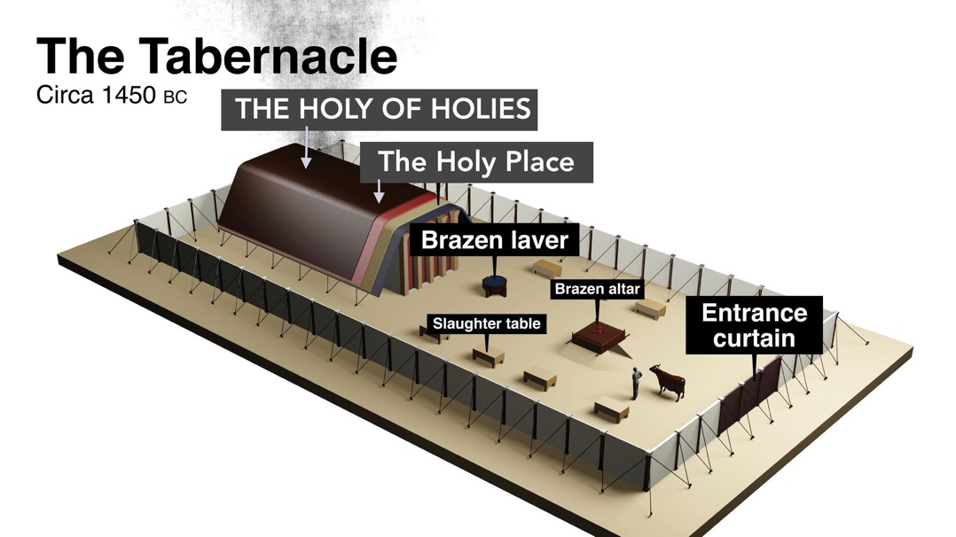

- Entrance Curtain – Entry point into the outer court.
- Brazen Altar – Also called the Altar of Burnt offering. First thing you’d encounter in the tabernacle. Made of acacia wood overlaid with bronze, It had horns on each corner and was used for burnt sacrifices.
- Slaughter Table – Used to sacrifice and butcher animals for various offerings (burnt, peace, sin, guilt).
- Brazen Laver – A bronze wash basin for ritual washing of hands (and feet).
- The Holy Place – First room entered by priests. It contained the Golden Lampstand (Menorah), Table of Showbread, and Golden Altar of Incense.

- THE HOLY OF HOLIES – Separated by a very thick “Veil” (heavy curtain). Only the High priest could enter, once a year on Yom Kippur (Day of Atonement).
  - In it was “The Ark of the Covenant” (Where God’s presence dwelled):
The Ark contained:
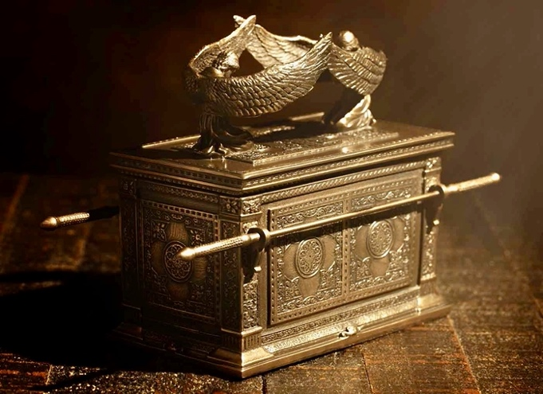

- Two golden Cherubim on the top of what is called the “mercy seat”.
Inside:
  - The gold jar of manna,
  - Aaron’s staff that had budded,
  - The stone tablets of the covenant

The author then describes how the priests would go about their duties within the tabernacle.

Hebrews 9:6-10 ^{“6} When everything had been arranged like this, the priests entered regularly into the outer room to carry on their ministry. ⁷ But only the high priest entered the inner room, and that only once a year, and never without blood, which he offered for himself and for the sins the people had committed in ignorance. ⁸ The Holy Spirit was showing by this that the way into the Most Holy Place had not yet been disclosed as long as the first tabernacle was still functioning.
⁹ This is an illustration for the present time, indicating that the gifts and sacrifices being offered were not able to clear the conscience of the worshiper. ¹⁰ They are only a matter of food and drink and various ceremonial washings—external regulations applying until the time of the new order.”

The Bible tells us that the High Priest would sprinkle blood on the Mercy Seat atop the Ark of the Covenant, once a year on Yom Kippur. The entire process of sacrifice, blood, and atonement did not completely remove the sins of the people, they only covered them. They did not “clear the conscience of the worshiper”. Forgiveness and cleansing of sin could only be done through the blood of Jesus.

Hebrews 10:1-4 “The law is only a shadow of the good things that are coming—not the realities themselves. For this reason it can never, by the same sacrifices repeated endlessly year after year, make perfect those who draw near to worship. ² Otherwise, would they not have stopped being offered? For the worshipers would have been cleansed once for all, and would no longer have felt guilty for their sins. ³ But those sacrifices are an annual reminder of sins. ⁴ It is impossible for the blood of bulls and goats to take away sins.”

The tabernacle, and even the Temple that came later, were “inferior and imperfect”, and only a shadow of the “more perfect tabernacle” that was to become reality through Jesus.

Hebrews 9:11-15 “But when Christ came as high priest of the good things that are now already here, he went through the greater and more perfect tabernacle that is not made with human hands, that is to say, is not a part of this creation. ¹² He did not enter by means of the blood of goats and calves; but he entered the Most Holy Place once for all by his own blood, thus obtaining eternal redemption. ¹³ The blood of goats and bulls and the ashes of a heifer sprinkled on those who are ceremonially unclean sanctify them so that they are outwardly clean. ¹⁴ How much more, then, will the blood of Christ, who through the eternal Spirit offered himself unblemished to God, cleanse our consciences from acts that lead to death, so that we may serve the living God! ¹⁵ For this reason Christ is the mediator of a new covenant, that those who are called may receive the promised eternal inheritance—now that he has died as a ransom to set them free from the sins committed under the first covenant.”

Those sacrifices of the Old Covenant did nothing more than make someone “outwardly clean”, their guilt remained and their conscience was not clear. The sacrifices still needed to be made every year as a reminder of their sins.
Jesus’ blood, however, was a once-for-all sacrifice that not only grants us forgiveness, but cleanses us of all unrighteousness.

1st John 1:7 “…and the blood of Jesus, his Son, purifies us from all sin.”

1st John 1:9 “If we confess our sins, he is faithful and just and will forgive us our sins and purify us from all unrighteousness.”

In 1876 a Pastor in Plainfield, NJ wrote a hymn that he presented during the Country’s Centennial celebration (100 years), in Ocean Grove that summer. The message of the song was simple, that there is no possible way to have your sins forgiven other than through the blood of Jesus. No good works, no rituals, no sacraments,…nothing but the blood of Jesus:

- What can wash away my sin?
Nothing but the blood of Jesus;
What can make me whole again?
Nothing but the blood of Jesus.
  - Refrain:
Oh! precious is the flow
That makes me white as snow;
No other fount I know,
Nothing but the blood of Jesus.
- For my pardon, this I see,
Nothing but the blood of Jesus;
For my cleansing this my plea,
Nothing but the blood of Jesus.
- Nothing can for sin atone,
Nothing but the blood of Jesus;
Naught of good that I have done,
Nothing but the blood of Jesus.
- This is all my hope and peace,
Nothing but the blood of Jesus;
This is all my righteousness,
Nothing but the blood of Jesus.

Why blood?
Giving up one’s blood actually implies the death of someone or something because the life is in the blood. The writer uses the example of a “will”, it does not go into effect until the “testator” (person who gives a will) has died. The writer of Hebrews declares that; “without the shedding of blood there is no forgiveness.”
Hebrews 9:16-22 “In the case of a will, it is necessary to prove the death of the one who made it, ¹⁷ because a will is in force only when somebody has died; it never takes effect while the one who made it is living. ¹⁸ This is why even the first covenant was not put into effect without blood. ¹⁹ When Moses had proclaimed every command of the law to all the people, he took the blood of calves, together with water, scarlet wool and branches of hyssop, and sprinkled the scroll and all the people. ²⁰ He said, “This is the blood of the covenant, which God has commanded you to keep.” ²¹ In the same way, he sprinkled with the blood both the tabernacle and everything used in its ceremonies. ²² In fact, the law requires that nearly everything be cleansed with blood, and without the shedding of blood there is no forgiveness.”

He is quoting Exodus 25 and 26 when Moses had completed reading the Book of the Covenant and when God instructed him to begin work on the Tabernacle.

This earthly Tabernacle was intended as a copy and shadow of a true Tabernacle in Heaven itself. God instructed Moses to make all things in the tabernacle according to a pattern shown to him on the mountain. The earthly tabernacle served as a symbolic earthly representation of God's dwelling place in heaven where Jesus entered on our behalf.

Hebrews 9:23-27 “It was necessary, then, for the copies of the heavenly things to be purified with these sacrifices, but the heavenly things themselves with better sacrifices than these. ²⁴ For Christ did not enter a sanctuary made with human hands that was only a copy of the true one; he entered heaven itself, now to appear for us in God’s presence. ²⁵ Nor did he enter heaven to offer himself again and again, the way the high priest enters the Most Holy Place every year with blood that is not his own. ²⁶ Otherwise Christ would have had to suffer many times since the creation of the world. But he has appeared once for all at the culmination of the ages to do away with sin by the sacrifice of himself.”

Jesus died on a cross that was erected outside the city on a place called Golgotha. He did not need to die in the physical temple outer court, and have his blood placed on the mercy seat of the Ark of the Covenant. He did not enter a sanctuary made with human hands that was only a copy of the true one; He entered heaven itself, now to appear for us in God’s presence.

In fact an amazing event took place when Jesus died that created a strange resonance between the earthly temple and what was going on in the heavenlies.

Matthew 27:50-51a “When Jesus had cried out again in a loud voice, he gave up his spirit. At that moment the curtain of the temple was torn in two from top to bottom”.
The tearing of the veil at the moment of Jesus’ death was a sign that His sacrifice, the shedding of His own blood, was a sufficient atonement for sins. It signified that now the way into the Holy of Holies was open for all people, for all time. God does not dwell in a temple made with human hands

Acts 17:24 “The God who made the world and everything in it is the Lord of heaven and earth and does not live in temples built by human hands.”

When Jesus died on the cross, the Tabernacle was long gone and the Temple was rendered useless.

Ending:

Hebrews 9:27-28 “Just as people are destined to die once, and after that to face judgment, ²⁸ so Christ was sacrificed once to take away the sins of many; and he will appear a second time, not to bear sin, but to bring salvation to those who are waiting for him.” < >

Jesus’ death on the cross was the once for all sacrifice for sins. The significance of this is astounding. This means that anyone, anywhere, can come to God by faith and be cleansed of sin, made righteous, and assured the eternal reward of heaven, simply by believing, and receiving the free gift of God of eternal life, through the blood of Christ Jesus our Lord!

This is truly something to celebrate. And we do this as we remember Him in the bread and in the cup, as we take communion.

1st Cor. 11:25-26 “He took the cup, saying, “This cup is the new covenant in my blood; do this, whenever you drink it, in remembrance of me.” ²⁶ For whenever you eat this bread and drink this cup, you proclaim the Lord’s death until he comes.”

###

