

HEBREWS

Heb. 1:1 “God, who at various times and in various ways spoke in time past to the fathers by the prophets, 2 has in these last days spoken to us by His Son,”

Heb 2:1 “Therefore we must give the more earnest heed to the things we have heard, lest we drift away.”

Heb. 3:1 “Therefore, holy brothers and sisters, who share in the heavenly calling, fix your thoughts on Jesus, whom we acknowledge as our apostle and high priest.”
HEBREWS 4

HEBREWS 4:1 “Therefore, since the promise of entering his rest still stands, let us be careful that none of you be found to have fallen short of it. ² For we also have had the good news proclaimed to us, just as they did; but the message they heard was of no value to them, because they did not share the faith of those who obeyed.”

The author then begins “exegeting” (explaining and interpreting) certain scriptures from Psalms and Torah having to do with “rest”.

³ Now we who have believed enter that rest, just as God has said, “So I declared on oath in my anger, ‘They shall never enter my rest.’” ^{[Ps. 95:11]}
And yet His works have been finished since the creation of the world. ⁴ For ‘somewhere’ he has spoken about the seventh day in these words: “On the seventh day God rested from all his works.” ^{(Gen. 2:2)}
⁵ And again in the passage above he says, “They shall never enter my rest.”
⁶ Therefore since it still remains for some to enter that rest, and since those who formerly had the good news proclaimed to them did not go in because of their disobedience, ⁷ God again set a certain day, calling it “Today.” This he did when a long time later he spoke through David, as in the passage already quoted:
“Today, if you hear his voice, do not harden your hearts.”^{[Psalm 95:7,8]}

⁸ For if Joshua had given them rest, God would not have spoken later about another day. ⁹ There remains, then, a Sabbath-rest for the people of God; ¹⁰ for anyone who enters God’s rest also rests from their works, just as God did from his. ¹¹ Let us, therefore, make every effort to enter that rest, so that no one will perish by following their example of disobedience (v.6).”

REST
Greek – Katapausis (where we get the word “pause”)
Hebrew – Menuchah (root word Noach, meaning “rest”)

In this chapter the writer uses the word “Katapausis” (rest) eleven times, many of them are simply quoting Old Testament passages (translating the word, “Menuchah”).

The word “rest” in these verses describe the promised reward for the people of God, particularly the Children of Israel who crossed the desert for 40 years. They did not enter the “rest” of living in the land of Canaan because of disobedience (verse 6). Only Joshua, Caleb, and the generations that came from those who were slaves in Egypt.

The writer also points out that the people in his time (1500 years later), who reject the gospel and refuse to put their faith in Jesus the Messiah, will also not enter His rest because of unbelief (verses 2,3,).

“Rest” in this context is symbolic of heaven (R.I.P.), but that is a very limited understanding of the word. It more specifically denotes the place of completion that one arrives at after working, laboring, or travailing diligently. It isn’t just a pause, or a state of dormancy, or inactivity, it is more of a state of being who you are intended to be, doing what you are intended to do, in a place that has been prepared for you.

When the Children of Israel got to the Promised Land, they entered their “rest”, but their purposes as a nation was not over, it had just begun.

The same thing applies to when God completed his work on creating the world in six “days”, He “rested” after the work was done. That didn’t mean He stopped doing anything, it meant that He now actively enjoyed all that He made, and the people whom He created. His desire was for Adam and Eve and their descendants to enjoy this rest with Him. It was only after sin entered the world that the ground was cursed and required “toil” (work) to produce food, by the sweat of their brow. (Gen. 3:17-19)

Verse 9 used a different word for rest;

Heb. 4:9 “There remains, then, a Sabbath-rest for the people of God.”

The word here is (sabbatismos). This is connected to the word “Shabbat” which means The Sabbath, (the seventh day of the week), which is based on God’s seventh day rest at Creation, and meant to be a set time of rest to enjoy God and the people in our lives (particularly family). Orthodox Jews place extreme restrictions on this day, which in many ways keep them from fully enjoying it. Jesus, however, allowed Himself and the Apostles to do things that the Pharisees deemed forbidden on the Sabbath, enjoying the day as God intended, and when confronted with this he said;

Mark 2:27 “Then He said to them, “The Sabbath was made for man, not man for the Sabbath.”

The Sabbath was given to man by God as a time to rest, refresh and restore. Not as a day to place unnecessary heavy burdens upon them.

Heb 4:10 “for anyone who enters God’s rest also rests from their works, just as God did from His.”

“Entering God's rest” means ceasing from self-reliant works and trusting in God's finished work, mirroring God's rest after the creation of the world.

Here's a deeper look at the commentary:
- "For whoever has entered God's rest":
This refers to believers who have placed their faith in Jesus Christ and are experiencing the peace and assurance that comes from trusting in Him.
- "also rests from their works":
This doesn't mean ceasing from all activity, but rather ceasing from relying on personal efforts or works to earn God's favor or salvation.

That’s why Jesus tells us in Matthew 11;

Matt 11:28-29 “Come to me, all you who are weary and burdened, and I will give you rest. ²⁹ Take my yoke upon you and learn from me, for I am gentle and humble in heart, and you will find rest for your souls.”

Interestingly, a “yoke” is a “work harness” for beasts of burden. Yet He tells us to take His yoke upon us and we will find rest. This is because He does the work with us and for us, giving us rest for our souls.

Speaking of Souls… The very next verse is very important. It is the key verse that helps us understand the difference between the soul and the spirit:

Hebrews 4:12 “For the word of God is alive and active. Sharper than any double-edged sword, it penetrates even to dividing soul and spirit, joints and marrow; it judges the thoughts and attitudes of the heart.”

Hebrews 4:12 ^{NKJV} “For the word of God is living and powerful, and sharper than any two-edged sword, piercing even to the division of soul and spirit, and of joints and marrow and is a discerner of the thoughts and intents of the heart.”
This is the primary verse where we find the words soul and spirit mentioned together in the same sentence. This is where we begin to understand the difference between the two, and how the Word of God helps us divide them.
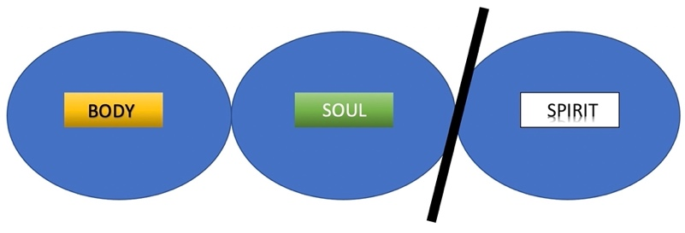
It seems at first glance, however, as though the author of Hebrews is suggesting that we are made up of not just two or three parts, but lists seven unique aspects, and that the Word of God is able to divide and discern between all of them. (joints, marrow, and thoughts, intents, and heart.)

Does that mean we are made up of all these parts, instead of just Body, Soul and Spirit?

What do all these terms mean, and what part of “us” are they?
As we study this closer, we see that each of the aspects listed in addition to soul and spirit are components or subcomponents of these two, OR are parts of the body.
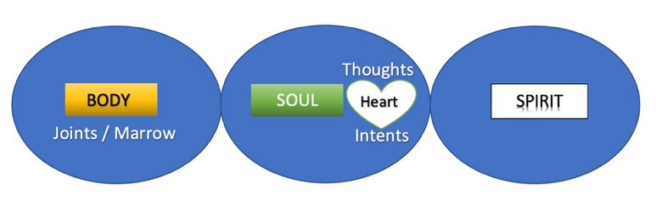

SOUL – The internal part of us that is made up of our mind and emotions. These often determine our will.

SPIRIT – The part that is made alive (regenerated) at rebirth and is created for us to “commune with God”

JOINTS – Part of the BODY. Referring to the bones and frame.
MARROW – Part of the BODY. Referring to the intricate workings of our physical design.

THOUGHTS – Part of the SOUL. Our minds and ideas.
INTENTS – Product of the SOUL. Our will and intentions.

HEART – Deepest part of the SOUL. Our deepest emotions, feelings, and innermost passions. Usually, our heart determines our will.

The author writes that the Word of God is effective in not only “piercing to the division of” the soul and spirit, but also the joints and marrow (parts of the body) as well. The phrase “piercing to the division of” obviously does not mean surgically dissecting the bones and marrow of a human body, but it is more closely related to the phrase “rightly dividing,” which Paul uses in 2nd Timothy 2:15 when he encourages Timothy to be faithful in “rightly dividing the word of truth.”

The Word of God, when correctly applied in every situation, will bring clarity, balance and wisdom in all things, especially those having to do with the soul and the spirit, but it actually effects the life of our physical bodies as well.

Romans 8:11 “He who raised Christ from the dead will also give life to your mortal bodies because of his Spirit who lives in you.”

The Word of God is effective in “rightly dividing” the soul and the spirit so that we can have a better understanding of all things, from God’s perspective.
The writer of Hebrews talks about this in the very next verse;

Hebrews 4:13 “Nothing in all creation is hidden from God’s sight. Everything is uncovered and laid bare before the eyes of him to whom we must give account.”

God knows EVERYTHING, and The Word of God teaches us all we need to know about it.

Hebrews 4:14-15 “Therefore, since we have a great high priest who has ascended into heaven, Jesus the Son of God, let us hold firmly to the faith we profess. ¹⁵ For we do not have a high priest who is unable to empathize with our weaknesses, but we have one who has been tempted in every way, just as we are—yet he did not sin.”

Once again the author of Hebrews refers to Jesus as our “Heavenly High Priest”. Jesus is ultimately the only one who can go before God on our behalf, and certainly the only one with the power to absolve us of sins, being both the High Priest and the sacrifice as well.

But what is beautiful about verse 15 is the “emphasis on His empathy”. The first part is a beautiful double negative;

Hebrew 4:15^{a “}For we do not have a high priest who is unable to empathize with our weaknesses…”

In other words we DO have a High Priest who is ABLE to empathize with our weaknesses. Jesus does not just sympathize with our feelings; he empathizes with them.
- sympathy simply means feeling compassion or pity for someone's situation.
- empathy is the ability to fully understand and feel someone else's feelings or experience yourself.
How is able to do that? The second half of verse 15 answers that…

Hebrew 4:15^{b “…}but we have one who has been tempted in every way, just as we are—yet he did not sin.”

Jesus understands the full weight of temptation. He was fully God, but also fully man. He knew the tempting, alluring, and enticing seduction of sin, even though He was always able to resist it.

The very first moments of His ministry, after He was baptized by John, He was led by the Spirit into the wilderness to be tempted by the Devil. He was faced with the three primary temptations of the world,

1st John 2:16 “For everything in the world—the lust of the flesh, the lust of the eyes, and the pride of life—comes not from the Father but from the world.”

- Lust of the flesh – He was fasting for 40 days and told to turn stones into bread.
- Lust of the eyes – He was shown and offered “all the kingdoms, and their splendor”
- Pride of life – He was taken to the highest point in the temple and told to jump off and let the angels catch you, (as Psalm 91 prophecies), in front of all the High Priests, the Pharisees, and the rest of the religious people who gather at the temple each day, so they would worship, fear, and revere Him.

Jesus resisted all of these, and any other temptation from the Devil His entire life. In doing so showed us two things;

- He showed us that all temptations can be overcome. We are not powerless against the Devil’s schemes.
- He understands just how hard it is, with these human bodies, with all of their cravings, urges, tendencies, and weaknesses to resist the temptations of the Devil.

That’s why He offers us such an abundance of both Grace and Mercy.

Grace – Blessings that we don’t deserve.
Mercy – Pardon from the punishment we do deserve.

Final verse;

Hebrews 4:16 “Let us then approach God’s throne of grace with confidence, so that we may receive mercy and find grace to help us in our time of need.” <>

Approaching the throne

In the time of Kings, one of the most dreadful fears was to be summoned to appear before the throne. It was very rarely good news, and would often result in punishment, imprisonment, or even death.

Here in this final verse of the chapter, we are being summoned to appear before the throne of God.

What do you envision when you think about God’s throne?
Is it a terrifying and intimidating picture of the Almighty seated in majesty among angels and elders, surrounded by clouds and fire?

This is normally what is portrayed in artwork depicting God’s throne;
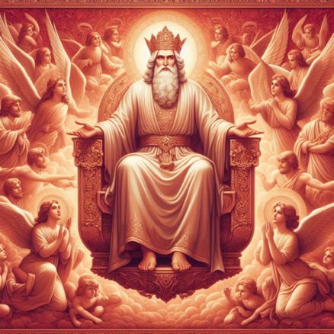
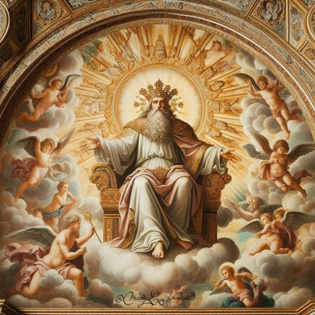


The truth is that we don’t know exactly what His throne looks like other that what we read on the Bible, with many descriptions of how He is “seated in majesty”, with angels and elders, and every living creature falling down before Him in worship.

But here in verse 16 we are offered a compassionate and empathetic invitation;

Heb. 4:16 “Let us come boldly to the throne of grace, that we may obtain mercy and find grace to help in time of need.”

Jesus knows our need for both Grace and Mercy, and invites is to come “boldly”, not cowardly or shamefully, to the throne of grace to receive mercy in time of need. When we approach His throne in humility, we offered complete forgiveness of our sins and invited to join in the heavenly worship service that continues day and night before the throne exalting the Lord most high! <>

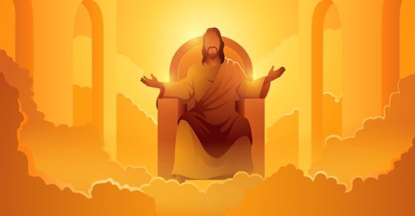

(graphic for final song)

