

HEBREWS

The book of Hebrews is the 19th book of the New Testament and the 58th book of the Bible. It's one the most interesting books in the Bible because more than any other book, it connects the foundational building blocks of the Hebrew Faith to Evangelical Doctrine.

It’s 13 chapters are filled with some of the most memorable verses and phrases in the Bible including;

- “Faith is the substance of things hoped for and evidence of things not seen”
- “We are surrounded by so great a Cloud of witnesses”
- “Come boldly to the Throne of Grace and receive mercy”
- “He is the anchor of the soul”
- “do not forsake the fellowship of the brethren”
- “The word of God is living and active”
- “the division of soul and spirit”
And many, many, more including one of my favorite verses, which is the title verse of the series;

Heb 12:2 “fixing our eyes on Jesus, the pioneer and perfecter of faith.”

(or as it reads in the NKJV)

Heb 12:2 “looking unto Jesus, the “author and finisher” of our faith.

One of the most unusual things about Hebrews is that scholars are not 100% certain about its authorship.

Who wrote the book?
The author of the letter to the Hebrews remains a mystery because he does not identify himself anywhere in the text the way Paul and other New Testament writers do.

Most early church fathers believed that Paul authored the book and many scholars still do today, although there are those who believe it was written by Apollos, Barnabas, Luke or someone else, but there is no definite answer as to who it was.

Interestingly, In order for a book to be considered part of the “canon” (list of books in the Bible), it needed to meet three criteria;

- apostolic origin,
- 2. acceptance by the church,
- 3. consistency with other Biblical writings.

Hebrews was not included in the early “canon” because they could not verify its authorship. It was later included in all canons because of its accurate representation of Jesus, the Old Testament, and congruence with all other books of the Bible.

We believe that it is God-breathed, Inspired, scripture, “and is useful for teaching, rebuking, correcting and training in righteousness.” [2nd Tim. 3:16]

When was it written?
The strongly Jewish character of the letter to the Hebrews helps to narrow down its date of composition, most likely AD 64–69. Significantly, the book makes no reference to the destruction of the temple at Jerusalem in AD 70, and the author wrote as if the temple sacrificial system was still in existence (Hebrews 10:1–2, 11).

Why is Hebrews so important?

- It verifies and galvanizes the fact that Christianity was not a new religion created by Jesus and the Apostles. It was the completion and continuation of the Hebrew Faith of the Old Testament Patriarchs, and Prophets.

- Hebrews clearly states that Jesus is greater than; the law, Moses, the angels, and is the actual “radiance of God’s glory and the exact representation of his being.”

- The book lays out the present priestly ministry of Jesus in the life of the believer, providing through His death on the cross “purification for sins.” (formerly provided only by a high priest through temple sacrifices).

Hebrews assumes that the reader has extensive knowledge of the Hebrew laws, writings, prophecies, and history. This is why it is called Hebrews, the premise is that most, if not all of the readers are Jewish “believers” in Jesus the “Messiah.”

Hebrews 1
“1 In the past God spoke to our ancestors through the prophets at many times and in various ways,”

How has God spoken?
The writer begins by stating two things right off the bat. One, is that God speaks! He is a God who communicates to and with His people.
Two, the manner with which he spoke was through the Jewish ancestors who wrote the Tanakh, The Hebrew Scriptures, or what we call the Old Testament.

_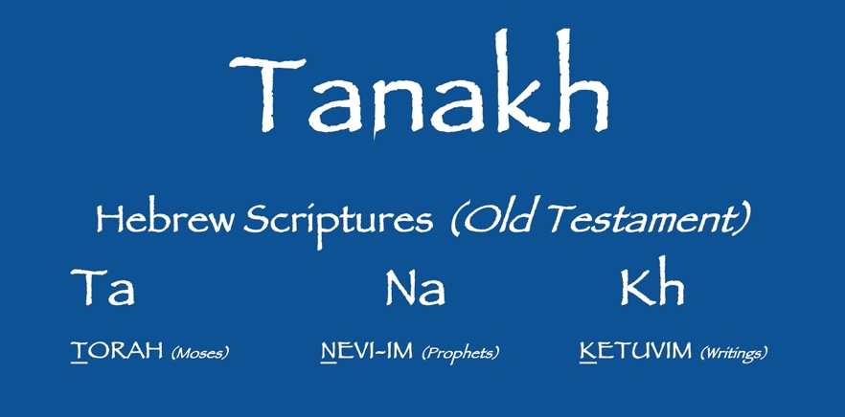_

The Tanakh is a combination of;
- The Torah (the five books of Moses, known as the Law),
- The Prophets, both major and minor prophets and even those who have no book named after them (like Elijah, and Nathan).
- The Writings, Psalms, Proverbs, Ecclesiastes and other non-prophetic and non-Torah books of the Hebrew Scriptures.

“2 but in these last days He has spoken to us by his Son,”

But…
In these last days…
He has spoken to us through “His son” [JESUS]

Jesus Speaks! He spoke to us throughout the Gospels, the books of the New Testament (which were then being written) and now continues to speak to us through the Holy Spirit!

“2b…whom He appointed heir of all things,”

Heir of all things…
The phrase "heir of all things" is based on Jewish inheritance laws, where the firstborn child received the family's wealth

“2c and through whom also He made the universe.”
Through whom He made the universe…

John tells us that, “In the beginning was the Word and the Word was with God and the Word WAS God.”

Col. 1:15-16 “The Son is the image of the invisible God, the firstborn over all creation. For in Him all things were created: things in heaven and on earth, visible and invisible, whether thrones or powers or rulers or authorities; all things have been created through Him and for Him.”

Jesus was with God and was God in the beginning when He made the Universe.

“3 The Son is the radiance of God’s glory
and the exact representation of His being,”

“Radiance of His glory and the Exact Representation”!
Knowing Jesus is knowing the Father, Seeing Jesus is seeing the Father.

John 14:9 “Anyone who has seen me has seen the Father.”

Continue,

“3a sustaining all things by His powerful word.”

“powerful word”
God created all things through his Word, “Let there be; Light, the waters, dry land, Stars and moon, vegetation, living creatures, etc.
He also sustains all things through His word as well!

“3c After He had provided purification for sins,”

“purification for sins…”
This is a very important phrase. The “Hebrews” to whom this book was written knew very well, the extensive work and meticulous practice of sin-offering sacrifices in the temple. No sins could be purged without a thorough strictly compliant offering of the High Priest in the temple, involving the blood, and slaughter of very specific animals, at exactly the correct time and manner.

Jesus, through His death on the cross, fulfilled all that so that we can have “purification for our sins”.

Matt. 5:17 “Do not think that I have come to abolish the Law or the Prophets; I have not come to abolish them but to fulfill them.”

Continue verse 3;

“3d He sat down at the right hand of the Majesty in heaven.”

A similar phrase shows up four times in Hebrews and several other times throughout the New Testament.
Jesus is seated at the right hand of the father in Heaven, an heir to His power and majesty. (Interestingly, when Stephen was being stoned in Acts 7, he said he saw the Son of Man “standing” at the right hand of the throne, as if to welcome him in.

Acts 7: 56 “Look,” he said, “I see heaven open and the Son of Man standing at the right hand of God.”

[continue]

“4 So He became as much superior to the angels as the name he has inherited is superior to theirs.”

His name is superior to the angels. He is above them, they exist to minister to, and worship Him.

Phil. 2:9-11 “Therefore God exalted Him to the highest place
and gave Him the name that is above every name,
¹⁰ that at the name of Jesus every knee should bow,
in heaven and on earth and under the earth,
¹¹ and every tongue acknowledge that Jesus Christ is Lord,
to the glory of God the Father.”

Continuing to declare Jesus’ superiority and preeminence, the author asks some simple “Rhetorical questions”…

“5 For to which of the angels did God ever say,
“You are my Son; today I have become your Father”?
Or again, “I will be his Father, and he will be my Son”?

The simple answer is “none”, “none of the angels have that level of authority or relationship with God”.

6 “And again, when God brings His firstborn into the world, He says,
“Let all God’s angels worship him.”

The angels actually worshiped Jesus, when He came into the world. Remember what they sang/said?

“Gloria in Excelsus Deo!” (Christmas)

Luke 2:13-14 “¹³ Suddenly a great company of the heavenly host appeared with the angel, praising God and saying, ¹⁴ “Glory to God in the highest heaven!”

The Author continues comparing Jesus’ superiority and preeminence, by pointing out in the Hebrew prophecy that Jesus is set above all others, including angels.

“7 In speaking of the angels he says, “He makes his angels spirits,
and his servants flames of fire.” 8 But about the Son he says,
“Your throne, O God, will last for ever and ever; a scepter of justice will be the scepter of your kingdom. 9 You have loved righteousness and hated wickedness;
therefore God, your God, has set you above your companions
by anointing you with the oil of joy.”
10 He also says, “In the beginning, Lord, you laid the foundations of the earth,
and the heavens are the work of your hands.
11 They will perish, but you remain; they will all wear out like a garment.
12 You will roll them up like a robe; like a garment they will be changed.
But you remain the same, and your years will never end.”

All of these quotes are taken right from the TaNaKh. Each one of the verses in the second half of this chapter are from;

- Numbers & Genesis (Torah),
- Isaiah (Nevi-im),
OR
- Psalms (Ketuvim).

Showing once again that “God spoke to our ancestors through the prophets at many times and in various ways”.
The writer Continues to declare Jesus’ superiority and preeminence, and ends the chapter some more simple “Rhetorical questions”…

“13 To which of the angels did God ever say, “Sit at my right hand until I make your enemies a footstool for your feet”?
14 Are not all angels ministering spirits sent to serve those who will inherit salvation?” <>

“those who will inherit salvation”, That’s us! We see all throughout the Bible how angels were sent to guide, minister to, rescue, and bring messages to the people of God. This verse tells us that they still continue to do so.

Let’s close by looking back at a very powerful verse in this chapter that shows us so much about who Jesus is in light of God’s glory (literally).
Hebrews 1:3 “The Son is the radiance of God’s glory and the exact representation of His being,”

(meditate on that for a moment)

Understanding Jesus as God is sometimes difficult without an accurate understanding of the Trinity.

The trinity is not a Biblical term but it is what we use to describe the Triune God.

There is One God, in Three Persons; The Father, Son, and Holy Spirit.
They are co-equals. Not separate Gods, and not different modes of the same God.

Think of God as a Being, and each member of the Godhead as a separate person within that one being (it may be difficult to comprehend in human terms, but it is possible with God).

Jesus is fully God, and is fully man as well (hypostatic union). He is the exact representation of His being

Col. 2:9 “For in Him dwells all the fullness of the Godhead in bodily form.”

He proclaimed to the Pharisees during Hanukkah

John 10:30 “I and the Father are one.”

It’s so important for us as believers to know the power, beauty, and glory of Jesus. He is our savior, healer, redeemer, and “friend”. But let’s not forget that “in Him dwells all the fullness of the Godhead”.

There are those who relegate him to an ordinary man who was kind to strangers and came simply to help the poor and marginalized, (like Ronin hood or Santa Claus),
but was killed by evil men who were jealous of his influence. This is only partly true.

Jesus is God in the flesh who fulfilled all the Hebrew prophecies of Messiah, gave himself up as a willing blood sacrifice for our sins, so that we can receive eternal life in heaven with Him.

Let us look unto Jesus, the author and finisher of our faith, who for the joy that was set before Him endured the cross, despising the shame, and has sat down at the right hand of the throne of God,

AND is able to save completely those who come to God through him, because he always lives, to intercede for them. <>

