FELLOWSHIP AND UNITY OF THE SPIRIT

Last verse of 2nd Corinthians:
2nd Cor. 13:14 “May the grace of the Lord Jesus Christ, and the love of God, and the fellowship of the Holy Spirit be with you all.”
`
The final exhortation of Paul’s letters to the Corinthians was that “the fellowship of the Holy Spirit be with you all”. This is an important, and vital message to the church.

He tells the Ephesians;
Eph.4:3 “Make every effort to keep the unity of the Spirit through the bond of peace.”

It’s so important that our fellowship with one another is not just physical, it’s not even mental and emotional, it is Spiritual.

1st Thessalonians 5:23 "May the God of peace himself sanctify you completely, and may your whole spirit and soul and body be kept blameless at the coming of our Lord Jesus Christ".

Unity of the Spirit can only happen among those who are Spiritual, i.e. have been “made alive” in the Spirit. It cannot happen among those who have yet to receive the Spirit.

This graphic represents a person who is not yet born of the Spirit (i.e., born again) and made alive in Christ. Their spirit is completely dormant. The truth is, without the Spirit of God in that part of our being, we are spiritually dead.

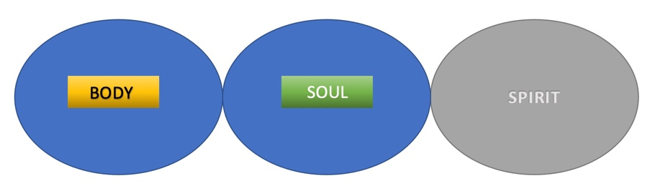

John 3:5-6 “Jesus answered, “Very truly I tell you, no one can enter the kingdom of God unless they are born of water and the Spirit. ⁶ Flesh gives birth to flesh, but the Spirit gives birth to spirit.”

Unfortunately, most people spend their whole lives this way. They can only operate and perceive things in their physical and mental capacity and are oblivious to things of the Spirit. The good news is that Jesus freely offers everyone the opportunity to be made alive in the Spirit simply by grace through faith. We read in Ephesians that He offers us this because of His great love for us:
Ephesians 2:4–5 “But because of His great love for us, God, who is rich in mercy, made us alive with Christ even when we were dead ...”

HOW DOES IT HAPPEN?
When we become born again, repenting of our sins and unbelief, opening our hearts to fully accepting Jesus as Lord, receiving His death on the cross as the sacrifice for our sins, and submitting ourselves fully to Him, something incredible happens to us. He breathes His Spirit into our spirit, and it comes to life.

Ephesians 1:13b “When you believed, you were marked in him with a seal, the promised Holy Spirit.”

Before someone is made alive in the Spirit, they are incapable of relating in the realm of the spirit. Their spirit remains dead, and they are limited to interacting only in the humanity of the soul and body. Within the realm of the soul, they can communicate and in some ways even relate to those who live in the Spirit, but only as much as their thoughts and emotions will allow.

We all have friends or family that we love and feel a strong connection with, maybe even have shared opinions, experiences, and even passions. Our interactions with them, however, will be devoid of any spiritual substance or resonance. This is not to say that our relationships with these people are meaningless or insignificant—they are very important—but we will not share “unity of the Spirit” with anyone until their spirits are made alive through Jesus.
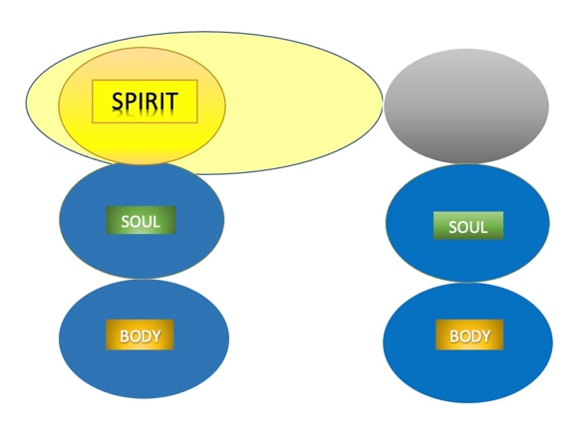
1 Corinthians 2:14 “The person without the Spirit does not accept the things that come from the Spirit of God but considers them foolishness.”

Ephesians 4:18 “They are darkened in their understanding and separated from the life of God because of the ignorance that is in them due to the hardening of their hearts.”
This scripture tells us that those who have yet to be made alive by the Spirit are separated from “the life of God” because the very means by which they can connect with God (the heart) has been hardened. This unfortunate reality is the work of the devil, which Jesus came to destroy. This is why God urges us to plead with them to be reconciled with Him. He wants all people to experience abundant life in Him.

John 10:10 “The thief does not come except to steal, and to kill, and to destroy. I have come that they may have life, and that they may have it more abundantly.”

The abundant life God wants us to experience is unity in the Spirit with Him and each other. This is His desire for us. When two people who have been made alive in the Spirit relate to one another, something truly amazing happens. They are no longer limited to a relationship built upon common interests, mutual aspirations, shared experiences, ethnicity, culture, or even family of origin.

Those who experience the unity of the Spirit are innately aware of the Holy Spirit’s presence in others and in the world. They can look at one another and the world through the “eyes of the heart.” They have a common view of the spiritual realities that surround them. They can share together in deep love, lasting peace, unquenchable joy, and every other benefit of the fruit of the Spirit, the power of the Spirit, and life in the Spirit. This is the essence of the word “koinonia,” which is defined as a deep level of fellowship, unity, and relationship that can only take place among those who are united together in Spirit with each other, and also with Christ.
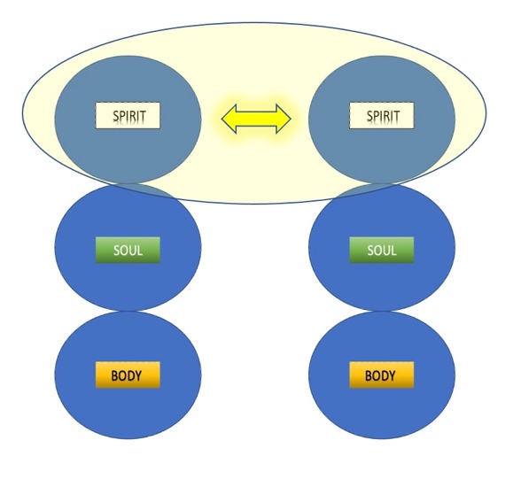

Philippians 2:1–2 “Therefore if you have any encouragement from being united with Christ, if any comfort from his love, if any common sharing in the Spirit, if any tenderness and compassion, then make my joy complete by being like-minded, having the same love, being one in spirit and of one mind.”

Being united with Christ means walking in His light. When we do this, two amazing things happen: we have deep fellowship with one another, and Jesus purifies us from all sin. In other words, the light of Jesus removes sin, which is the great separator, and the very thing that is responsible for keeping us from fellowship with God and with one another. We are able to experience deep fellowship with God and with each other. This can only take place in the light of His Spirit.

1st John 1:7 “But if we walk in the light, as he is in the light, we have fellowship with one another, and the blood of Jesus, his Son, purifies us from all sin.”
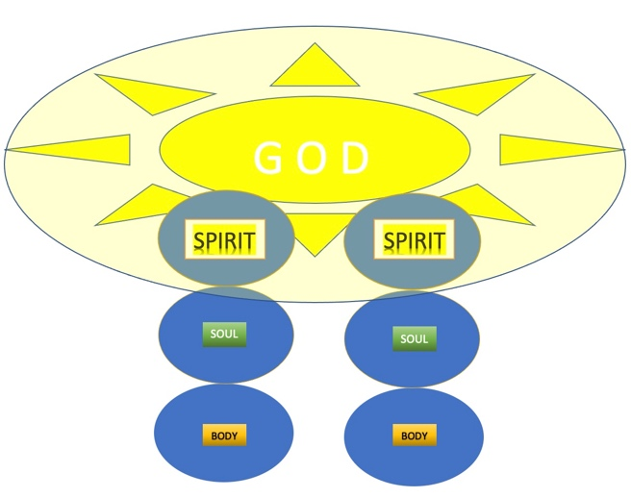

Something that also happens, that may be more amazing than two people experiencing this type of fellowship, is when many people share this same level of koinonia. Jesus told us, “For where two or three gather in my name, there am I with them” (Matthew 18:20 NIV). When believers gather in His name, the Holy Spirit within them unifies them and resonates from within them creating a deep spiritual level of fellowship.

Not only can we share this level of spiritual unity with those in our church family and community but we can also find ourselves experiencing this same level of koinonia with people throughout the world whom we have never met. During my ministry travels through the years, I have had many experiences of finding instant spiritual connections and deep relationships with people whom I had just met, simply because we were united in the Spirit.
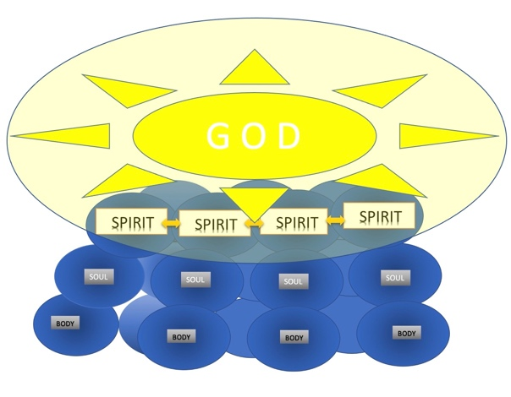
Ephesians 4:3–6 “Make every effort to keep the unity of the Spirit through the bond of peace. There is one body and one Spirit, just as you were called to one hope when you were called; one Lord, one faith, one baptism; one God and Father of all, who is over all and through all and in all.”

There is nothing sweeter and more fulfilling on earth than being part of a group of people who are truly experiencing “the unity of the Spirit and the bond of peace.” We as human beings crave that type of connection. We are designed by our Creator to live in deep fellowship with one another and experience true communion with God and one another. Anything less than that is unfulfilling and never satisfying.

Regardless of where we’ve come from ethnically, culturally, and even theologically, we are all joined together by the Spirit to be God’s household. Paul compares us to a temple building, being joined together and built together as a place where God lives by His Spirit.

Ephesians 2:19–22 “Consequently, you are no longer foreigners and strangers, but fellow citizens with God’s people and also members of his household, built on the foundation of the apostles and prophets, with Christ Jesus himself as the chief cornerstone. In Him the whole building is joined together and rises to become a holy temple in the Lord. And in him, you too are being built together to become a dwelling in which God lives by his Spirit.”

In fact, it is by His Spirit that God invites us to become His children.

Romans 8:15b–16 “. . . you received the Spirit of adoption by whom we cry out, ‘Abba, Father.’ The Spirit Himself bears witness with our spirit that we are children of God.”

Think about the words we just read. “Spirit of adoption,” “cry out,” “Abba Father,” “our spirit,” and “children of God.” It’s fascinating that in each of these phrases we see the heart of God and His love for us displayed so clearly. Each verse reveals the method by which our heavenly Father, who longs to be reconciled with His children, brings us into complete unity with Himself through the Spirit.

Our connection with God and one another through His Spirit is what Jesus talked about with such great passion and utmost priority. When asked what the greatest commandment was, His reply was to not only love God with everything within us but also love one another. When He introduced a new commandment, it was similar. He said, “Love one another, as I have loved you.” His emphasis was on bringing us into a level of unity with Himself and the Father that we could not accomplish on our own, but only through His Spirit, alive in our spirits.

On His final night before the cross, he prayed for this. He asked God to bring us into the “complete unity” and love, that He and His Father experience. Pay careful attention to how He emphasizes oneness and unity. God is Spirit, so this type of unity with Him and one another cannot take place merely in the body or soul but must take place in the Spirit.

John 17:20–23 “My prayer is not for them alone. I pray also for those who will believe in me through their message, that all of them may be one, Father, just as you are in me and I am in you. May they also be in us so that the world may believe that you have sent me. I have given them the glory that you gave me, that they may be one as we are one— I in them and you in me—so that they may be brought to complete unity. Then the world will know that you sent me and have loved them even as you have loved me.”

This is the essence of unity of the Spirit. A unity where His Spirit bears witness with our spirits, that we are children of God. This is why He created us. He is a loving Father, longing for complete unity with His children, whom He loves deeply.
This cannot take place merely in the body. Our bodies are an important vessel, but they are temporary and not equipped to experience complete unity with an eternal God.

This cannot take place “solely in the soul.” Our minds and emotions are extremely limited until the “eyes of our hearts” are enlightened.

[This is why there is so much disunity in areas of the body (our physical/ethnic identity), and the soul (opinions/persuasions of mind and emotion). This is the source of dissention, and also dissention within people’s own families, even Christians. When our perspectives and opinions are firmly tethered to our own ethnic family of origin, or those who think/feel the way we do, it’s very unlikely that we will have unity with others who are different.
Even among Christians we are sometimes like the “5 blind men and the elephant”]

True unity can only take place through the Spirit—His Spirit alive in our spirit. The same Spirit that hovered over the waters in the beginning and said, “Let there be light!” The same Spirit that came upon young David when he was anointed by Samuel. The same Spirit that the virgin Mary encountered in Nazareth when she became the mother of our Lord. The same Spirit that Jesus promised He would send, and that the apostles experienced at Pentecost. The same Spirit that raised Jesus from the dead, and lives in us!

Romans 8:12-15 “Therefore, brothers, we have an obligation, but it is not to the flesh, to live according to it. For if you live according to the flesh, you will die; but if by the Spirit you put to death the deeds of the body, you will live. For all who are led by the Spirit of God are sons of God. For you did not receive a spirit of slavery that returns you to fear, but you received the Spirit of adoption to sonship, by whom we cry, “Abba! Father!” The Spirit Himself testifies with our spirit that we are God’s children.”

The more we live by the Spirit, the more unified we’ll be, with each other, but also with God.

