

The Gospel of John – Chapter 4 “Come, See and Believe”

Last week – “Nic at Night” John 3:16 “For God so loved the world that he gave his one and only Son, that whoever believes in him shall not perish but have eternal life.”
This week Jesus and the apostles take a side trip to Samaria, and meet a woman at a well.
John 4 Now Jesus learned that the Pharisees had heard that he was gaining and baptizing more disciples than John— ² although in fact it was not Jesus who baptized, but his disciples. ³ So he left Judea and went back once more to Galilee.
⁴ Now he had to go through Samaria. ⁵ So he came to a town in Samaria called Sychar, near the plot of ground Jacob had given to his son Joseph. ⁶ Jacob’s well was there, and Jesus, tired as he was from the journey, sat down by the well. It was about noon.
(Jacob’s well is only mentioned in John’s Gospel, so biblical information about it is quite limited. The traditional site of Jacob’s well cannot be located by finding Sychar, as that city is no longer in existence. However, the site thought to be the biblical Shechem because the Bible says Jacob bought land from Shechem and lived at that place for a long time as seen in Genesis 33:19).

Note: Jesus went out of his way to go to Samaria, the common route was along the Jordan.

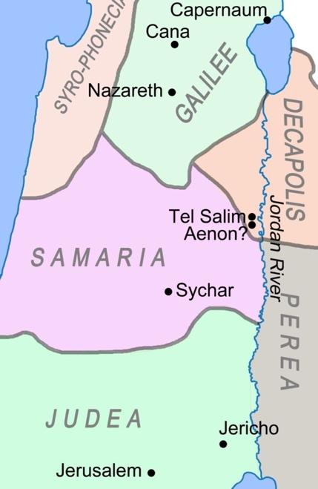
[see map ]
⁷ When a Samaritan woman came to draw water, Jesus said to her, “Will you give me a drink?” ⁸ (His disciples had gone into the town to buy food.)
⁹ The Samaritan woman said to him, “You are a Jew and I am a Samaritan woman. How can you ask me for a drink?” (For Jews do not associate with Samaritans.)
Who are the Samaritans?

The Samaritans were a group of people who lived in Samaria - an area north of Jerusalem. They were half-Jews and half-Gentiles. When Assyria captured the northern kingdom of Israel in 721 B.C. some were taken in captivity while others left behind. The ones left behind intermarried with the Assyrians. These people were neither fully Hebrews nor fully Gentiles. The Samaritans had their own unique copy of the first five books of Scripture as well as their own unique system and place of worship. They rejected the Prophets, the kings and Jerusalem including the Temple. They believed that Moses commanded the people to worship and live on Mount Gerizim. At the time of Jesus the Jews and the Samaritans did not deal with one another.
¹⁰ Jesus answered her, “If you knew the gift of God and who it is that asks you for a drink, you would have asked him and he would have given you living water.”
¹¹ “Sir,” the woman said, “you have nothing to draw with and the well is deep. Where can you get this living water? ¹² Are you greater than our father Jacob, who gave us the well and drank from it himself, as did also his sons and his livestock?”
¹³ Jesus answered, “Everyone who drinks this water will be thirsty again, ¹⁴ but whoever drinks the water I give them will never thirst. Indeed, the water I give them will become in them a spring of water welling up to eternal life.”
¹⁵ The woman said to him, “Sir, give me this water so that I won’t get thirsty and have to keep coming here to draw water.”
¹⁶ He told her, “Go, call your husband and come back.”
¹⁷ “I have no husband,” she replied.
Jesus said to her, “You are right when you say you have no husband. ¹⁸ The fact is, you have had five husbands, and the man you now have is not your husband. What you have just said is quite true.”
¹⁹ “Sir,” the woman said, “I can see that you are a prophet. ²⁰ Our ancestors worshiped on this mountain, but you Jews claim that the place where we must worship is in Jerusalem.”
She was amazed that Jesus was not only talking to her, but was able to see through her and know her secrets.
²¹ “Woman,” Jesus replied, “believe me, a time is coming when you will worship the Father neither on this mountain nor in Jerusalem. ²² You Samaritans worship what you do not know; we worship what we do know, for salvation is from the Jews. ²³ Yet a time is coming and has now come when the true worshipers will worship the Father in the Spirit and in truth, for they are the kind of worshipers the Father seeks. ²⁴ God is spirit, and his worshipers must worship in the Spirit and in truth.”
Jesus is revealing a very deep truth to this woman; that God is Spirit, and there is no other way to fully experience Him than through the Spirit (and truth).

Not only was this woman not a Jew, but she was a woman, AND she was a Samaritan which meant she did not believe in anything beyond the writings of Moses. None of the writings of the prophets or even the Kings and Psalmists meant anything to her. She had been through multiple marriages and relationships and was seemingly ostracized by her community. (Perhaps that’s why she came alone in the heat of the day, rather than in morning with the other women). She was at the well looking for the most natural thing in the world, water. Jesus offered her the most supernatural thing in the world, the Holy Spirit. Listen to what He says to her about God and those who seek Him;

"But the hour is coming, and now is, when the true worshipers will worship the Father in spirit and truth; for the Father is seeking such to worship Him. God is Spirit, and those who worship Him must worship in spirit and truth..” (John 4:23-24 NKJV)

God is Spirit, and true worshippers must worship in spirit (the presence of the Living Holy Spirit of God) AND in Truth (the knowledge and understanding of the Word of God). We don't have a choice. If we want to worship God, or even seek, follow, serve or believe in God, we must do it through the spirit, because He is Spirit.
²⁵ The woman said, “I know that Messiah” (called Christ) “is coming. When he comes, he will explain everything to us.”
²⁶ Then Jesus declared, “I, the one speaking to you—I am he.”

This is remarkable! According to John, the first person to whom Jesus revealed that He is the Messiah is this seemingly obscure, adulterous woman who was not even Jewish. He does not reveal this to the disciples until Peter’s revelation in Matthew 16.
²⁷ Just then his disciples returned and were surprised to find him talking with a woman. But no one asked, “What do you want?” or “Why are you talking with her?”
²⁸ Then, leaving her water jar, the woman went back to the town and said to the people, ²⁹ “Come, see a man who told me everything I ever did. Could this be the Messiah?” ³⁰ They came out of the town and made their way toward him.
Note: This is the same thing Philip said to Nathaniel when they first met Jesus “Come and see” (John 1:46). This is the best way to tell anyone about Jesus. Invite them to come see what you’ve seen, and experience what you’ve experienced. It’s the #1 way that churches grow. Friends and Family invited others to “come see”.
³¹ Meanwhile his disciples urged him, “Rabbi, eat something.”
³² But he said to them, “I have food to eat that you know nothing about.”
³³ Then his disciples said to each other, “Could someone have brought him food?”
³⁴ “My food,” said Jesus, “is to do the will of him who sent me and to finish his work. ³⁵ Don’t you have a saying, ‘It’s still four months until harvest’? I tell you, open your eyes and look at the fields! They are ripe for harvest. ³⁶ Even now the one who reaps draws a wage and harvests a crop for eternal life, so that the sower and the reaper may be glad together. ³⁷ Thus the saying ‘One sows and another reaps’ is true. ³⁸ I sent you to reap what you have not worked for. Others have done the hard work, and you have reaped the benefits of their labor.”
Jesus is saying that the things that are transpiring here in Samaria are more satisfying and fulfilling than even food itself. This “harvest” of souls is exactly what their purpose was all about, and they are about to see a “bumper crop” of ripe people who are about to become believers.
³⁹ Many of the Samaritans from that town believed in him because of the woman’s testimony, “He told me everything I ever did.” ⁴⁰ So when the Samaritans came to him, they urged him to stay with them, and he stayed two days. ⁴¹ And because of his words many more became believers.
⁴² They said to the woman, “We no longer believe just because of what you said; now we have heard for ourselves, and we know that this man really is the Savior of the world.”
Jesus spent two unplanned days in this out-of-the-way village of Sychar, preaching to them, telling them about Salvation. And “ because of his words many more became believers.” The apostles were probably flabbergasted. Several were probably not sure that Samaritans could receive salvation.
This is an example of being willing, available, and obedient to allow God to lead us to unplanned places, and speak to people who are different from us.
⁴³ After the two days he left for Galilee. ⁴⁴ (Now Jesus himself had pointed out that a prophet has no honor in his own country.) ⁴⁵ When he arrived in Galilee, the Galileans welcomed him. They had seen all that he had done in Jerusalem at the Passover Festival, for they also had been there. ⁴⁶ Once more he visited Cana in Galilee, where he had turned the water into wine…

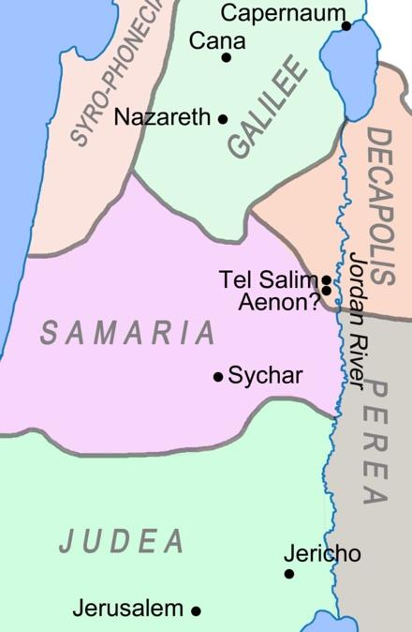
[ see map ]

So Jesus continues his journey northward to Galilee. He makes the comment that “a prophet has no honor in his own country”, which may be to explain why He is not stopping in his hometown of Nazareth, even though they pass right by. This is consistent with Mark 6:4-6
Mark 6:4-6a “Jesus said to them, “A prophet is not without honor except in his own town, among his relatives and in his own home.” ⁵ He could not do any miracles there, except lay his hands on a few sick people and heal them. ⁶ He was amazed at their lack of faith.”
When he went to Cana of Galilee, He encountered a royal official whose so was sick in Capernaum (Northern part of Galilee), and it is here where we see what John describes as Jesus’s second sign (miracle).
^{46b}…And there was a certain royal official whose son lay sick at Capernaum. ⁴⁷ When this man heard that Jesus had arrived in Galilee from Judea, he went to him and begged him to come and heal his son, who was close to death.
⁴⁸ “Unless you people see signs and wonders,” Jesus told him, “you will never believe.”
⁴⁹ The royal official said, “Sir, come down before my child dies.”
⁵⁰ “Go,” Jesus replied, “your son will live.”
The man took Jesus at his word and departed. ⁵¹ While he was still on the way, his servants met him with the news that his boy was living. ⁵² When he inquired as to the time when his son got better, they said to him, “Yesterday, at one in the afternoon, the fever left him.”
⁵³ Then the father realized that this was the exact time at which Jesus had said to him, “Your son will live.” So he and his whole household believed.
⁵⁴ This was the second sign Jesus performed after coming from Judea to Galilee.
Jesus does healing in a number of ways throughout the gospels, (sometimes he touched them, sometimes they touch him, or his garment, once he put his fingers in a man’s ears, once he put schmutz in a man’s eyes, sometimes he prayed, sometimes he didn’t). There is no set method or model for healing.
In this instance, he simply proclaimed that the “boy will live” and the boy was healed many miles away. “The man took Jesus at his word” In other words, he believed in Jesus’ words. Regardless of how Jesus chooses to heal you or someone else, it is of vital importance that when you hear the word of the Lord, that you believe.
When we pray for someone, or ask God for something, we cannot ask with doubt in our hearts, (doubt is the same thing as unbelief), we need to ask in Faith, which is the root of belief.
What if you’re not sure, what if you are struggling to know God’s will for your life, or a certain situation. You want to pray and believe according to God’s will, but you lack the wisdom to know exactly what it is. In those cases the Word of God invites you to ask for wisdom, but once again, even asking for wisdom must be done in Faith believing, not doubting.
James 1:5-7 “If any of you lacks wisdom, you should ask God, who gives generously to all without finding fault, and it will be given to you. But when you ask, you must believe and not doubt, because the one who doubts is like a wave of the sea, blown and tossed by the wind. That person should not expect to receive anything from the Lord.”
I heard an old interview of Keith Green this week, he was saying that he did not come to the Lord for two years after being witnessed to, because he was not convinced that the people telling him to believe in Jesus, fully believed in Him themselves.
Zach Meercreebs, in the sermon that sparked the Asbury Revival simply stated, “Don’t try to convince people that God loves them unless you truly believe that God loves you.
Our message must be “Come see, and believe”, but it needs to be more than words. We need to believe in Jesus, and fully trust His Word ourselves before we can expect others to.
When we are 100% sure of the presence of God in our lives, along with the life-giving power of the Holy Spirit, and the assurance of salvation through the cross of Jesus the Messiah, it’s convincing and contagious, and people will come, see and believe.

Let’s fully believe in our hearts, and fully trust Jesus with our lives, so we can legitimately say; “Come see what I’ve seen, and believe as I have believed”.

